––
Press Release

Bachmann electronic Achieves New Sales Record
Automation specialist increases turnover to 104 million euros

Feldkirch, Austria – 04/11/2024

Bachmann electronic reported a new record revenue of 104 million euros in 2023, marking a moderate increase from the previous year's figure of 102 million euros. The automation expert announced this news as part of its annual report.

Despite challenging conditions on global markets, Bachmann achieved positive results in most strategic business areas, going against the trend.

As a world market leader in wind power automation, Bachmann has equipped more than 150,000 wind turbines with automation components, accounting for nearly one third of all installed worldwide. In addition, the company has automated over 6,000 block heat and power plants and up to 20,000 ship and port facilities in the maritime sector. By the end of last year, Bachmann employed 538 people.

According to CEO Bernhard Zangerl, the successful completion of the 2023 fiscal year can be attributed to the consistent implementation of the strategy "When waters are rough, stability is needed at the helm," along with exceptional contributions from the entire workforce. However, despite Bachmann's success in 2023, CEO Zangerl remains somewhat dissatisfied: "A lingering thorn in our side is our social policy straightjacket. With increasing regulations and higher tax burdens, it becomes increasingly difficult for companies to shine in international competition," appeals the manager for policies that offer businesses greater freedom.

Investments in research and development amounted to a double-digit million amount in 2023, with expansion plans including increased presence on the US market and strengthening personnel resources at the Indian subsidiary.

For 2024, Bachmann will continue to follow its current course, investing heavily in innovation and global presence while remaining committed to being a reliable partner with stable delivery capabilities, laying the foundation for economic growth and job security for employees.
Image

Image 01 (Image 01a and 01b to choose from):

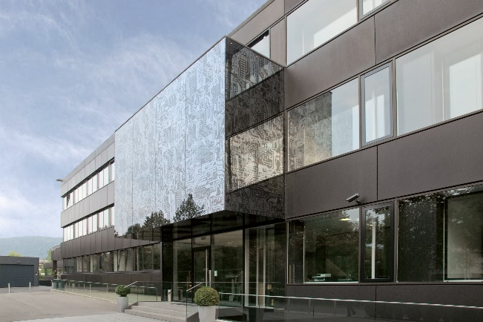 | 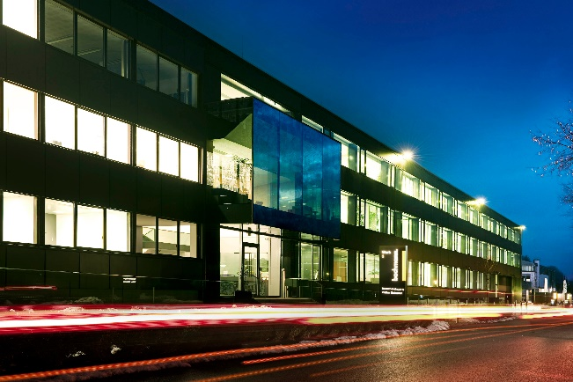

Bachmann electronic increased its turnover to 104 million euros in 2023. Here the Headquarter in Feldkirch. Image: Bachmann

Image 02 (Image 02a and 02b to choose from):

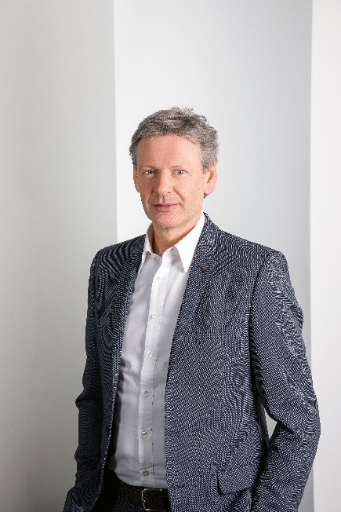 | 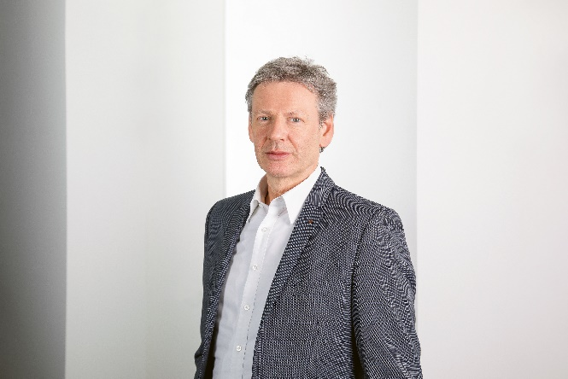

Bachmann CEO Bernhard Zangerl would like to see a policy from the government that offers companies more freedom. Image: Bachmann

Bachmann electronic GmbH
Automation, grid measurement and protection, visualization and condition monitoring of plants and machines: This is the world of Bachmann.
Headquartered in the Austrian town of Feldkirch and 19 locations worldwide, worldwide, Bachmann is an internationally aligned and strong-growth enterprise.
Robustness and reliability, these are the outstanding characteristics of the Bachmann solutions and to ensure these characteristics, every module is subjected to 100 % testing, plus a 48-hour run-in test. The intelligent, scalable technology is based on over 50 years of experience in the field of integrated engineering.
https://www.bachmann.info/

Press contact:
Bachmann electronic GmbH, Bochum Office
Frank Fladerer
Konrad-Zuse-Straße 3
44801 Bochum, Germany
Tel.: +49 234 932598-3029
Email: frank.fladerer@bachmann.info

