––
Press Release

Bachmann receives Red Dot Design Award
New automation system proves itself internationally

Feldkirch, Austria / Bochum, German – 22.04.24

Bachmann electronic receives the coveted Red Dot Design Award this year. The automation specialist prevailed in the international competition and has just been honored in the "Product Design" category for its M100 input/output system. This also gives Bachmann's automation system a special place in the Red Dot Design Museum. For one year, it will be part of the special exhibition "Design on Stage" and presented to thousands of visitors on the grounds of the UNESCO World Heritage Site Zeche Zollverein in Essen, Germany.

"We are extremely pleased to have won the Red Dot Award for M100, as it confirms our efforts to have developed a product that is particularly user-friendly and also looks good," says Daniel Pfeifer, Technical Director at Bachmann, enthusiastically.

The M100 input/output system not only stands out from the market standard due to its visual appearance, but also impressed the jury with its technical innovations.

An important external feature is its compactness: the M100 series is only about half as wide as its predecessor. This was made possible by an innovative housing design that enables a much greater density of functions. This gives the customer's development engineers decisive advantages when planning space in the control cabinet, which in turn increases efficiency. Thanks to the use of aluminum as the housing material, the M100 series is also very robust and can withstand extreme environmental influences. This applies, for example, to shock, vibration, humidity and low and high temperatures.

A QR code is also applied to the clearly designed display panel for signaling the module status. It can be read with any standard smartphone. The device designation, article and serial number as well as the connection diagram, data sheet and installation instructions are displayed immediately. The M100 series is configured in a newly developed, web-based section of the tried-and-tested Bachmann SolutionCenter tool. The new configurator saves a considerable amount of engineering time.

The features of the M100 series stand out from the market standard and made it the winner of this year's award, as emphasized not only by the jury but also by Daniel Pfeifer: "The M100 stands out among industrial controllers because we have implemented robustness, durability, user-friendliness and performance without compromise. The Red Dot Award confirms that we have achieved these goals."

The award ceremony will take place on June 24, 2024 in the historic Aalto Theater in Essen.

Keyword "Red Dot Design Award":
The Red Dot Design Award is a globally renowned competition that is one of the most coveted seals of quality for design. The **jury divides the award into three disciplines - product design, communication design and design concept. In the "Product Design" category, prizes are awarded to finished products with industrial series production that impress with their outstanding design.
https://www.red-dot.org/

More information about the M100 series:
https://www.bachmann.info/en/campus/performance/m100-series

Images

Image 01 (Images 01a and 01b to choose from):

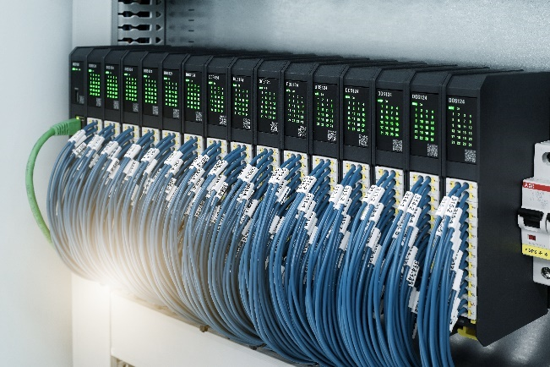 | 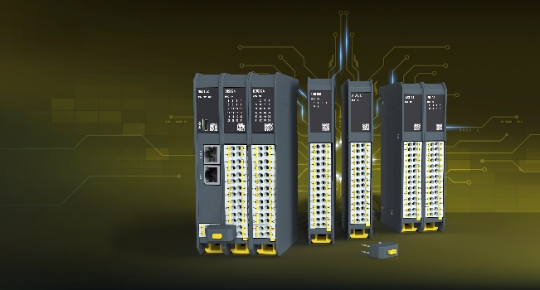

Bachmann electronic receives the coveted Red Dot Design Award this year. The M100 input/output system from the specialist for automation solutions prevailed against international competitors and was honored in the "Product Design" category. Image: Bachmann

Image 02:

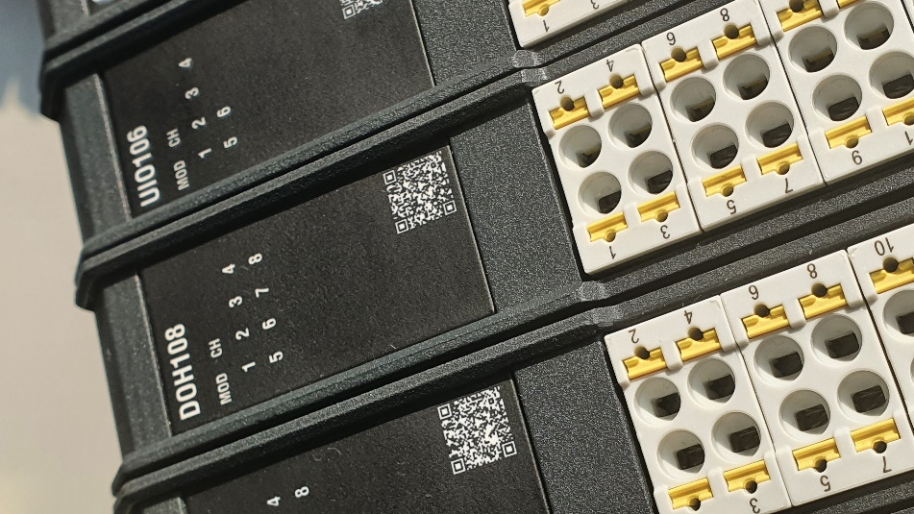

The modules in the M100 series are equipped with a QR code and generous connection technology. The connectors are easy to remove, offer a wide range of strand diameters, are shock and vibration resistant, and very easy to handle. Image: Bachmann

Image 03:

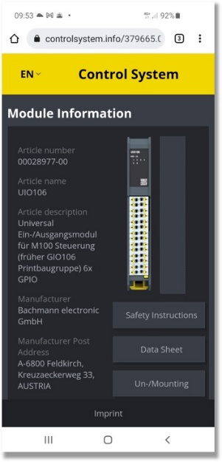

The QR code on the modules of the M100 I/O system can be read with any standard smartphone. This gives the user direct access to information such as the wiring diagram, data sheet or user manual. Image: Bachmann

Image 04:

The Red Dot Design Award is a globally renowned competition that is one of the most coveted seals of quality for design. Bachmann electronic was awarded this year for its M100 series. Image: Red Dot

Bachmann electronic GmbH
Automation, grid measurement and protection, visualization and condition monitoring of plants and machines: This is the world of Bachmann.
Headquartered in the Austrian town of Feldkirch and 19 locations worldwide, worldwide, Bachmann is an internationally aligned and strong-growth enterprise.
Robustness and reliability, these are the outstanding characteristics of the Bachmann solutions and to ensure these characteristics, every module is subjected to 100 % testing, plus a 48-hour run-in test. The intelligent, scalable technology is based on over 50 years of experience in the field of integrated engineering.
https://www.bachmann.info/

Press contact:
Bachmann electronic GmbH, Bochum Office
Frank Fladerer
Konrad-Zuse-Straße 3
44801 Bochum, Germany
Tel.: +49 234 932598-3029
Email: frank.fladerer@bachmann.info

