PRESS RELEASE
June 2022

Also available for the BMW M3 and BMW M4:
The three-way adjustable ST XTA plus 3 coilover with top mounts

The ST XTA plus 3 coilover suspension significantly improves both the driving dynamics and handling of any vehicle. This is also the case with sporty mid-range models such as the BMW M3 Sedan and the BMW M4 Coupe. Responsible for the performance gain are the KW dampers, which are independently adjustable in the ST XTA plus 3 in the low-speed compression stage, high-speed compression stage and low-speed rebound stage. This coilover suspension also features adjustable unibal top mounts on the front axle strut and racing springs. The ST XTA plus 3 also allows maximum lowering. According to the parts certificate, the M3 sedan (F80) and the M4 coupe (F82) can be lowered continuously between 15 and 40 millimeters on both axles. Optionally, the ST XTA plus 3 coilover suspension can also be ordered individually in terms of spring coating, spring labeling, and soon ST suspensions also plan to offer different spring packages with different spring rates. More at www.st-suspensions.net

An increasing number of ST suspension components are now available for the BMW M3 Sedan (F80) built from 2014 to 2018 and the BMW M4 Coupé (F82) built from 2014 to 2020. There is now also the ST XTA plus 3 coilover suspension on top of the ST height adjustable springs, ST wheel spacers, and the ST XTA coilover suspension with adjustable rebound. Compared to the other ST coilovers, the ST XTA plus 3 allows the preset damper setup to be individually adjusted in various parameters in just a few steps.
Because of the wide range of separately adjustable compression and rebound damping, the ST coilover suspension allows almost any setup required road suspension setup. With 24 clicks each, the low-speed and high-speed compression stage forces can be adjusted. The low-speed rebound stage can be set with 16 clicks. The adjustable rebound damping influences, among other things, how quickly the chassis rebounds when the suspension is compressed during load changes. Together with the spring rate of the suspension spring, the compression damping influences the immersion speed of the piston rod in the damper. In addition, the compression damping also affects the body's pitching and rolling movements as well as its turn-in behavior. In the case of performance suspensions such as the ST XTA plus 3 coilover suspension, the specifications Low-speed and Highspeed refer to the speed of movement of the piston rod when immersing and retracting. Slow piston rod movements are typical steering maneuvers and, for example, braking before corners, while fast piston rod movements are caused by road irregularities due to bumps and transverse joints in the road surface. On the BMW M3 (F80) and BMW M4 (F82), support mounts on the front axle struts are an integral part of the scope of delivery. They make the steering even more precise than with normal strut mounts using rubber-metal elements. In addition, the ST strut mounts can also be used to adjust the wheel camber.

ST Make it Yours

Like all ST height-adjustable springs and ST coilover suspension kits, the ST XTA plus 3 coilover suspension is part of the so-called "Make it Yours" program. The XTA plus 3 coilover suspension can be ordered in 18 different surface colors from specialist dealers and also directly from the suspension manufacturer. In addition, the springs can also be individually labeled. Optional spring packages are in preparation for the ST XTA plus 3 coilover suspension for the BMW M3 (F80) and BMW M4 (F82). These different springs are available with different spring rates in order to be able to adapt, for example, the ST XTA plus 3 to lightweight modifications of the car. More at www.st-suspensions.net

Publication for free / copy requested

This press release can also be found at www.tuningpress.com

Contact und Copy Address:
MediaTel Communication & PR, Haldenweg 2, D-72505 Krauchenwies-Ablach
Tel.: +49/7576/9616-12, E-Mail: presse@mediatel.biz
Press Contact:
Christian Schmidt, E-Mail: Christian.Schmidt@kwautomotive.de, Tel. +49/7971/9630-547
KW automotive GmbH, Aspachweg 14, D-74427 Fichtenberg, Web: www.stsupensions.net
Facebook: www.facebook.com/STsuspensionsINT, ST suspensions at KW Blog: http://blog-de.kwautomotive.net/

Also available for the BMW M3 and BMW M4:
The three-way adjustable ST XTA plus 3 coilover with top mounts

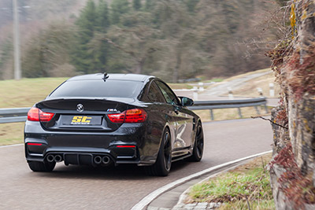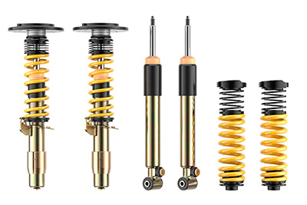

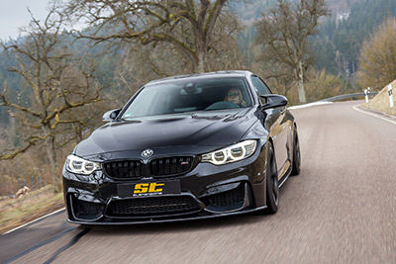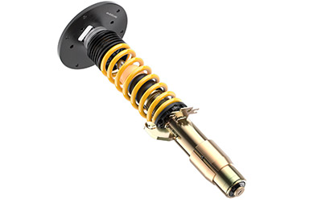

About KW automotive:
The KW entrepreneurial group includes the suspension manufacturer KW automotive with its brands KW suspensions, ST suspensions, ap Sportfahrwerke, as well as the SimRacing brands TrackTime and Ascher Racing. With its immense suspension portfolio, state-of-the-art production technology and its development and test center, KW successfully operates in all markets for more than 25 years. Over the past years, KW automotive has developed over 16 distinct damping technologies in order to fulfill its own requirement of supplying "the perfect suspension for every demand". Beside its core business, the development and production of manually and adaptively adjustable coilover kits and other suspension components for the aftermarket as well as the range of accessories of various automobile manufacturers in the premium segment, the business field of original equipment for special models and super sports cars of the automotive industry is developing tremendously positively for the German suspension manufacturer. Since KW is a development partner of sophisticated controlled suspension systems, the manufacturer disposes of the entire product portfolio of hydraulics, electronics, sensor technology, control units and damper control systems as well as the necessary know-how for the application and tuning of complex vehicle performance systems from a single source. KW has become an indispensable part of customer motor sports throughout the past years and produces homologated racing dampers and suspensions for a constantly growing number of racing cars of several manufacturers. Worldwide, successful racing teams rely on the patented valve technology of KW Competition suspensions. The entrepreneurial group has subsidiaries in the most significant markets, such as Belgium, Great Britain, China, Japan, Switzerland, Taiwan and the USA. 360 employees from the 1200 employees worldwide of the Group are located at the headquarters in Fichtenberg. Software and hardware solutions are further business segments as well as events for virtual motor sports in the scope of the brand RaceRoom. Equally, the suspension manufacturers AL-KO Damping Unit, Belltech and Reiger Suspension as well as the alloy wheels manufacturer BBS are brands of the KW entrepreneurial group.

Publication for free / copy requested

This press release can also be found at www.tuningpress.com

Contact und Copy Address:
MediaTel Communication & PR, Haldenweg 2, D-72505 Krauchenwies-Ablach
Tel.: +49/7576/9616-12, E-Mail: presse@mediatel.biz

Press Contact:
Christian Schmidt, E-Mail: Christian.Schmidt@kwautomotive.de, Tel. +49/7971/9630-547
KW automotive GmbH, Aspachweg 14, D-74427 Fichtenberg, Web: www.stsupensions.net
Facebook: www.facebook.com/STsuspensionsINT, ST suspensions at KW Blog: http://blog-de.kwautomotive.net/

