MIKHAIL KARIKIS  VOICES, COMMUNITIES, ECOLOGIES.  April 5–July 27, 2025, Kunstmuseum St.Gallen  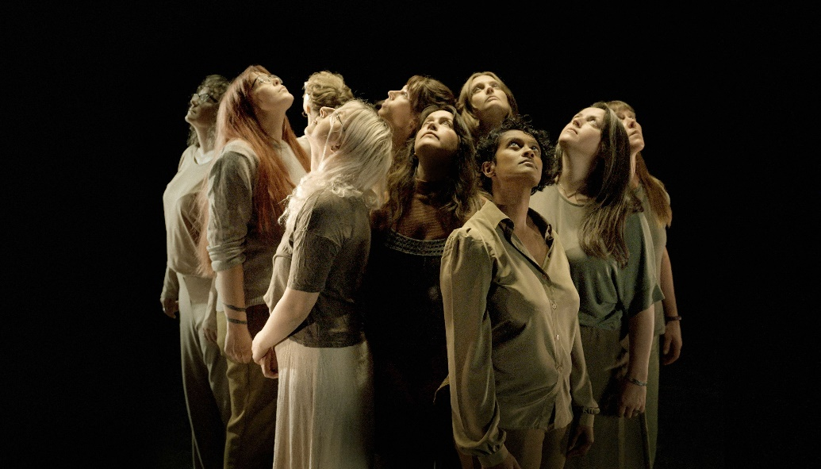  Mikhail Karikis, Songs for the Storm to Come, 2024  The Kunstmuseum St.Gallen is dedicating a comprehensive solo exhibition to the internationally renowned Greek-British artist Mikhail Karikis. Karikis is known for his interdisciplinary works that unite sound, film, and performance. His work is shaped by social and environmental responsibility and amplifies the voices of communities that often go unheard. With Voices, Communities, Ecologies., the Kunstmuseum St.Gallen presents a mid-career retrospective featuring a selection of his highly acclaimed works alongside a newly commissioned piece created specifically for the exhibition.  A Soundscape of Transformation  In his art, Karikis explores the interplay between sound, the environment, and human experience. Through immersive audiovisual installations, he creates spaces that encourage reflection on social justice, collective action, and visions of the future. This exhibition features significant works created with communities from across the continents, such as Sounds from Beneath, in which former coal miners preserve their memories of industrial decline through song, and Children of Unquiet, which captures children’s perspectives on a post-industrial world. Also on display are SeaWomen, a tribute to ecofeminist traditions, and Songs for the Storm to Come, which intertwines protest music with communal speculative visions of the future.  New Commission: A Universe of Solutions (CH)  A highlight of the exhibition is the newly commissioned work A Universe of Solutions (CH). In collaboration with musicians from the Youth Symphony Orchestra in St.Gallen, Karikis has developed an innovative sound and video project that musically and visually explores the idea of a sustainable future. The work was created in multiple phases, including workshops, a film shoot in the iconic Theater St.Gallen, and the subsequent film installation at the museum. The costumes were designed by Albert Kriemler, Creative Director of the fashion house Akris, and lend the production a visual strength in white.  Mikhail Karikis – Voices, Communities, Ecologies. is an invitation to engage with the pressing issues of our time and experience the transformative power of art, sound, and community.  Catalogue  In June 2025, a publication will be released by the renowned publisher MOUSSE, featuring a foreword by Gianni Jetzer and texts by Jack Nicholl, Henna Keski-Mäenpää, and Iwona Blazwick, as well as a conversation between Mikhail Karikis and former collaborators Sonia Boyce and Zineb Sedira.  Curators and Supporting Programme  This exhibition is curated by Gianni Jetzer, Director of the Kunstmuseum St.Gallen, and Henna Keski-Mäenpää, Assistant Curator. Alongside the exhibition, talks, workshops, and interactive formats will be organized, inviting the audience to actively engage with the themes of the works. The full programme can be found on our website. | Exhibition Dates  April 5–July 27, 2025  Kunstmuseum St.Gallen  Press Conference  April 4, 2025, 11 a.m.  Kunstmuseum St.Gallen  Exhibition Opening  April 4, 2025, 6:30 p.m.  Kunstmuseum St.Gallen  Opening Hours  Tue–Sun: 10:00 a.m. – 5:00 p.m.  Thu: 10:00 a.m. – 8:00 p.m.
Press Contact

Nadine Sakotic
Head of Communications
Museumstrasse 32
9000 St. Gallen
T +41 71 242 06 84

kommunikation@kunstmuseumsg.ch
kunstmuseumsg.ch

MIKHAIL KARIKIS
VOICES, COMMUNITIES, ECOLOGIES

Exhibition Dates | April 5-July 27, 2025
Exhibition Venue | Kunstmuseum St.Gallen
Press Conference | April 4, 2025, 11 a.m.  Kunstmuseum St.Gallen
Exhibition Opening | April 4, 2025, 6:30 p.m.  Kunstmuseum St.Gallen
Curator | Gianni Jetzer, Director of the Kunstmuseum St.Gallen and Henna Keski-Mäenpää, Assistant Curator
Opening Hours | Tue – Sun: 10:00 a.m. – 5:00 p.m.  Thu: 10:00 a.m. – 8:00 p.m.
Press Contact | Nadine Sakotic  T +41 71 242 06 84  kommunikation@kunstmuseumsg.ch
Website | kunstmuseumsg.ch
Press Photos | kunstmuseumsg.ch/presse

