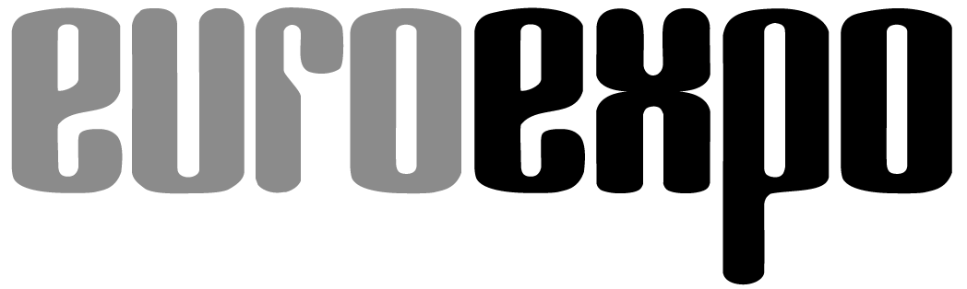

Messe- und Kongress-GmbH

Joseph-Dollinger-Bogen 7

D-80807 Munich, Germany

Phone: +49 89 32 391 259

Fax: +49 89 32 391 246

www.euroexpo.de/en

www.logimat-messe.de/en

www.tradeworld.de/en

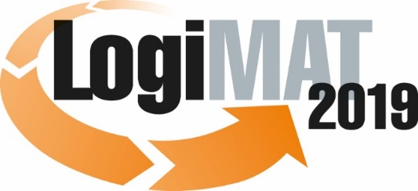

**The 17th International Trade Show for  
Intralogistics Solutions & Process Management  
February 19–21, 2019 | Messe Stuttgart**

# Also featured at LogiMAT:



Munich, January 16, 2019

# Press Release

# LogiMAT 2019 in Stuttgart

**LogiMAT 2019 – First-hand conveyance technology**

**International equipment and system manufacturers from the conveyance technology industry are converging on Stuttgart for the 17th edition of LogiMAT to unveil their latest product and system innovations for today’s intralogistics material flow. Exhibitors are due to present a diverse selection from their growing product lines, illustrating the latest trends in product development and highlighting the growing sophistication of industry requirements around software, AGVs, and robotics.**

Equipment and system manufacturers from around the world are gathering for the 17th International Trade Show for Intralogistics Solutions and Process Management, bringing along products and services for warehouse and conveyance technology that illustrate the industry’s current positioning and future direction. This exhibitor group, traditionally the strongest at LogiMAT, will occupy Hall 1 (including the gallery) plus Halls 3, 5, and 7 this year. The diverse portfolio of innovations and other optimizations from established system architectures and material flow components ranges from equipment and process optimizations of traditional static warehouse technology to automated conveyance technology, fully automated system solutions, automated guided vehicles (AGVs), robot-guided picking solutions, and software systems for material flow control and warehouse management. The system architectures focus on end-to-end process automation with scalable options for optimized production processes of small quantities – right down to fully customized manufacturing of individual products.

Just as diverse as the products on display is the corporate culture of the exhibitors: “The exhibitors at the 17th LogiMAT once again represent a cross-section of cultures in the industry, from global all-rounders integrating complex logistics systems to smaller businesses specializing in custom equipment and system components,” notes Michael Ruchty, LogiMAT Exhibition Director at event organizer EUROEXPO Messe- und Kongress-GmbH in Munich. “And the trend we’ve seen for several years now continues – namely, that the big players in particular continue to expand their hardware portfolios while also cultivating a market presence for software, complete with dedicated business units for in-house development, offering warehouse management systems that go far beyond system controllers and material flow computers.” Aberle, Knapp, SSI Schäfer, Vanderlande, Viastore are among the exhibitors who are not only bringing system and conveyance technology to Stuttgart but in some cases are actually renting additional booth space among the software companies in Hall 8 to showcase their warehouse management and process control systems.

On the hardware end, the focus among the international exhibitors is on innovations in the areas of robotics, AGVs, and shuttle technology – in other words: mobility and flexibility in the warehouse. The US logistics startup 6 River Systems from Boston (Hall 1, Booth K37), founded by former executives from Kiva Systems (now Amazon Robotics), is introducing European audiences to its collaborative mobile fulfillment robot Chuck. The AI-guided solution is designed to offer a cost-effective alternative to traditional warehouse automation and boost picking rates by 200 to 300 percent over manually operated pick carts. Beijing Geek+ Technology Co., Ltd. (Hall 7, Booth C51), China’s leading provider of warehouse and logistics robotics, is coming to Stuttgart with the latest version of the Geek Picking System, an integrated robotic sorting system, including the P800 picking robot with a load-carrying capacity of up to 1,000 kg and operating temperature range of -22° to 122° C. Vanderlande Industries GmbH (Hall 1, Booth J21 and Hall 2, Booth A05) introduces the latest collaborative robot (“cobot”) in its smart item robotics (SIR) series, which can handle dynamic product lines without preliminary SKU teaching – an automated item-picking solution that works alongside humans.

The investments that customers must make to keep up with digital innovation, automation, and e-commerce are driving developments and boosting the revenues of system providers. Meanwhile, rapid technological developments necessitate the ability to constantly adapt the system layout, material flow design, and system configuration. Shuttle or AGV solutions and tugger trains are increasingly deployed to accommodate dynamic, fully automated warehouse systems and intralogistical transports with both containers and pallets. Here, the 17th LogiMAT offers many innovations and new product launches. Storax Ramada (Hall 1, Booth L70), for example, is bringing the latest version of its Ranger shuttle system to Stuttgart, while Savoye is presenting its Intelis PTS shuttle system specifically for the frozen food industry on the gallery level in Hall 1 (Booth OG30), and Knapp AG (Hall 3, Booth B03) is showing the new version of its OSR shuttle system Evo.

Typically, shuttles pass containers and pallets to stationary conveyance technology systems. But AGVs and transport shuttles are being deployed as an increasingly popular, barrier-free alternative for transports outside fully automated warehouse systems. Trapo AG (Hall 5, Booth D37) is coming to the 17th LogiMAT to unveil the Trapo Transport Shuttle (TTS), which works autonomously and can also communicate and collaborate with the Trapo Warehouse Shuttle (TWS). EXOTEC Solutions SAS (East Entrance, Booth EO30) is displaying its multi-dimensional Skypod robot shuttle system, which transports containers and can place them on shelves up to 10 meters high. Propoflex UG (Hall 1 gallery, Booth OG06) is bringing the latest developments in its mobile shelf systems.

Another trending technology in warehousing and intralogistics driven by e-commerce is overhead conveyor systems with pouch sorters. The companies currently making a name for themselves in this segment include SSI Schäfer (Hall 1, Booth D21) and psb intralogistics GmbH (Hall 1, Booths B04 and B07). Also on display are new compact systems like the Storojet storage and picking system, which ICO Innovative Computer GmbH (East Entrance, Booth EO40) is calling the world’s first automated multi-level shelf storage system.

Nor has the pace of innovation slowed among traditional warehouse and conveyance technologies or their components: The innovations and breakthroughs at LogiMAT 2019 include new light-duty conveyor systems (Blume-Rollen GmbH, Hall 3, Booth B77), pallet inspection machines (CCI Fördertechnik GmbH, Hall 3, Booth C46), sorters for small and lightweight items (EuroSort Systems B.V., Hall 3, Booth D52), innovative plastic modular conveyor belts and flat belts (Forbo Siegling GmbH, Hall 3, Booth A01), and new transfer cars whose integrated-hub rotation forks accommodate all types of unit load devices for ground-level load transfer (AFB Anlagen- und Filterbau GmbH & Co. KG, Hall 3, Booth C79). Zhejiang Damon Technology Co. Ltd. from China (Hall 1 gallery, Booth OG24) is exhibiting several new products, including its IoT-based modular conveyor platform i-G5. LT Fördertechnik GmbH (Hall 5, Booth F20) is centering its trade show presentation around a new Pegasus-class automated storage and retrieval system for automatic small-parts storage areas. Visitors to Stuttgart can also discover a wide range of products for niche areas and specialized applications, such as the new electric heavy-duty roll-out shelf system model 5003 from Lützenkirchen Lagertechnik GmbH (Hall 1, Booth K11).

Looking at the above examples, we see that among material flow solutions for the warehouse, automation and digital technology are setting the trends in conveyance technology and systems engineering developments. When it comes to designing systems and material flows, the top priority is variable systems and flexibility in the scalability of solutions. The range of options and spectrum of components that each exhibitor offers is as broad as the needs of the various customers. “In all areas – from new standalone components to the latest trends in fully automated systems – the 17th edition of LogiMAT offers one-stop shopping and the opportunity for a side-by-side comparison of the latest innovations and forward-looking solutions from all major manufacturers worldwide,” concludes LogiMAT’s Exhibition Director Ruchty. “A unique industry overview where industry professionals from around the world can find the right system for every intralogistics process.”

Event organizer: EUROEXPO Messe- und Kongress-GmbH

Joseph-Dollinger-Bogen 7 | 80807 Munich, Germany

Phone: +49 89 32 391 259 | Fax: +49 89 32 391 246

[www.logimat-messe.de](http://www.logimat-messe.de/en) | [www.tradeworld.de](http://www.tradeworld.de/en)

8,556 characters (with spaces)

Munich, January 16, 2019 - This text may be reprinted free of charge, but please send a copy to EUROEXPO Messe- und Kongress-GmbH, Press and Public Relations Department, 80912 Munich.

About LogiMAT

LogiMAT 2019, the 17th International Trade Show for Intralogistics Solutions and Process Management, takes place February 19–21 on the grounds of Messe Stuttgart, directly adjacent to Stuttgart International Airport. LogiMAT, the world’s largest intralogistics trade show, offers a comprehensive overview of everything driving the intralogistics industry, from procurement to production to shipping. International exhibitors gather early in the year to showcase innovative technologies, products, systems, and solutions for streamlining operations, optimizing processes, and cutting costs in a company’s internal logistics.

TradeWorld, the Professional Platform for Trade Processes embedded within LogiMAT, features products and solutions for e-commerce and omnichannel. Beyond the exhibitor booths, visitors to this combined event can also experience a different program of presentations each day covering a wide range of topics.