PRESS RELEASE
Schwaebisch Hall, June 18, 2018

COMEDCO – the complete solution for transdermal dressings and oral dispersible films
A new alliance: Coating and converting combined

Reaching your objective fast and safe with a new alliance: COMEDCO. The new alliance assists pharmaceutical companies with their start into the manufacturing and packaging process of transdermal dressings and oral dispersible films. The technology leaders Coatema Coating Machinery GmbH and OPTIMA life science GmbH are behind COMEDCO with their expertise in converting and coating with pharmaceutical medicines.

Today’s technology offers new methods to administer medication. Pills and syringes will remain; however, there are many reasons to expand how to administer medications. An example is older people in need of care who have difficulty swallowing and where pills might not safely reach the intended “target”. Or illnesses, which may require frequent shots. Cases like these require alternative solutions that are still effective but more convenient for the patient.

It also makes sense to transport the substances as close as possible directly to the affected area during administering. A lower drug concentration and less stress to the gastrointestinal tract are additional advantages to choose transdermal dressings or oral dispersible films.

A higher demand in oral dispersible film (ODF) and transdermal dressings (TDS – transdermal systems) is already apparent for the machine manufacturing industry, especially in the Asian and U.S. market.

New administration forms for pharmaceutical agents becoming increasingly important

The packaging industry has the responsibility to follow this trend and to develop new designs and present solutions. The idea behind COMEDCO is to make it easy and safe for pharmaceutical companies to start their new developments for transdermal and ODF products. The COMEDCO portfolio includes laboratory or development equipment platforms, which are scalable to medium and large size production capacities.
Development expenses occur during the launch of ODF or TDS product. Here the machine builder can help to reach the objective faster and with less expenditure. Answers to questions like: What is the best suitable application and dosing system for a certain drug? What is the best carrier material for which drug? How can a correct homogeneous substance per piece or unit be guaranteed and controlled?

The production of transdermal dressings and ODF products starts with the coating process where the substance is applied to the carrier material by a COMEDCO machine. Depending on the product, a certain drying time has to be considered which takes place within the machine.

Subsequently the carrier material with the applied substance is cut and rolled into individual rolls. The product, depending on the drying process and the strict separation of different pharmaceutical substances, to avoid cross-contamination, may require a batch process. The coating process takes place in the first part of the COMEDCO machine.

Our COMEDCO partner Coatema Coating Machinery GmbH provides decade long expertise in the development and distribution of different coating machinery. Projects from the medical and pharmaceutical industry are a part of their expertise. The company is well known worldwide for its diverse technology center in coating technologies. With COMEDCO, customers are able to rely on our experts, to define the different possibilities and discuss advantages and disadvantage of the different technologies for their product. In addition, our coating experts are in a close contact with scientific institutes and well connected through several scientific projects.

Expert Duo

The packaging process is completed in the second part of the COMEDCO machine. In this part of the machine, existing (product depending) carrier material can be removed, new carrier material introduced, film would be cut to a defined size, separated and reunited on a carrier film and packaged. Packaging of transdermal dressing is often more complex than packaging of oral dispersible film due to a wider variety of product options and different processing methods. The COMEDCO machine offers continuous or intermittent converting and packaging processes.

This part of the COMEDCO machine is based on technologies from Optima Life Science. Optima Life Science offers expertise from a variety of completed projects for ODF and TDS products, as well as from state-of-the-art wound care packaging processes. The company made a name for itself across the industry through flexibility with complex automated processes. First with the production and packaging of diagnostic products and thereafter, in medical web converting.
Optima Life Science is part of the Optima Packaging Group, which has successfully built manufacturing and packaging machinery for decades, among other industries, also for the pharmaceutical industry and life science companies.

Loose connection or strong partnership?

An intense search for the right partner preceded the COMEDCO alliance. One of the deciding factors for the alliance was the perfectly complementary expertise of Coatema Coating Machinery GmbH and Optima Life Science. Both companies are similar regarding their focus – keywords are: pioneering achievements, philosophy, and company size. In addition, both companies are convinced that the partnership will bring many advantages to customers and end-users.

The contractual partner for customers will always be Optima Life Science, therefore, customers will benefit from one responsible party and a clear structure. Both companies provide expert contacts. In addition, both companies are still operating as separate entities if the project is related to only coating or packaging.

COMEDCO made its first public appearance during the Achema show. This joint kick-of emphasizes the commitment to the alliance. A COMEDCO website is also available (wwww.comedco.de). At the start of 2018, the founding of COMEDCO was contractually finalized. An initial joint order was won shortly after.

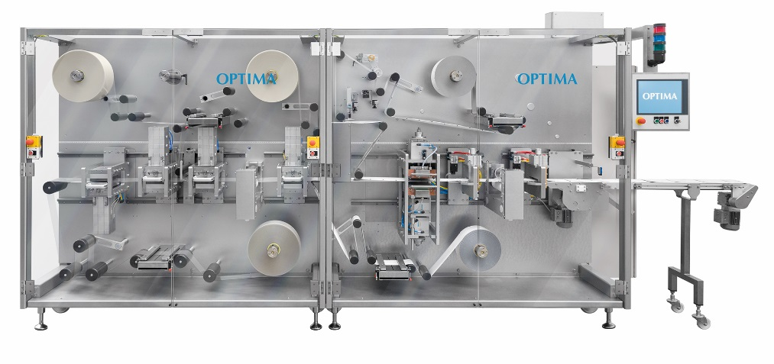
OPTIMA TDC125

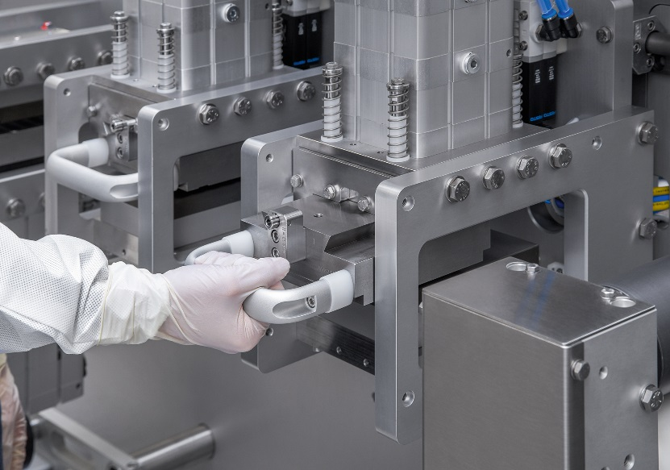
Change of cutting tools at the OPTIMA TDC125

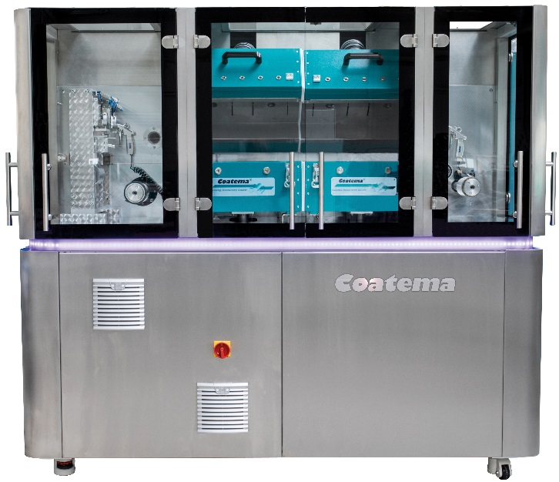
Coatema machine
Characters (incl. spaces): 6,022

Contact:
OPTIMA packaging group GmbH
Sabine Gauger
Marketing Director
sabine.gauger@optima-packaging.com
www.optima-packaging.com
Thank you very much for your publication. We look forward to receiving a specimen copy.

