Hochdruckpistole EASY!Force Advanced ausgezeichnet

German Innovation Award 2018 für Kärcher

Pressekontakt
Alexander Becker
Pressereferent
Alfred Kärcher GmbH & Co. KG
Alfred-Kärcher-Str. 28-40
71364 Winnenden
T +49 71 95 14-4256
F +49 71 95 14-2193
alexander.becker@de.kaercher.com
Winnenden, im Juni 2018 – Kärcher hat für seine Hochdruckpistole EASY!Force Advanced den German Innovation Award 2018 in der Kategorie „Machines & Engineering“ erhalten. Der Preis, der vom Rat der Formgebung vergeben wird, soll Innovationen sichtbar machen und wird einmal im Jahr vergeben.
„Das wesentliche Merkmal der neuen Hochdruckpistole ist der Abzug, der mit dem Handballen in den Griff geschoben wird. Dadurch erübrigt sich nach dem Auslösen praktisch jegliche Haltearbeit“, erklärt Denis Dammkoehler, Leiter Industrial Design für die Produktsparte Professional bei Kärcher. „Der Rückstoß des Wasserstrahls drückt den Abzug von selbst in die Hand. Die bisher nötige, dauerhafte Anspannung von Hand- und Fingermuskulatur entfällt, einer Verkrampfung der Muskulatur wird somit vorgebeugt.“ Die EASY!Force-Pistole ist geeignet für alle Kaltwasser- und Heißwasser Hochdruckreiniger aus dem Professional-Segment von Kärcher mit einem maximalen Druck von bis zu 300 bar.
German Innovation Award
Der German Innovation Award zeichnet branchenübergreifend Produkte und Lösungen aus, die sich vor allem durch Nutzerzentrierung und einen Mehrwert gegenüber bisherigen Lösungen unterscheiden. Denn: Innovationen, die Zukunft gestalten und das Leben verbessern, gibt es in allen Branchen. Manchmal sieht man sie auf den ersten Blick – oftmals aber auch nicht. Das will der German Innovation Award ändern. Er macht großartige Leistungen für ein breites Publikum sichtbar und sorgt für eine erfolgreiche Positionierung am Markt.
Die Bewertung der Einreichungen erfolgt nach den Kriterien Innovationshöhe, Anwendernutzen und Wirtschaftlichkeit. Die Innovationsstrategie sollte Aspekte wie soziale, ökologische, ökonomische Nachhaltigkeit und den Energie- und Ressourceneinsatz berücksichtigen. Auch Faktoren wie Standort- und Beschäftigungspotenzial, Langlebigkeit, Marktreife, technische Qualität und Funktion, Materialität und Synergieeffekte spielen eine entscheidende Rolle im Jurierungsprozess.

Eine Word-Datei und druckfähige Bilder zu dieser Presseinformation liegen für Sie in unserem Newsroom https://www.kaercher.com/presse zum Download bereit.

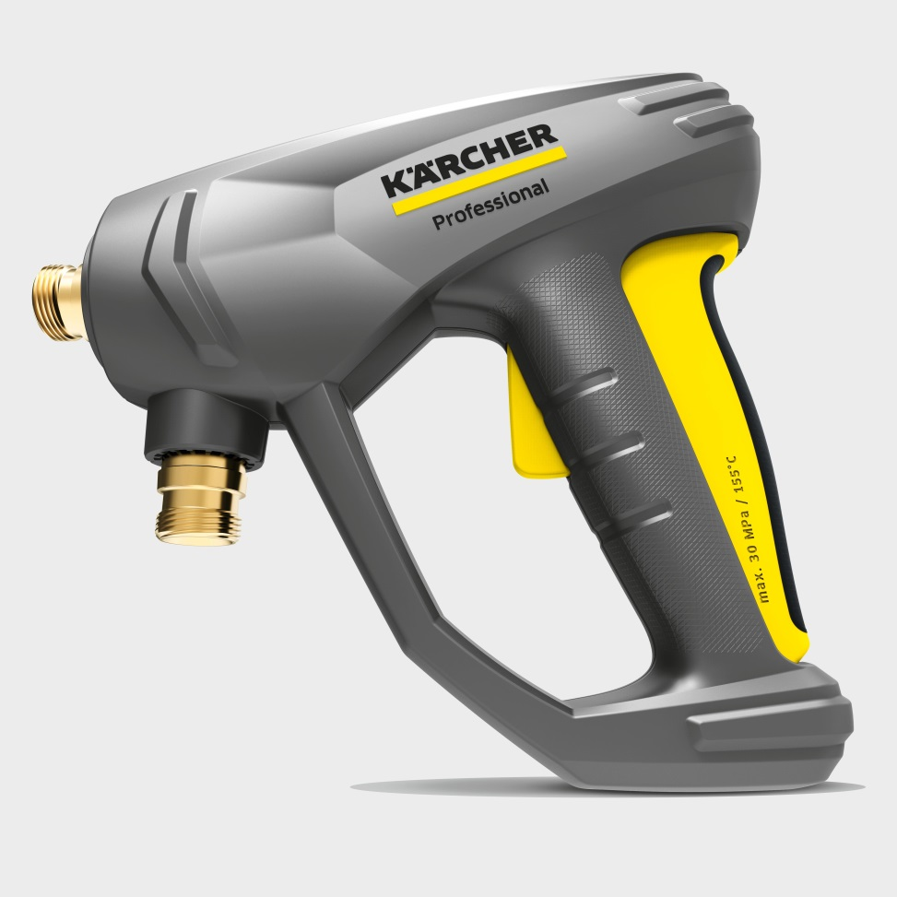
Die ergonomische Pistole für Hochdruckreiniger EASY!Force Advanced hat den German Innovation Award 2018 erhalten.

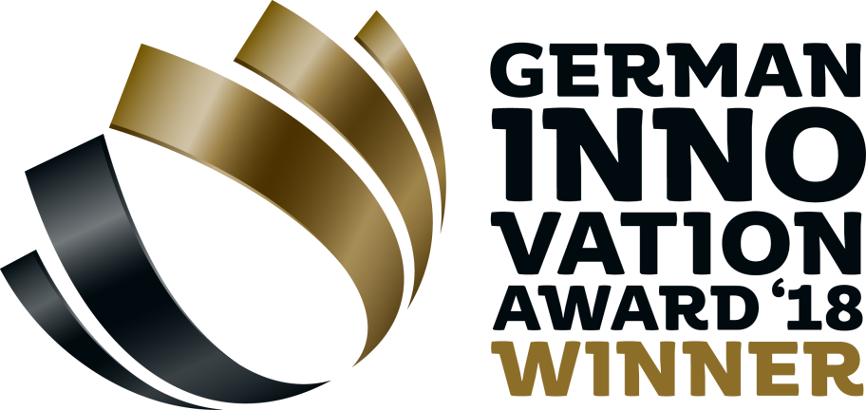
Der German Innovation Award zeichnet branchenübergreifend Produkte und Lösungen aus, die sich vor allem durch Nutzerzentrierung und einen Mehrwert gegenüber bisherigen Lösungen unterscheiden.

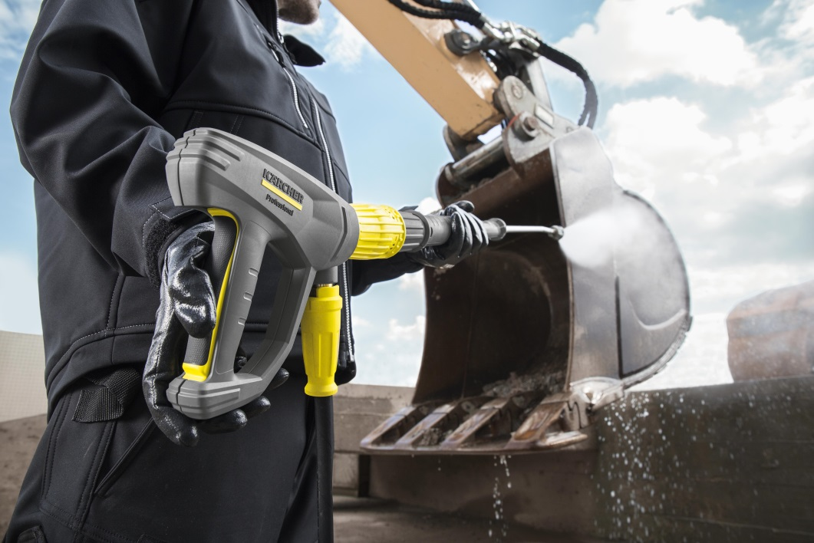
Die EASY!Force-Hochdruckpistole nutzt die Rückstoßkraft des Hochdruckstrahls und reduziert damit die Haltekraft für den Anwender.

