Three Blue Timepieces for the Winter Season
Ice Cold: A Bracing Call to Adventure
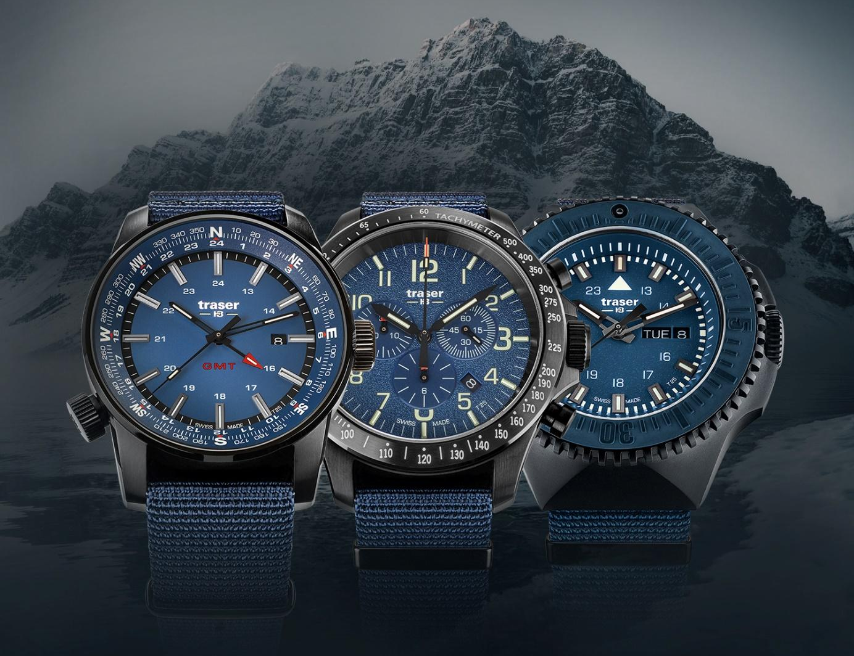
Winter reveals the raw might of nature – yet also arouses an unbridled thirst for adventure in sports enthusiasts. Equipped with traser’s unique trigalight self-powered illumination technology and boasting uncompromising independence, traser’s swiss H3 watches are the perfect timepieces for those who aren’t stopped in their tracks by rugged icy landscapes, bone-chilling cold and biting wind.

Made to push the limits: designed to shrug aside challenges and defy even the most hostile conditions, the swiss H3 timepieces from Swiss watch pioneer traser are characterized by uncompromising functionality, extreme ruggedness and trigalight self-powered illumination technology. The watches’ hands and indices are equipped with refined trigalight technology, guaranteeing ongoing, effortless timekeeping even in complete darkness and poor visibility, and delivering constant luminescence for decades – all without an external energy or power source.
A robust PVD-coated, stainless-steel case, screw-down crowns, an anti-reflective sapphire glass and a rugged textile strap ensure the watches are prepared for any and every adventure in the biting cold. With their characteristic cool blue design, they embody all of the fascination of winter sports. The P67 Officer Pro Chronograph, P68 Pathfinder GMT and P69 Black Stealth: traser timepieces designed especially for those who can’t wait to face the harshest of winter weather conditions.
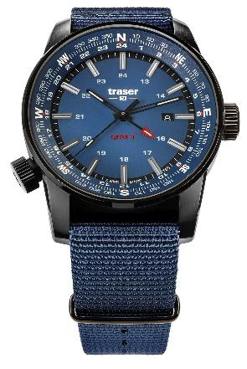
P68 Pathfinder GMT: Always Leading the Way, Wherever You Are
Whether you love deep snow adventures or ski tours in the icy dawn, the P68 Pathfinder GMT will point you in the right direction. While the watch’s Swiss GMT quartz movement guarantees precise timekeeping in two time zones, its compass ring will always show you the way home. Rugged, independent, and functional, the P68 is a true-blue pathfinder designed for all those who seek adventure far from the humdrum of everyday life.

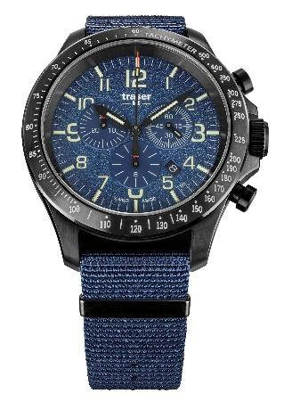
P67 Officer Pro Chronograph: Keep Your Journey Times Firmly in View
High above sea level in the lowest of temperatures, experienced alpinists seek a little winter fun with snowshoeing and ice climbing. On the shortest days of the year, it’s vital not to lose track of time if you want to get back to base camp before nightfall. Fortunately, mountaineers will find a reliable companion in traser’s P67 Officer Pro Chronograph, whose stop function makes it easy to check your travel times for each leg of a tour. Featuring a rugged textile strap, an anti-reflective sapphire glass, a hard-wearing, PVD-coated, stainless-steel case and screw-down crowns, this timepiece is well-protected from close encounters with sharp-edged rocky outcrops and ice formations.
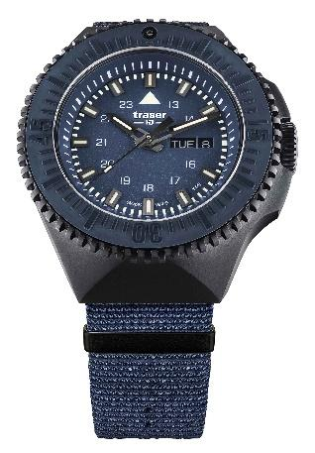
P69 Black Stealth: Fear No Test of Endurance
From harsh, icy landscapes to biting wind and sub-zero temperatures, the challenges winter poses for adventurers and explorers demand endurance, determination, and tenacity. The P69 Black Stealth can be counted on for all of these – while also cutting a fine figure thanks to its striking design. With its rugged, yet functional construction, this timepiece easily faces down every test of endurance, defying even the most extreme winter conditions.

Uncompromisingly functional and unerringly reliable: thanks to their rugged design and trigalight self-powered illumination technology, you can rely on traser swiss H3 watches even in the darkest and coldest season of the year. Deep snow and freezing temperatures are sure to arouse an irrepressible thirst for adventure in both the watches and their wearers.
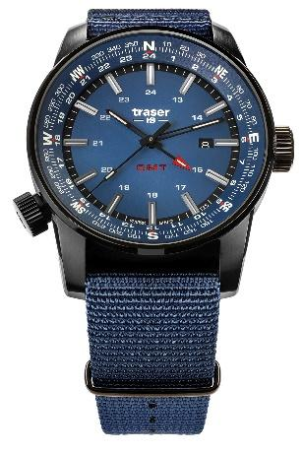 | P68 Pathfinder GMT  Blue, NATO 109034
 | Illumination: | trigalight & Super-LumiNova  Luminescent glass seal
 | Movement: | Swiss Made Quartz GMT
 | Size: | Ø 46 mm
 | Glass: | Anti-reflective sapphire
 | Watch case: | PVD-coated stainless steel
 | Crown: | Screw-down crown
 | Strap: | NATO strap
 | Water resistance: | 10 atm / 10 bar
 | Price: | CHF 495,00
P67 Officer Pro Chronograph:
Blue, NATO 109461

 | Illumination: | trigalight & Super-LumiNova  Luminescent glass seal
 | Movement: | Swiss Made Quartz Chronograph
 | Size: | Ø 46 mm
 | Glass: | Anti-reflective sapphire
 | Watch case: | PVD-coated stainless steel
 | Crown: | Screw-down crown
 | Strap: | NATO strap
 | Water resistance: | 10 atm / 10 bar
 | Price: | CHF 550,00
P69 Black Stealth
Blue, NATO 109856

 | Illumination: | trigalight & Super-LumiNova  Luminescent glass seal
 | Movement: | Swiss Made Quartz
 | Size: | Ø 46 mm
 | Glass: | Anti-reflective sapphire
 | Watch case: | PVD-coated stainless steel  PVD-coated stainless-steel bezel with a ceramic inlay and trigalights at 12 o’clock Bidirectional rotation
 | Crown: | Screw-down crown
 | Strap: | NATO strap
 | Water resistance: | 20 atm / 20 bar
 | Price: | CHF 495,00

About traser swiss H3 watches – #theoriginal #unlimited #illumination

traser swiss H3 watches are developed and manufactured under the SWISS MADE quality seal in Niederwangen, Bern, in Switzerland. All traser watches boast a unique feature: permanent, non-stop illumination of the time in darkness and poor visibility. This is achieved thanks to traser’s proprietary trigalight self-powered illumination technology. These trigalights require no external energy or power source and deliver constant luminescence for decades.

Customers from all over the world, including active individuals, explorers, athletes, nature-lovers, and tactical and special forces professionals, rely on the functional, rugged watches from traser.

Press contact:

Ferris Bühler Communications GmbH
Stadtturmstrasse 8
5400 Baden
Switzerland
Svenja Peters, +41 (0)56 544 61 68, svenja@ferrisbuehler.com

