LogiMAT.digital
Best product 2021 / ivii.smartdesk digitalizes manual processes
PLEASE NOTE: Not to be disclosed before June 22, 8 p.m.
Hart bei Graz, June 23, 2021

KNAPP’s ivii.smartdesk Work Station Awarded Best Product 2021
KNAPP AG wins the prize for best product 2021 at the LogiMAT for its ivii.smartdesk, an intelligent work station that digitalizes manual processes. Work at the ivii.smartdesk involves a zero error strategy and a 100 percent quality check for production as well as goods-in and goods-out. What’s more, the ivii.smartdesk is a great solution when it comes to the shortage of qualified personnel as it digitalizes expert knowledge.

Assembly work station for production
Equipped with an image recognition and image processing system, the ivii.smartdesk is used in production as an assembly work station. All assembly work is supported by software. A real-time feedback system is integrated into the ivii.smartdesk and monitors every work step. This provides a zero error strategy and end-to-end traceability for the assembly process.

Image recognition and image processing technologies
The image recognition and image processing system records all the components required for assembly. Each work step is checked and validated. The next work step is only possible when the image processing system has confirmed the previous one as “OK”. This way, all components are assembled in the right sequence and quality. Thanks to the real-time feedback system, employees immediately receive feedback on the quality of the work step.

Monitors provide an optimal overview of the work in progress at the assembly work station. While one of the monitors displays the theoretical status of a product, the other monitor displays the actual camera image. The various components need to be assembled so that the theoretical and actual images match each other. As soon as the assembly process has been completed, the employee presses a button to begin the final check by the feedback system. One of the monitors shows the result to the employee. Green means that everything is OK, while red indicates that an error has occurred. The possible error is displayed on the monitor and can be corrected immediately by the employee. This is how error-free production becomes a reality.

100 percent quality check in goods-in and goods-out
In the goods-in area, the ivii.smartdesk is used to check whether all the goods have been delivered to the warehouse in the correct quantities and quality. The delivery is documented and saved for the burden of proof later on. This not only saves time, but also lowers complaint costs.

In the goods-out area, the ivii.desk is used to check whether the right products are in the right container in the right quantity and quality. This application is perfectly suited for OEM suppliers in the automotive sector as the requirements in this industry are particularly high.

Recognizing items without using barcodes
The ivii.smartdesk recognizes items within split seconds without a conventional means of identification such as barcodes. The ivii.smartdesk simply compares the item on the desk to data it has on characteristics for that article. Consequently, lengthy searches in catalogues are eliminated in both the goods-in and goods-out areas. With the article number being displayed, the employee can rapidly and correctly match the articles.
A helpful feature is that employees can teach the system new articles.

Focus on people
The ivii.smartdesk supports people in their daily work. Employees work confidently, knowing that they are not making errors that are a hassle to correct later on. At the same time, the playful approach to the work steps – gamification – motivates employees, helping to establish a learning organization and increased employee satisfaction.

About KNAPP
KNAPP AG is an internationally operating technology company offering efficient, economical and intelligent automation solutions for the entire value chain. From its headquarters in Hart bei Graz, Austria, the KNAPP AG network spans the globe with 55 locations and 5,300 employees. Countless customers from various sectors place their trust in the experience and innovative power of the KNAPP group. Since the founding of the company in 1952, innovation has been an integral part of the company philosophy. KNAPP will continue pursuing research, development, innovation and building knowledge to meet the market challenges.
www.knapp.com

About ivii
ivii GmbH, headquartered in Dobl near Graz, Austria, specializes on developing innovative image processing systems for the automotive, logistics and metal processing industries. Even bakeries are relying more and more on ivii when it comes to digitalization measures to increase efficiency and gain a competitive advantage in production. ivii GmbH was founded in April 2016 as a 100 percent subsidiary of KNAPP AG. As a dynamic, independent company, ivii is conquering the quality assurance market with intelligent image processing, backed by the stability of the internationally active KNAPP group.
www.ivii.eu/de/smartdesk

Image information (© KNAPP AG)

KNAPP-ivii_smartdesk_1
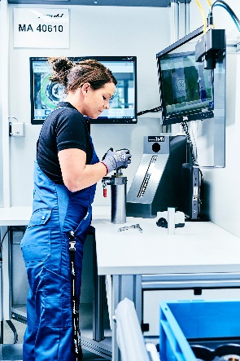
The ivii.smartdesk provides a zero error strategy and end-to-end traceability for the assembly process.

KNAPP_ivii_smartdesk_2
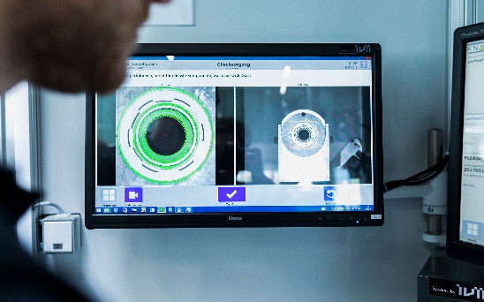
Feedback system at the ivii.smartdesk achieves error-free production

Press contact KNAPP AG:
Margit Wögerer
+43 5 04952-2501
presse@knapp.com
www.knapp.com/en/newsroom/

