PRESS RELEASE
Schwaebisch Hall, February 20, 2019

The most comprehensive portfolio for the packaging of diapers
OPTIMA LUCK: showcased at CIDPEX 2019 for the first time

Optima Nonwovens will put its machine portfolio for the packaging of baby and adult diapers in the spotlight at CIDPEX, where the new OPTIMA LUCK entry-level machine system will make its debut. What makes this machine special is that it was specifically developed for the Asian market. The OPTIMA MIDNIGHT ticks plenty of boxes when it comes to packaging adult diapers, whilst the Optima portfolio has got you covered with all manner of performance ranges. All machine types are characterized by stable processes, flexible automation solutions and the exceptionally high quality of the packaging.
Optima Nonwovens covers the entire spectrum, from the top entry-level machines to the most powerful packaging machines for paper hygiene products. At CIDPEX, the company is showcasing a comprehensive portfolio for baby and adult diapers. The machines have been specially designed for the exacting requirements of the Asian market.
The new machine system, the OPTIMA LUCK, is an advanced version of the successful DS1. In just 60 seconds, the OPTIMA LUCK can draw up to 800 baby diapers into the infeed and produce up to 50 packs. A manual infeed station for the products is also integrated as standard here, giving the option to operate it as a semi- or fully automatic system. The system is rounded off by enhanced compression and an extended size range.
For adult diapers, the OPTIMA MIDNIGHT is the entry-level model with the corresponding size range. With every minute that passes, up to 250 products are taken into the infeed and processed into 40 packages. Both systems can be supplemented with a bag-making device.
Nowadays, Optima is not only one of the world's technological leaders among packaging machine manufacturers in the nonwovens sector, it also offers perfect systems for consumer products such as coffee capsules or cosmetics as well as in the pharmaceutical sector, for sterile liquids, for instance. The portfolio comprises numerous industry 4.0 solutions as well as software products – and not least the Optima Service available across the globe.
Optima Nonwovens at CIDPEX (April 17 to 19, 2019):
Wuhan, China: booth no. B2F42

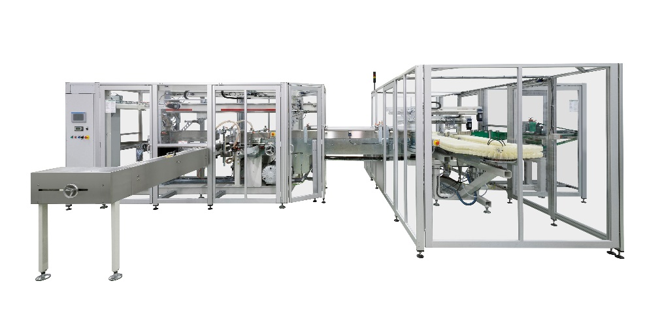
The OPTIMA LUCK was specifically developed for the Asian market. It boasts a capacity of 800 products/min in the infeed or 50 packs/min.
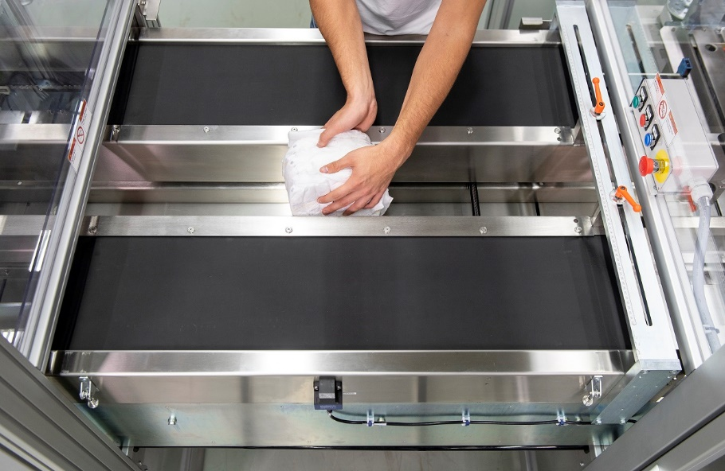
Thanks to the manual infeed station, the OPTIMA LUCK can be operated as a semi- or fully automatic system.

Characters (incl. spaces): 2,183

Press contact:
OPTIMA packaging group GmbH
Jan Deininger
Editor
+49 (0)791 / 506-1472
jan.deininger@optima-packaging.com
www.optima-packaging.com
Thank you very much for your publication. We look forward to receiving a specimen copy.

