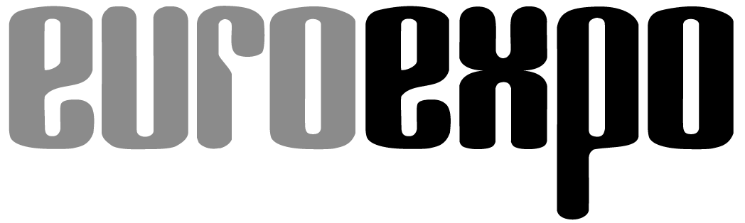
Messe- und Kongress-GmbH
Joseph-Dollinger-Bogen 7
D-80807 Munich, Germany
Phone: +49 89 32 391 259
Fax: +49 89 32 391 246
www.euroexpo.de/en
www.logimat-messe.de/en

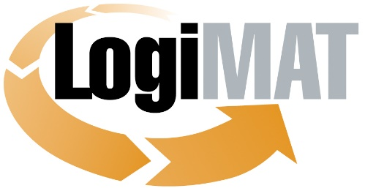

International Trade Fair for
Intralogistics Solutions and Process Management
March 8–10, 2022 | Messe Stuttgart

Munich, January 26, 2021

Press Release

LogiMAT 2021 in Stuttgart will not take place. Date postponed to March 2022.

Munich, January 26, 2021: LogiMAT—the International Trade Show for Intralogistics Solutions and Process Management scheduled for June 22–24, 2021, in Stuttgart, Germany—has to be postponed due to the difficult ongoing situation with Covid-19. The organizer, EUROEXPO Messe- und Kongress-GmbH, has decided to push back the upcoming trade show to March 8–10, 2022, to give exhibitors the certainty they need for long-term planning. The organizer is working on a digital concept so that visitors and exhibitors can still meet virtually in 2021.

LogiMAT, the International Trade Show for Intralogistics Solutions and Process Management, will not take place as planned from June 22 to 24, 2021, due to the difficult ongoing situation with Covid-19. The organizer, EUROEXPO Messe- und Kongress-GmbH, is compelled to postpone LogiMAT to March 8–10, 2022, due to current infection rates and the unclear vaccination timeline, with the restrictions on movement that this entails.

“Given the current state of vaccinations and the virus mutations, there is no foreseeable end to the travel restrictions in place today. We must offer a timely response. Our exhibitors need certainty for their planning, and this simply isn’t available right now,” explains Michael Ruchty, Exhibition Director of LogiMAT Stuttgart. “From today’s perspective, it isn’t clear whether it will be possible to host the full live event in June. The exhibitors would like to have an on-site event, but if we end up having to go forward without the key visitors from abroad, that is not in the interests of all concerned. We must do everything we can to ensure that the in-person event lives up to the understandable expectations of exhibitors and visitors. Another postponement of 2 to 3 months would not make sense or be feasible. In the end, we are also honoring the express wishes of many exhibitors by returning in 2022 to our regular schedule in March and the first quarter, when LogiMAT Stuttgart traditionally takes place.”

The organizer is currently working on a digital communication and information platform so that exhibitors and visitors can still connect digitally in 2021.

“Alongside exciting, high-quality presentations and the opportunity for our exhibitors to present their products and solutions, the digital event will focus on smart matchmaking,” explains Peter Kazander, Managing Director of EUROEXPO Messe- und Kongress-GmbH. The organizer offers the digital solution as a way to bridge the gap until the next live trade show in March 2022 and fulfill its primary mission of bringing exhibitors and visitors together in a state-of-the-art event.

LogiMAT returns to Stuttgart from March 8 to 10, 2022.

Organizer: EUROEXPO Messe- und Kongress-GmbH
Joseph-Dollinger-Bogen 7 | 80807 Munich, Germany
Phone: +49 89 32 391 259 | Fax: +49 89 32 391 246
www.logimat-messe.de/en

2.755 characters (with spaces)

Munich, January 26, 2021—This text may be reprinted free of charge, but please send a copy to EUROEXPO Messe- und Kongress-GmbH, Press and Public Relations Department, 80912 Munich.

