The new traser P67 Diver Automatic
Highest reliability in all waters
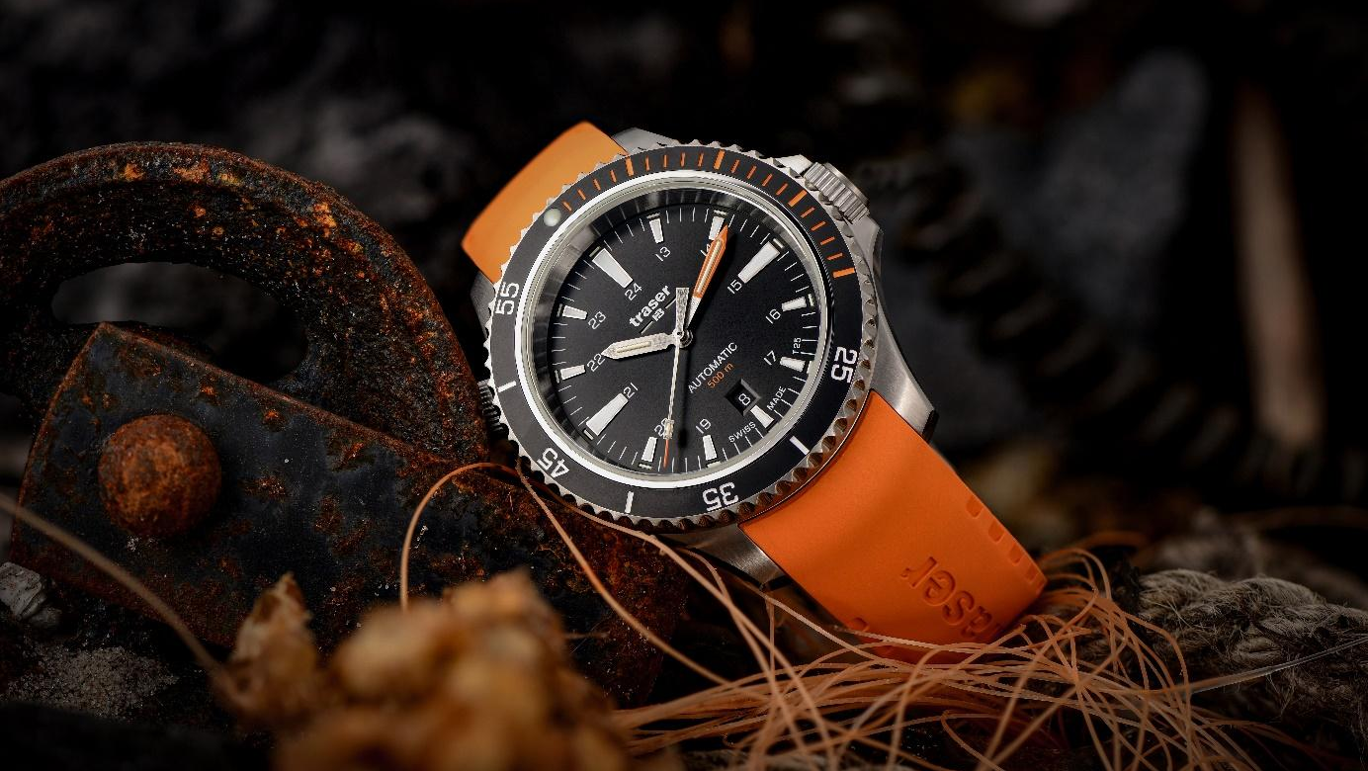
Strong currents and changing temperatures: If you want to master the various tests under water, you need equipment that you can always rely on. With the P67 Diver Automatic, the Bern-based watchmaker traser complements its "P67 Diver" watch family with a mechanical dive watch. Equipped with the in-house–developed trigalight self-powered illumination technology, a water resistance of 50 bar and a Swiss automatic movement, no situation is too extreme and no challenge too big for this new diver's watch.

With ice-cold waters, strong river currents and changing pressure conditions at different altitudes, diving in mountain lakes and drift diving in particular places high demands on divers and their equipment. The new mechanical diving watch P67 Diver Automatic from the Bern-based watchmaker traser is the perfect companion for all who seek real challenges and love absolute freedom.
Constant readability at any depth
Swiss mountain lakes with crystal clear water and roaring rivers suitable for drift diving are particularly fascinating for divers. Given the limited air in scuba tanks, a perfect timing underwater is essential. Even if the light and color intensity diminish with increasing depth, the hands and hour indices of the P67 Diver Automatic glow without an external energy source thanks to the in-house–developed trigalight self-powered illumination technology. This makes timekeeping effortless, even in complete darkness and poor visibility. With a water resistance of 50 bar, no mountain lake is too deep for the P67 Diver Automatic and it can even withstand the extreme water pressure of the deep sea. The helium valve allows the helium molecules to escape in a controlled manner when surfacing in a diving bell.
Defying strong currents
Neither strong currents nor rough rock formations can harm this robust and functional diving watch: Screw-down crowns, a resistant ceramic bezel with luminescent glass sealing ring and an anti-reflective sapphire glass protect the precise Swiss automatic movement. Thanks to notches, the ceramic bezel, which is designed unidirectional for safety reasons, can be perfectly adjusted even with diving gloves. In addition to its high level of functionality under water, the P67 Diver Automatic draws all eyes on land, too: the diver's watch is available with dials in black, green and gray and can be combined with either a stylish stainless steel bracelet or different colored rubber straps. The case back is decorated with an engraving of a silver lightfish - a reference to the unique benefit of the trigalight self-powered illumination technology: constant readability of the time at any depth. The P67 Automatic Diver with all its extensive features is also available in a special set with a stainless steel bracelet, a rubber strap and a bracelet extension. The durable rubber strap is quick and easy to open thanks to an oversized buckle, while the extension means it fits over any diving suit.
No matter how icy-cold the water, how strong the current, or how uncharted your underwater world – the P67 Diver Automatic is up to any challenge.

Technical specifications – P67 Diver Automatic – Swiss Made
Illumination: trigalight self-powered illumination technology on the hour indices,
hands and under the traser logo
for T100*: also on minute indices
Super-LumiNova coating on hour appliques (T25) and ceramic bezel
Luminescent glass seal
Movement: Swiss Made Automatic
Size: Ø 46 mm
Glass: Anti-reflective sapphire
Case: Stainless steel case with a ceramic bezel
Screw-down crown
Bezel: Ceramic bezel, unidirectional
Helium valve: Screw-down crown at 10 o’clock
Dial: Black (T25)
Green (T25)
Grey (T100*)
Date window at 6 o’clock
Strap: Rubber black (T25, T100*)
Rubber orange (T25)
Rubber green (T25)
Rubber yellow (T100*)
Stainless steel (T25, T100*)
Rubber strap extension (black only)
Water resistance: 50 atm / 50 bar
Availability: From end of August (T25)
From September (T100*)
MSRP: T25 CHF 1,095.00 with rubber strap
T25 CHF 1,195.00 with stainless steel bracelet
T25 CHF 1,295.00 for the special set
T100* CHF 1,170.00 with rubber strap
T100* CHF 1,270.00 with stainless steel bracelet
T100* CHF 1,370.00 for the special set

*T100 is available in selected markets only.

References:
110322 P67 Diver Automatic Black
Stainless steel case, black dial
Black rubber strap

110323 P67 Diver Automatic Black
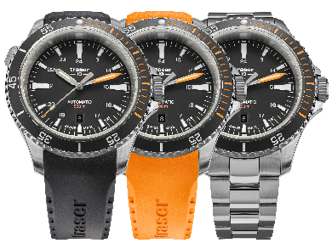
Stainless steel case, black dial
Orange rubber strap

110324 P67 Diver Automatic Black
Stainless steel case, black dial
Stainless steel bracelet

110321 P67 Diver Automatic Black (special set)
Stainless steel case, black dial
Stainless steel bracelet
Stainless steel bracelet, rubber strap, rubber strap extension,
Tool for changing bracelet

110326 P67 Diver Automatic Green
Stainless steel case, green dial
Black rubber strap

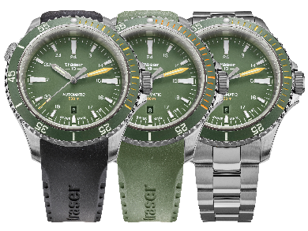
110327 P67 Diver Automatic Green
Stainless steel case, green dial
Green rubber strap

110328 P67 Diver Automatic Green
Stainless steel case, green dial
Stainless steel bracelet

110325 P67 Diver Automatic Green (special set)
Stainless steel case, green dial
Stainless steel bracelet
Stainless steel bracelet, rubber strap, rubber strap extension,
Tool for changing bracelet

110330 P67 Diver Automatic T100* Grey
Stainless steel case, grey dial
Black rubber strap

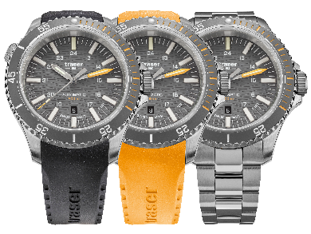
110331 P67 Diver Automatic T100* Grey
Stainless steel case, grey dial
Yellow rubber strap

110332 P67 Diver Automatic T100* Grey
Stainless steel case, grey dial
Stainless steel bracelet

110329 P67 Diver Automatic T100* Grey (special set)
Stainless steel case, grey dial
Stainless steel bracelet
Stainless steel bracelet, rubber strap, rubber strap extension,
Tool for changing bracelet

* T100 is available in selected markets only.

About traser swiss H3 watches – #theoriginal #unlimited #illumination

traser swiss H3 watches are developed and manufactured under the SWISS MADE quality label in Niederwangen near Bern, Switzerland. traser watches have a unique feature: permanent and consistent readability of the time even in total darkness and poor visibility This is achieved with the in-house–developed trigalight self-powered illumination technology, which requires no external energy source and delivers constant luminescence for decades.

Customers from all over the world (including active people, adventurers, athletes, nature enthusiasts, tactical professionals, and special forces) rely on traser's robust and functional watches.

Press contact:
Ferris Bühler Communications GmbH
Stadtturmstrasse 8
5400 Baden
Switzerland
Annina Steffen, +41 (0)56 544 63 84, annina@ferrisbuehler.com
Svenja Peters, +41 (0)56 544 61 68, svenja@ferrisbuehler.com

