PRESS RELEASE
February 2022

In setup and style versatile customizable:
ST XTA plus 3 coilover suspension kit for the Audi S3 and Audi RS3

ST suspensions has developed different suspension components such as wheel spacers and coilovers, for the Audi S3 and Audi RS4 (8V). Our new ST XTA plus 3 coilover suspension kit is made with state-of-the-art technology. It features top-notch options like customizing the preset damper setup in various parameters like low-speed compression damping, high-speed compression damping, and low-speed rebound damping. These dampers are based on KW automotive technologies established in motorsport. With linear racing springs and multi-adjustable shocks, the coilover kit enables a sportier ride and more control. Even at the edge of driving physics. The adjustable lowering range covered by the parts certificate is between 15 and 35 millimeters. The scope of delivery of the ST XTA plus 3 coilover suspension also includes top mounts with unibal bearings to adjust the camber. More at www.st-suspensions.net.

Manufactured from 2013 to 2020, the Audi S3 and Audi RS3 models offered from 2015 to 2020 are among the most popular used cars in the Audi A3 8V series. The ST XTA plus 3 coilover suspension with a two-piece racing spring system, aluminum top mounts, and triple-adjustable dampers is available for these models. Our ST coilover kit offers all Audi S3 and Audi RS3 enthusiasts the opportunity to combine a sporty suspension setup with excellent handling characteristics and sufficient ride comfort. The multiple-adjustable dampers used in the XTA plus 3 make this possible. They are based on the suspension developments of KW automotive for the Audi accessories program. Similar to the Audi Sport Performance Parts suspension for the Audi R8, the damper forces can be individually adjusted in the low-speed and high-speed compression stage (with 24 clicks each) and the low-speed rebound stage (with 16 clicks). Thus, the suspension now available for Audi S3 and RS3 offers a large tuning window for an individual setup.

Standard components of the ST XTA plus 3 are also unibal top mounts on the front struts. The unibal-mounted bearings make the steering much more precise than conventional strut mounts with rubber-metal elements. In addition, the ST top mounts can also adjust the wheel camber.

Optional customization options

The ST XTA plus 3 coilover suspension is also part of the "Make it Yours" program. For instance, he coilover can be ordered with suspension springs in various finish colors from ST specialist dealers or directly from ST suspensions' online website. Additionally, there is also a choice of individual marking of the springs. Many also opt for the optional spring packages. These are springs with a different spring rate, so that the ST XTA plus 3 can be perfectly adapted in the case of major vehicle modifications such as vehicle weight optimization. More at www.st-suspensions.net

Publication for free / copy requested

This press release can also be found at www.tuningpress.com

Contact und Copy Address:
MediaTel Communication & PR, Haldenweg 2, 72505 Krauchenwies-Ablach, Germany
Tel.: +49/7576/9616-12, E-Mail: presse@mediatel.biz

Press Contact:
Christian Schmidt, E-Mail: Christian.Schmidt@kwautomotive.de, Tel. +49/7971/9630-547
KW automotive GmbH, Aspachweg 14, 74427 Fichtenberg, Germany, Web: www.stsupensions.net
Facebook: www.facebook.com/STsuspensionsINT, ST suspensions at KW Blog: http://blog-de.kwautomotive.net/

In setup and style versatile customizable:
ST XTA plus 3 coilover suspension kit for the Audi S3 and Audi RS3

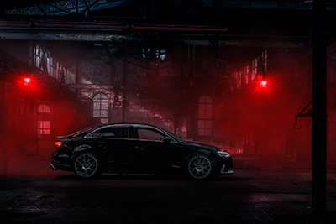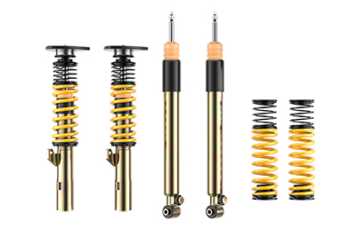

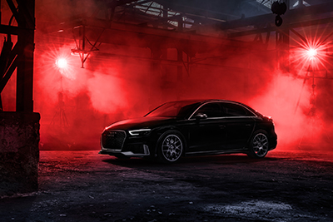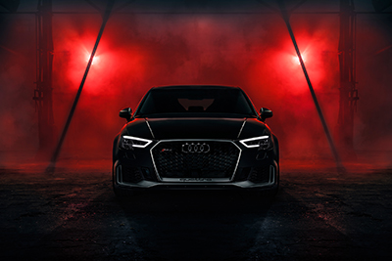

About KW automotive:

The KW entrepreneurial group includes the suspension manufacturer KW automotive with its brands KW suspensions, ST suspensions, ap Sportfahrwerke, as well as the SimRacing brands TrackTime and Ascher Racing. With its immense suspension portfolio, state-of-the-art production technology and its development and test center, KW successfully operates in all markets for more than 25 years. Over the past years, KW automotive has developed over 16 distinct damping technologies in order to fulfill its own requirement of supplying "the perfect suspension for every demand". Beside its core business, the development and production of manually and adaptively adjustable coilover kits and other suspension components for the aftermarket as well as the range of accessories of various automobile manufacturers in the premium segment, the business field of original equipment for special models and super sports cars of the automotive industry is developing tremendously positively for the German suspension manufacturer. Since KW is a development partner of sophisticated controlled suspension systems, the manufacturer disposes of the entire product portfolio of hydraulics, electronics, sensor technology, control units and damper control systems as well as the necessary know-how for the application and tuning of complex vehicle performance systems from a single source. KW has become an indispensable part of customer motor sports throughout the past years and produces homologated racing dampers and suspensions for a constantly growing number of racing cars of several manufacturers. Worldwide, successful racing teams rely on the patented valve technology of KW Competition suspensions. The entrepreneurial group has subsidiaries in the most significant markets, such as Belgium, Great Britain, China, Japan, Switzerland, Taiwan and the USA. 360 employees from the 1200 employees worldwide of the Group are located at the headquarters in Fichtenberg. Software and hardware solutions are further business segments as well as events for virtual motor sports in the scope of the brand RaceRoom. Equally, the suspension manufacturers AL-KO Damping Unit, Belltech and Reiger Suspension as well as the alloy wheels manufacturer BBS are brands of the KW entrepreneurial group.

Publication for free / copy requested

This press release can also be found at www.tuningpress.com

Contact und Copy Address:
MediaTel Communication & PR, Haldenweg 2, 72505 Krauchenwies-Ablach, Germany
Tel.: +49/7576/9616-12, E-Mail: presse@mediatel.biz

Press Contact:
Christian Schmidt, E-Mail: Christian.Schmidt@kwautomotive.de, Tel. +49/7971/9630-547
KW automotive GmbH, Aspachweg 14, 74427 Fichtenberg, Germany, Web: www.stsupensions.net
Facebook: www.facebook.com/STsuspensionsINT, ST suspensions at KW Blog: http://blog-de.kwautomotive.net/

