International Book on German Family Businesses Celebrates Its Premiere

Temperature control specialist LAUDA selected for “The Secrets of German Family Businesses”

Lauda-Königshofen, January 30, 2026 – LAUDA DR. R. WOBSER GMBH & CO. KG is featured in a four-page portrait in the newly published book “The Secrets of German Family Businesses.” Recently published in Germany, the book highlights 50 German family businesses and their strategies for success. The volume, written in English, is published by the renowned Prestel Verlag, part of the Penguin Random House publishing group, and is aimed specifically at an international audience.

Edited by Uwe Rittmann, Head of Family Businesses and SMEs at PwC Germany, Tobias Rappers, Managing Director of Maschinenraum GmbH, and Olaf Salié, publisher of the “ABOUT Germany” series, the 300-page anthology presents the DNA of German family businesses. The focus is on values such as tradition, innovation, resilience, and long-term entrepreneurial thinking. In well-researched essays and personal portraits, leading experts from academia and practice show why German family businesses stand for reliability, quality, and technical excellence worldwide.

LAUDA was nominated for the book as the global market leader for temperature control devices and systems for precise temperature generation. As a hidden champion, the third-generation family-owned company embodies the key success factors of German SMEs: technological excellence, global market presence, and the ability to combine tradition with innovation. Membership in “Maschinenraum”, the leading innovation ecosystem for German SMEs, underscores the exceptional innovative strength of LAUDA.

“We are extremely pleased that LAUDA is one of the important companies portrayed in this internationally significant work,” explains Dr. Gunther Wobser, President & CEO of LAUDA. “For a company with twelve international subsidiaries in particular, this presence on the global market is of strategic importance. The book gives German SMEs visibility and highlights the particular strengths of family businesses in times of global challenges.”

Dr. Gunther Wobser was present at the book launch on November 28, 2025, in Berlin, where he took part in a panel discussion. The official sales launch in Germany was on December 17, 2025, the international premiere in the UK was on January 20, 2026, and the planned release in the US is scheduled for March 3, 2026. The international reach of the work supports LAUDA in its global business development: The portrait promotes dialogue with international business partners and creates additional visibility for the company's two US subsidiaries and for the sales company “Degree LAUDA Precision” in Pune, India, which was founded last year. The publication also coincides with the company's 70th anniversary, which LAUDA will celebrate on March 1, 2026.

“The Secrets of German Family Businesses” is part of the “ABOUT Germany” series published by Prestel Verlag and is available in bookstores under ISBN 978-3-7913-9190-8.
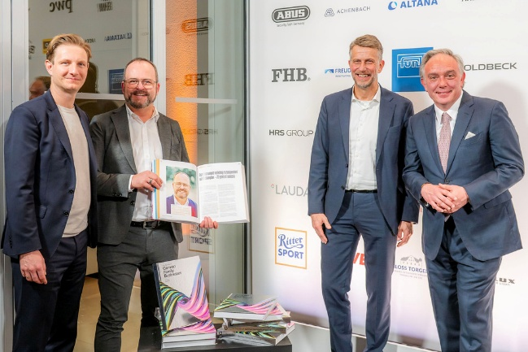  Picture 1: Dr. Gunther Wobser (2nd from left), President & CEO of LAUDA, with publishers Tobias Rappers, managing director of Maschinenraum GmbH, Uwe Rittmann, head of family businesses and SMEs at PwC Germany, and Olaf Salié, publisher of the “ABOUT Germany” series, at the book premiere on November 28, 2025, in Berlin. © Peter J. Kierzkowski | 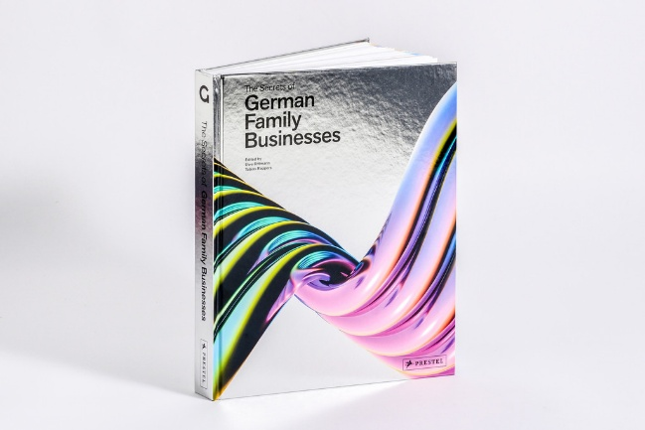  Picture 2: “The Secrets of German Family Businesses” presents 50 German family businesses and highlights their strategies for success for an international audience. The 304-page anthology is available in bookstores under ISBN 978-3-7913-9190-8. © Prestel Verlag
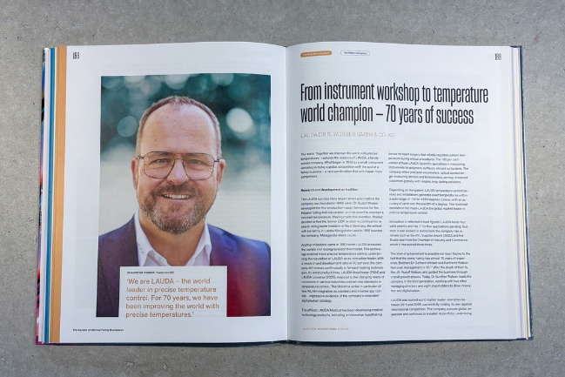  Picture 3: The four-page portrait of LAUDA DR. R. WOBSER GMBH & CO. KG highlights the international orientation and innovative strength of the world market leader for temperature control devices and systems for precise temperature generation. © LAUDA | 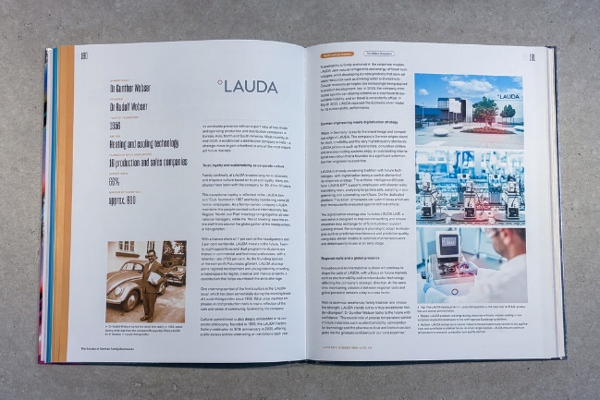  Picture 4: The second double page of the LAUDA portrait in the book “The Secrets of German Family Businesses” illustrates the combination of tradition, innovation, and global market presence of the third-generation family-owned company. © LAUDA

We are LAUDA – the world leader in precise temperature control. Our constant temperature equipment and systems are at the heart of important applications, contributing to a better future. As a complete one-stop supplier, we guarantee the optimum temperature in research, production and quality control. We are the reliable partner for Aerospace, Electromobility, Hydrogen, Chemistry, Pharmaceuticals/Biotech, Semiconductors and Medtech. We have been inspiring our customers for 70 years with our expert mentoring and innovative solutions – every day anew and all over the world.

In our company, we always go one step further. We support our employees’ development and are constantly developing ourselves: to create a better future together.

Press contact
We are more than happy to make prepared information about our company, the LAUDA Factory Gallery and our projects in the area of innovation promotion, digitalization and idea management available to the press. We look forward to hearing from you – just give us a call!

CHRISTOPH MUHR
Director Corporate Communications
T + 49 (0) 9343 503-349
christoph.muhr@lauda.de

LAUDA DR. R. WOBSER GMBH & CO. KG, Laudaplatz 1, 97922 Lauda-Königshofen, Deutschland/Germany. Limited partnership: Headquarters Lauda-Königshofen, Registration court Mannheim HRA 560069. General partner: LAUDA DR. R. WOBSER Verwaltungs-GmbH, Headquarters Lauda-Königshofen, Registration court Mannheim HRB 560226. Managing Directors: Dr. Gunther Wobser (President & CEO), Dr. Mario Englert (CFO), Dr. Marc Stricker (COO)

