Reduction of fossil fuel consumption

GEA launches a carbon-free dairy evaporator for the dairy industry

Düsseldorf (Germany), January 29, 2025 – With the GEA Dairy Evaporator eZero, GEA Group presents an innovative evaporator that operates with zero CO₂ emissions. This solution is designed to meet the increasing demands of the dairy industry, which is facing challenges such as high energy prices and stricter climate targets.

Evaporators are among the largest energy consumers in dairies. They are used in the production of whole and skim milk powder, infant formula and whey powder. Reducing their energy consumption can have a significant impact on both energy costs and overall plant sustainability. The new eZero Dairy Evaporator enables these energy savings without compromising product quality.

Energy consumption reduced by up to 60%, CO₂ emissions down to zero
GEA's Dairy Evaporator eZero aligns with the company's commitment to eliminating dependency on fossil fuels by transitioning to renewable energy sources and empowering customers to produce more sustainably. Depending on plant operation specifics, resources, and the electricity emission factor, the new system can reduce energy consumption up to a 60 percent and eliminates CO₂ emissions entirely compared to conventional mechanical vapour recompression (MVR) evaporators.

Engineering competence for future proofed solutions
Thermal vapour recompression (TVR) is typically applied to multi-effect evaporators powered by live steam, while mechanical vapour recompression (MVR) is more energy efficient and uses electricity to recompress and recycle product vapour in single-effect evaporators. Both technologies rely on steam for heating products before evaporation. The eZero evaporator is compatible with MVR systems and can also be applied to TVR evaporators after conversion to MVR technology. It is also adaptable to new and existing systems.

To convert an existing TVR evaporator to use the eZero, the thermocompressor is replaced by a standard compressor, while reusing the evaporator's calandria and the high-speed mechanical compressor for the evaporation process. This conversion is the first crucial step in reducing steam consumption and CO₂ emissions by moving away from fossil fuels.

The eZero evaporator takes a further step by integrating an ammonia heat pump to transfer the heat from the vapor at the condenser to a low-pressure steam generator or flash vessel. This process naturally creates two loops of water: a cold loop (approximately 35–45°C) that cools the condenser water loop, and a hot loop (approximately 80–90°C) that provides heat for the heat treatment system. Hot water is flashed to produce low-pressure steam, which is then recompressed to higher pressure for efficient product heating.

gea.com

Picture preview

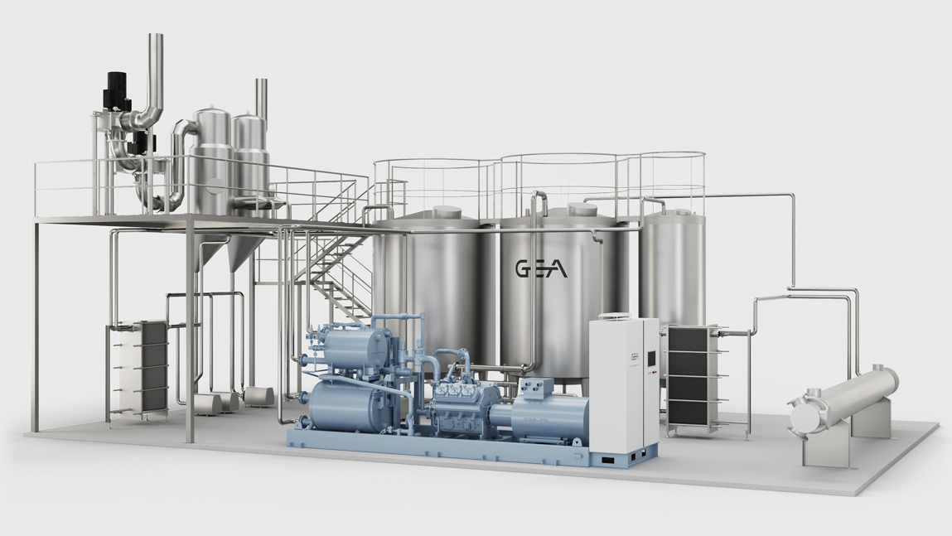

Pic. The new GEA Dairy Evaporator eZero reduces energy consumption and CO₂ emissions for producing whole/skim milk powder, infant food formula, whey powder. Source: GEA

NOTES TO THE EDITORS
- Further information about GEA
- To the GEA Media Library
- Features on current topics
- Overview press events
- Follow GEA on  

Media Relations
GEA Group Aktiengesellschaft
Nicole Hoffmann
Peter-Müller-Str. 12, 40468 Düsseldorf, Germany
Phone +49 211 9136-1503
nicole.hoffmann@gea.com

About GEA
GEA is one of the world’s largest suppliers of systems and components to the food, beverage and pharmaceutical industries. The international technology group, founded in 1881, focuses on machinery and plants, as well as advanced process technology, components and comprehensive services. With more than 18,000 employees, the group generated revenues of about EUR 5.4 billion in more than 150 countries in the 2023 fiscal year. GEA plants, processes, components and services enhance the efficiency and sustainability of customer’s production. They contribute significantly to the reduction of CO₂ emissions, plastic usage and food waste. In doing so, GEA makes a key contribution toward a sustainable future, in line with the company’s purpose: ”Engineering for a better world“.

GEA is listed on the German MDAX the European STOXX® Europe 600 Index and is among the companies comprising the DAX 50 ESG, MSCI Global Sustainability as well as Dow Jones Sustainability World and Dow Jones Sustainability Europe Indices.

More information can be found online at gea.com.
If you do not want to receive any further information from GEA, please send an e-mail to pr@gea.com.

