PRESS RELEASE
Schwaebisch Hall, June 20, 2018

DECOpulse: Efficient and gentle, with greater production safety
Atomization of H₂O₂ in isolators – highly reduced consumption during bio-decontamination

With the DECOpulse, Metall+Plastic presented a new, innovative system to introduce H₂O₂ into isolators at the Achema show with the advantage of a decontamination cycle that is 50 percent shorter. And, due to the reduced utilization of H₂O₂, there is less strain on the material, substances and product.

H₂O₂ is atomized through specific DECOpulse injection nozzles, producing a very fine spray. The nozzles have two channels on the inside to atomize the H₂O₂ with compressed air as a carrier gas directly inside the isolator. The relatively high inside pressure in very small droplets makes them evaporate very fast. Approximately 90 percent of the DECOpulse droplets have a cross section of less than 1.5 micrometers and therefore, will evaporate several centimeters from the nozzle.

The opening and closing of the valve for the liquid H₂O₂ is defined in quick and exact intervals, for example 100 milliseconds, that create a pulsing effect. This allows a very fine dosing of the introduced H₂O₂ amount. Due to the continuous supply of the nozzles with compressed air, turbulences prevail in the isolator. These turbulences ensure an excellent distribution of the released gaseous H₂O₂. Due to the excellent distribution of H₂O₂, the DECOpulse only requires a few injection nozzles (and piping).

Techniques at their best

Besides the fine dosing, an additional benefit of the DECOpulse is that no H₂O₂ will be lost to decomposition, since no additional heating is required for the evaporation of the droplets. In addition, the system offers a higher injection rate per nozzle than common evaporation systems. Consequently, a faster H₂O₂ concentration and hence, a faster elimination of microorganisms is achieved. Subsequently less H₂O₂ has to be used for a complete bio-decontamination process, leading to a much shorter decontamination cycle.

METALL+PLASTIC
Clean room units for the aspetic production of pharmaceutical products

METALL+PLASTIC is a global leader in the design, manufacture, installation, qualification and validation of custom-designed isolators. The company that was founded in 1957 as manufacturing isolators for customers working in laboratory animal science from 1960. This was followed later by the further development and production of isolation and containment technology for the pharmaceutical industry. METALL+PLASTIC set new standards from the very beginning and brought in innovations that offer many options for production. But priority is always given to the protection of the product, the operator and the environment. Unique and patented technologies, an orientation to meeting customer wishes and providing excellent service differentiate METALL+PLASTIC in this market. The range of products includes isolators for filling machines, sterility testing isolators, glove testing systems, H₂O₂ decontamination locks, electron accelerator for the "e-beam" sterilization system and gastight doors. The options for integration are extremely varied - whether for the filling of aseptic liquids or powders, in connection with e-beam tunnels, hot air tunnels, lyophilising units, autoclaves and other aseptic processing systems. Our intelligent process equipment markedly reduces process and shutdown times. In addition to leadership in this field of technology the many years of experience of the staff that numbers over a hundred forms the basis for continuous and successful growth.

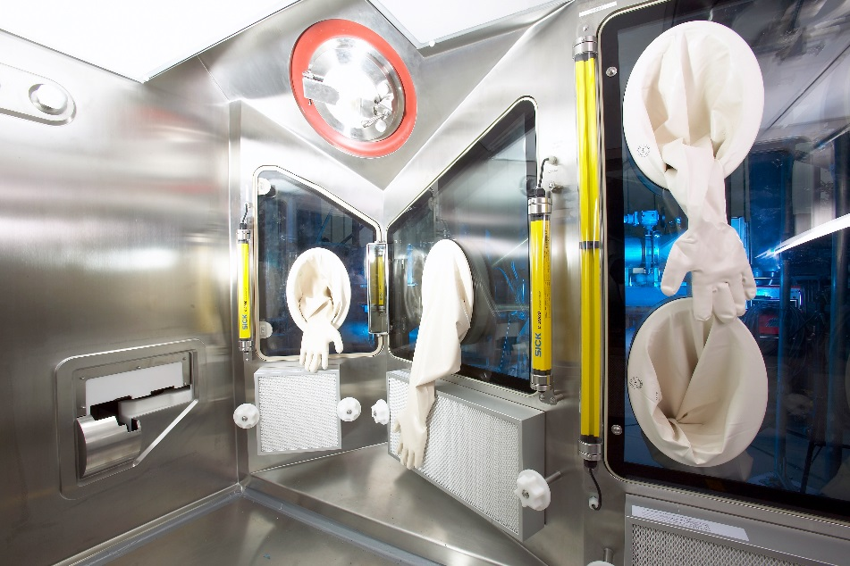
Isolator technology from Metall+Plastic.

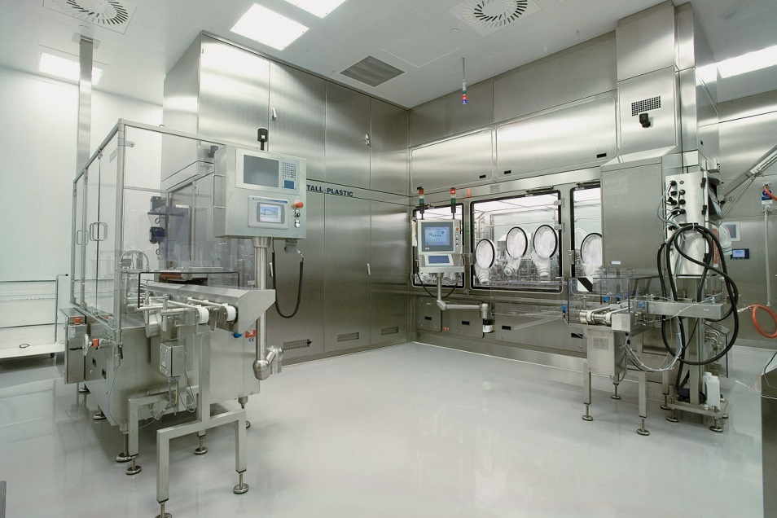
Isolator technology from Metall+Plastic.

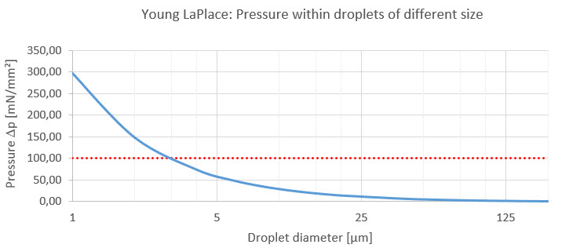
The Young-Laplace equation says, the smaller the droplet diameter, the higher the internal pressure. The greater the pressure, the more efficient the evaporation.

Characters (incl. spaces): 3,556

Contact:
OPTIMA packaging group GmbH
Sabine Gauger
Marketing Director
sabine.gauger@optima-packaging.com
www.optima-packaging.com
Thank you very much for your publication. We look forward to receiving a specimen copy.

