Partnership agreement between GEA and I&L Biosystems for the distribution of the world's smallest premium separator
Duesseldorf (Germany), November 11, 2025 – GEA, one of the world’s leading suppliers of systems, components and solutions for the food, beverage and pharmaceutical industries, and I&L Biosystems GmbH, a leading European distributor of life science equipment, have signed a partnership agreement for the sale and distribution of the GEA kytero® 10 in the Benelux. The GEA kytero® 10 is the world's smallest premium separator for small-batch disposable biopharmaceutical processing. The centrifuge combines efficiency, biosafety, and user-friendliness in a fully enclosed disposable concept. Thanks to the patented contactless GEA breezeDrive® system, the kytero® 10 operates completely contamination-free, with low maintenance and quiet operation. Only electricity and optional sterile air are required for installation, no CIP or SIP, making it ideal for laboratories with limited space and limited utilities.

Innovative solution for applications in the pharmaceutical, biotech, and new food

For customers in the biopharmaceutical industry, single use technology means the ability to bring products to market even faster. New, flexible cell culture production systems are based on smaller systems with disposable elements, therefore the GEA kytero® 10 meets the requirements and wishes of the biopharmaceutical industry. This compact system was developed specifically for research, laboratories, universities, and institutes and offers an innovative solution for applications in the pharmaceutical, biotech, and new food sectors.

GEA kytero® disc separators are pioneering work – technology fits perfectly with I&L Biosystems' product portfolio

GEA kytero® disc separators are pioneering work in the time- and cost-efficient extraction of pharmaceutical proteins from cells. During a biotech event in the Netherlands, GEA and I&L Biosystems began discussions about a possible collaboration. It quickly became clear that the kytero® 10 fits seamlessly into I&L Biosystems' focus and product portfolio. The partnership will initially cover the Benelux countries, with the possibility of expansion to the whole of Europe. With locations throughout Europe, I&L Biosystems is responsible for the distribution, installation, and maintenance of high-quality laboratory equipment and solutions, particularly in biotechnology. "The kytero® 10 fits perfectly into our product portfolio, which focuses on sustainable and innovative solutions for bioprocess technology. Through the collaboration with GEA, our customers in the Benelux countries will have access to a unique technology that simplifies and accelerates research and production processes, “says Daniël Bindels, CEO at I&L Biosystems. ”With the kytero® 10, we are bringing industrial separation technology to the laboratory. This is a real milestone in bioprocess technology," adds Edwin Telgenkamp, Account Manager Sales at GEA.

Key features and benefits of kytero® 10 at a glance

· World first on a laboratory scale: compact, user-friendly and equipped with advanced disc stack technology.
· Central role in pharmaceutical development: supports the research and production of modern active ingredients.
· Efficient cell and bacteria separation: optimizes fermentation separation for a wide range of cell cultures.
· Flexible application: ideal for very small batches, early development phases, perfusion and pilot trials.
· Seamless scalability: from the laboratory to large-scale production using the same industry standards.
· Maximum simplicity: Quick implementation with minimal cleaning and space requirements thanks to the single-use concept.

Photos

Photo 1:

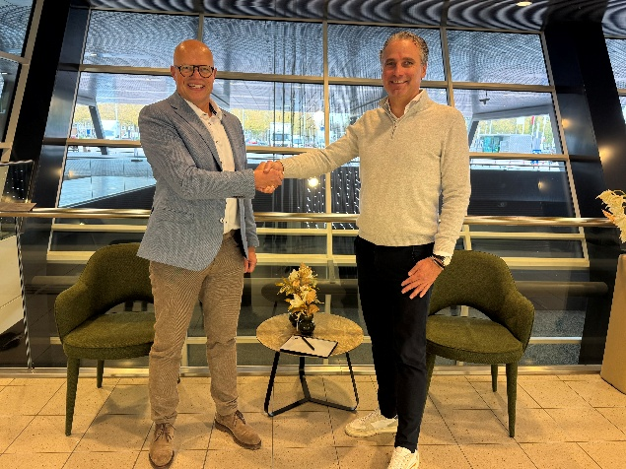

Photo 1, caption: Edwin Telgenkamp, GEA Account Manager Sales (left), and Daniel Bindels, CEO of I&L Biosystems GmbH (right), seal the cooperation agreement. (Photo: GEA)

Photo 2:

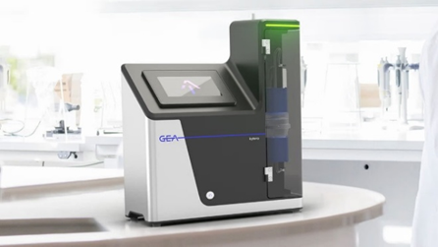

Photo 2, caption: The GEA kytero® 10 is the world's smallest premium separator for processing small batches of single-use biopharmaceuticals. (Photo GEA/Sophie Bastian)

About GEA
GEA is one of the world’s largest suppliers of systems and components to the food, beverage and pharmaceutical industries. The international technology group, founded in 1881, focuses on machinery and plants, as well as advanced process technology, components and comprehensive services. For instance, every second pharma separator for essential healthcare products such as vaccines or novel biopharmaceuticals is produced by GEA. In food, every fourth package of pasta or every third chicken nugget are processed with GEA technology. With more than 18,000 employees, the group generated revenues of about EUR 5.5 billion in more than 150 countries in the 2024 fiscal year. GEA plants, processes, components and services enhance the efficiency and sustainability of customers’ production. They contribute significantly to the reduction of CO2 emissions, plastic usage and food waste. In doing so, GEA makes a key contribution toward a sustainable future, in line with the company’s purpose: ”Engineering for a better world.”

GEA is listed on the DAX, the STOXX® Europe 600 Index and is also a constituent of the leading sustainability indices DAX 50 ESG, MSCI Global Sustainability and Dow Jones Best-in-Class World.

More information can be found online at gea.com.
If you do not want to receive any further information from GEA, please send an e-mail to pr@gea.com.

About I&L Biosystems
With a focus on science and service, I&L Biosystems is a leading European-wide solutions provider of best-in-class and innovative laboratory products. For over 30 years, they have been the go-to partner for high-end lab solutions for customers in biotechnology, cell biology, and microbiology. We distinguish ourselves by our scientific expertise, personal touch, and service level with a local approach.
More information can be found online at il-biosystems.com

NOTE TO EDITORS

- Further information about GEA
- To the GEA Press page
- To the GEA Media Center
- Background information on current topics can be found at Features
- Follow GEA on  

GEA
Media Relations GEA
Dr. Michael Golek
Ulmenstraße 99, 40478 Düsseldorf
Phone +49 211 91361505
Tel. +491736205746
michael.golek@gea.com

