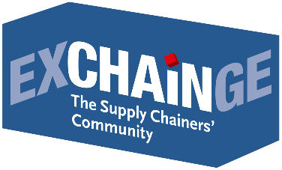
Press Release

Continental wins Supply Chain Management Award 2019 –
parcelLab earns Smart Solution Award 2019

Frankfurt am Main, November 28, 2019—Global automotive supplier Continental has won the Supply Chain Management Award for 2019. The award was presented for the 14th year by Strategy&, the global strategy consulting team at PwC, and by the industry trade journal LOGISTIK HEUTE, a publication of HUSS-VERLAG in Munich. The Smart Solution Award, presented for the second year in 2019, was given to parcelLab. The award ceremony took place in Frankfurt at the EXCHAiNGE supply chain summit, part of the Hypermotion event platform, on November 27, 2019.
The jury of prominent supply chainers, researchers, consultants, and industry journalists reached its decision after vetting the field of finalists: Bosch, Continental, Lufthansa Technik Logistik Services, and Nokia for the Supply Chain Management Award as well as Magazino, Metrilus, parcelLab, and shipcloud for the Smart Solution Award. These eight companies presented their outstanding concepts live at EXCHAiNGE on November 26. Attendees were also encouraged to submit their votes, and the results were taken into consideration in the jury’s deliberations.
Supply Chain Management Award 2019
Winner: CONTINENTAL
Concept: The Continental Automotive Group’s submission for the Supply Chain Management Award was the “Fast Forward 2030” supply chain vision. The objective is to develop a readiness for “Industry 4.0” automation, which brings greater agility and transparency to the complex supply chain of more than 100 production sites, 5,700 suppliers, and 157 billion product components. The first cost savings have already been realized at the two smart pilot factories in Regensburg (Germany) and Zvolen (Slovakia). Continental develops pioneering technologies and services for sustainable and connected mobility of people and goods. Founded in 1871, the technology giant offers safe, efficient, smart, affordable solutions for vehicles, machines, transit, and transport. Continental generated sales of €44.4 billion in 2018 and currently employs more than 244,000 people in 60 countries and markets.

“We are very proud to receive the Supply Chain Management Award 2019. Our entire supply chain ecosystem is currently in flux, which has a huge impact on our factories, suppliers, and customers. A bold response to these changes and to the automation of ‘Industry 4.0’ will strengthen our competitive edge and open up many new opportunities for growth,” remarked Jan Axt, Head of Automotive Supply Chain Management Strategy & Innovation at Continental Teves AG & Co. oHG, Frankfurt am Main. “Our interdisciplinary team is already working hard on the transition from a traditional supply chain to an autonomous supply network.”

Voices from the jury
Presenter and juror Kerstin Gliniorz (Director of Supply Chain Strategy at ADM Wild): “This year’s presentation of the Supply Chain Management Award honors the outstanding implementation of a long-term supply chain vision toward an autonomous supply network in 2030. Continental’s concept addresses the entire value chain from supplier to customer with a clear vision of the supply chain’s evolution through various levels of maturity, from connectivity to autonomy. The key ingredient of success in this approach is to embed it in the organization and its operations. This allows for quick decision-making and scalability of the various digital implementations.”

Juror Harald Geimer (Partner at PwC Management Consulting): “Continental has found the right mix of effective governance, scalability of the developed solutions, elimination of traditional boundaries between IT and the supply chain—and above all, employee integration. The successes it has demonstrated in its factories in Regensburg und Zvolen show that Continental is already ahead of its time when it comes to issues such as geolocation or geofencing, the use of cobots and AGVs, and the development of key enablers like cloud systems.”

Juror Dr. Petra Seebauer (Managing Director of EUROEXPO Messe- und Kongress-GmbH, Publisher of the trade journal LOGISTIK HEUTE): “The Fast Forward 2030 vision ensures that the company will not lose sight of the big picture as it moves forward on a structured path toward its ultimate goal. All of this prompted us to honor Continental with the Supply Chain Management Award 2019. The concept for developing an autonomous supply network is impressive and entirely appropriate for a company of Continental’s complexity. From vision to implementation: All facets of this transformation are well organized and implemented. It’s exciting to see the foundation that Continental is now building for its digital future and how much of it has already become a reality.”

About the award
The Supply Chain Management Award is presented by Strategy&, the global strategy consulting team at PwC, and by the industry trade journal LOGISTIK HEUTE, a publication of HUSS-VERLAG in Munich. The honorary sponsor in 2019 is Steffen Bilger, Member of the German Bundestag and Parliamentary State Secretary at the Federal Ministry of Transport and Digital Infrastructure. Each year since 2006, the award has honored outstanding solutions in industrial value chains and the companies that exhibit perseverance or creativity in optimizing their supply chain. The award recognizes powerful end-to-end supply chain solutions and outstanding implementations within individual links in the value chain. Previous winners include CEMEX Deutschland (2018), Gries Deco (2017), PERI (2016), Nokia Networks (2015), and GF Piping Systems (2014).
Smart Solution Award 2019
Winner: parcelLab
Concept: parcelLab’s submission for the Smart Solution Award focused on improving the ecommerce customer experience during post-checkout. parcelLab offers real-time monitoring of each individual order for personal, individual, and emotional customer communications supported by machine learning. The white-label solution lets online retailers design their post-checkout customer relationships around their unique wishes and needs. Founded in 2015, the company has offices in Munich, London, and Paris and partnerships with more than 350 retailers in 38 countries.

“Here at parcelLab, we are very proud and pleased that we were able to win this year’s Smart Solution Award and impress the logistics experts on the jury with our idea. We hope that our participation in the Smart Solution Award helped shine a spotlight on the importance of personalized post-purchase communications and that ecommerce will become even more personalized in the future—from checkout to shipping to returns,” said a proud Tobias Buxhoidt, Founder & CEO of parcelLab GmbH, Munich.

Voices from the jury
Presenter and previous year’s winner Maximilian Schäfer (Managing Director at digital freight forwarding service InstaFreight): “parcelLab addresses a specific pain point of online retailers. The white-label solution brings heightened transparency and monitoring to the post-checkout process, making it possible to significantly enhance customer value. Their collaboration with large online retailers in the German market is a testament to the success of this business model.”
Juror Harald Geimer (Partner at PwC Management Consulting): “The solution from parcelLab offers tremendous potential to take the benefits they already offer customers and retailers in B2C ecommerce checkout and expand them in a revolutionary new way to B2B operations. B2B companies also face the challenge of ceding control of their valuable customer relationships to a third party once their own transactions have been successfully completed.”
Juror Dr. Petra Seebauer (Managing Director of EUROEXPO Messe- und Kongress-GmbH, Publisher of the trade journal LOGISTIK HEUTE): “parcelLab underscores the hypothesis that successful solutions focus on the essential needs of the customers. This approach makes it possible to achieve a better overall customer experience in the post-checkout process.”

About the award
The Smart Solution Award will be presented for the second year, honoring particularly innovative concepts that are still in an early stage of implementation. The prize highlights solutions with the potential to fundamentally transform traditional value chains. The past winner from 2018 is InstaFreight GmbH.

Like last year, the EXCHAiNGE supply chain summit was held as part of the Hypermotion trade show (organized by Messe Frankfurt), which draws some 3,000 attendees. Those attending EXCHAiNGE also had the opportunity to visit the Hypermotion exhibit space with its multiformat focus on the digital transformation of transport and mobility: November 26–28, 2019.

SAVE THE DATE
EXCHAiNGE—the Supply Chainers Community 2020
with sessions, interactive supply chain roundtables, final round of awards competition, and Award Night ceremony
November 10–11, 2020 | at Hypermotion in Frankfurt am Main
Learn more: www.exchainge.de

Click here for images.

For more information, please contact:

Hendrikje Rother
Marketing/Press
EUROEXPO Messe- und Kongress-GmbH
Phone: +49 89 323 91 240
hendrikje.rother@euroexpo.de
www.exchainge.de/en

(Characters with spaces: 9,135)

EUROEXPO press releases may be reprinted free of charge. Texts and images can be found at the EXCHAiNGE press page under www.exchainge.de.
Please send a copy of any republication by email to hendrikje.rother@euroexpo.de or by postal mail to EUROEXPO Messe- und Kongress-GmbH | Presse- und Öffentlichkeitsarbeit | Joseph-Dollinger-Bogen 7 | 80807 München.

Supply Chain Awards 2019
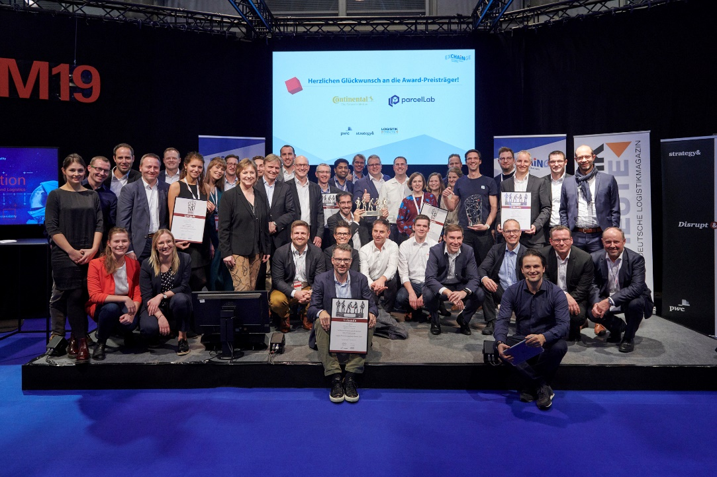
Congratulations to the award winners Continental and parcelLab as well as to the other finalists Lufthansa Technik Logistik Services, Magazino, Metrilus, Nokia, Robert Bosch and shipcloud who showed innovative and outstanding solutions in the finalist pitches at the EXCHAiNGE conference.

Supply Chain Management Award 2019
Winner 2019: Continental
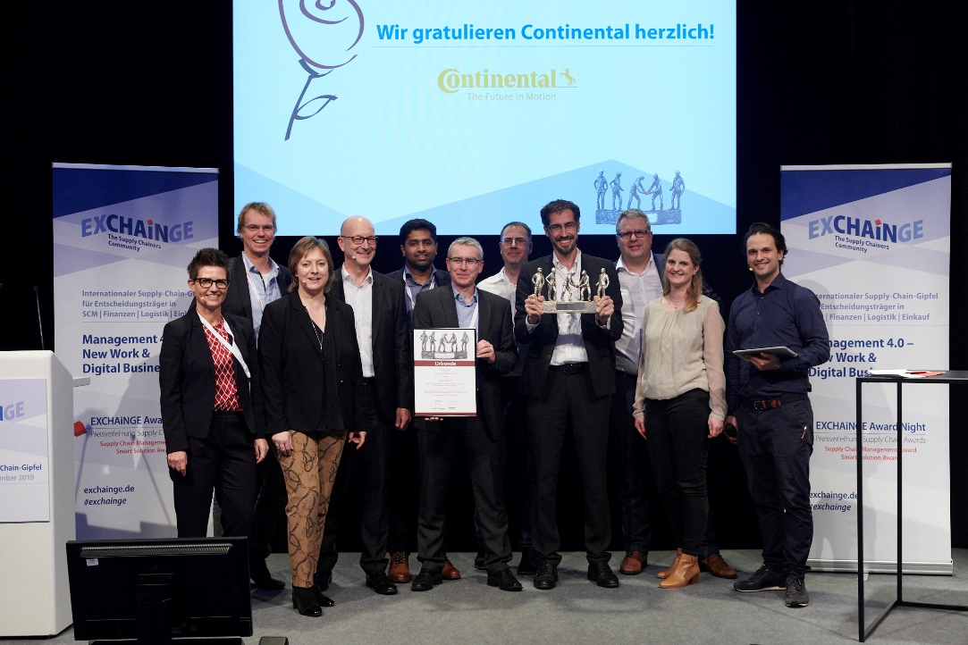

Happy winners: Jan Axt (Head of Logistics, Area of Strategy & Innovation with central organization of Automotive SCM,; 4th from right) and team, Continental, are delighted to receive the Supply Chain Management Award 2019. Dr. Petra Seebauer (Managing Director EUROEXPO Messe- und Kongress-GmbH and Publisher LOGISTIK HEUTE; 3rd from left), Harald Geimer (Partner at PwC Management Consulting; 4th from left.) and Kerstin Gliniorz (Laudator and Director Supply Chain Strategy at ADM Wild; left) congratulate on behalf of all jury members.

Finalists Supply Chain Management Award 2019

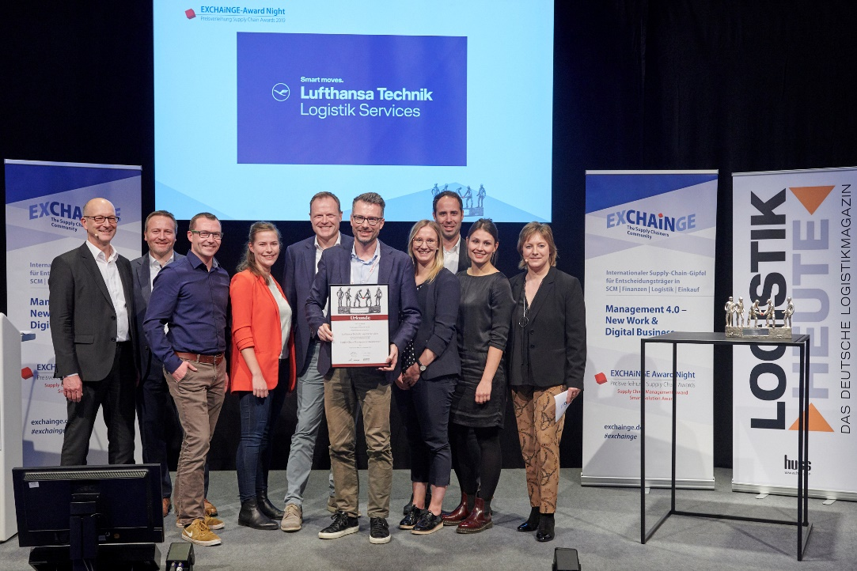
The finalists for this year’s award also included Lufthansa Technik Logistik Services, represented here by Dr. Harald Kolbe (Head of Digital Innovation; 5th from right) with his team, Lufthansa Technik Logistik Services. Congratulated by Dr. Petra Seebauer (Managing Director EUROEXPO Messe- und Kongress-GmbH and Publisher LOGISTIK HEUTE; right) and Harald Geimer (Partner at PwC Management Consulting; left).

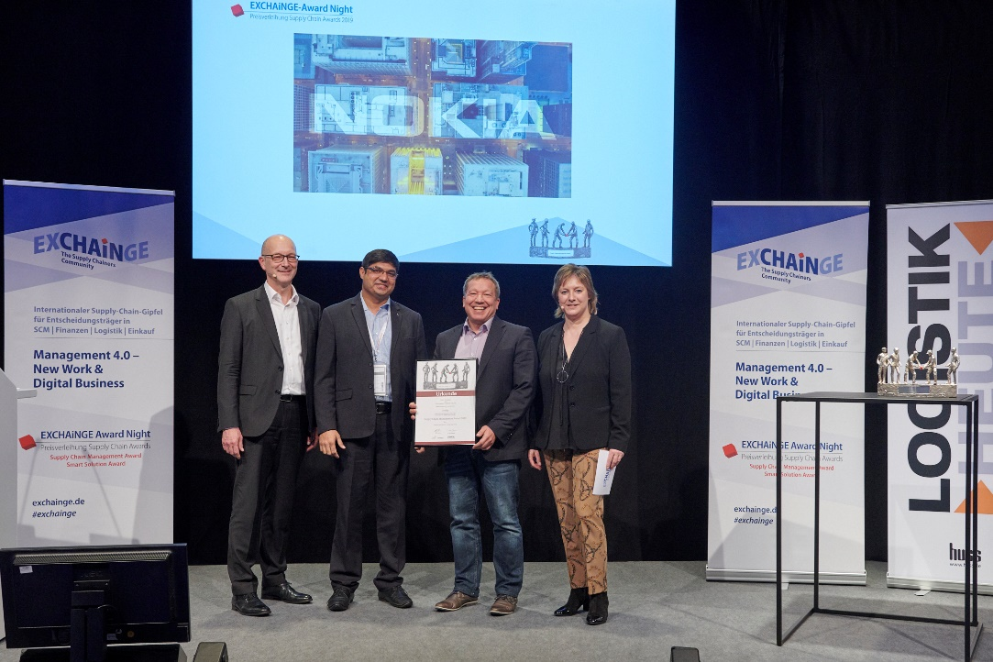
Schaeffler was also a finalist for the Supply Chain Management Award 2019 and was represented by Christian Schewtschenko (Head of Operations Strategy; 2nd from right) and his team, Nokia. The jury members Dr. Petra Seebauer (Managing Director EUROEXPO Messe- und Kongress-GmbH and Publisher LOGISTIK HEUTE; right) and Harald Geimer (Partner at bei PwC Management Consulting; left.) congratulate cordially.

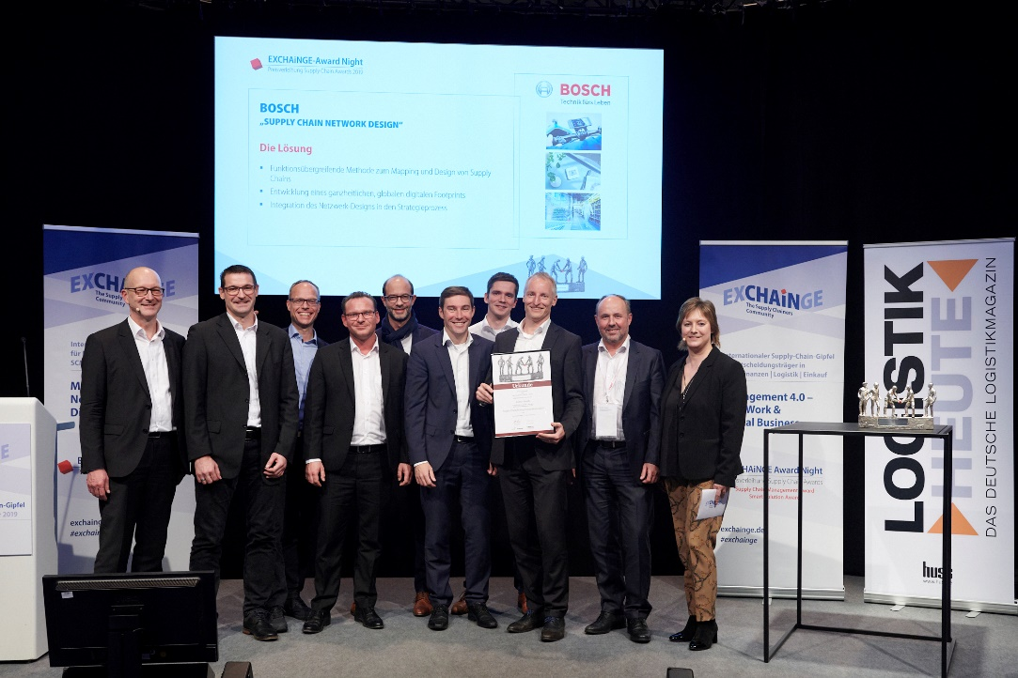
The finalists for this year’s award also included Robert Bosch GmbH, represented here by Michael Bühler (Head of Logistics, Automotive Division; 5th from right) and Dr. Christian Lippolt (Head of Process Management Logistics Planning; 3rd from right) with his team, Robert Bosch GmbH. Congratulated by Dr. Petra Seebauer (Managing Director EUROEXPO Messe- und Kongress-GmbH and Publisher LOGISTIK HEUTE; right) and Harald Geimer (Partner at PwC Management Consulting; left).

Smart Solution Award 2019
Winner 2019: parcelLab
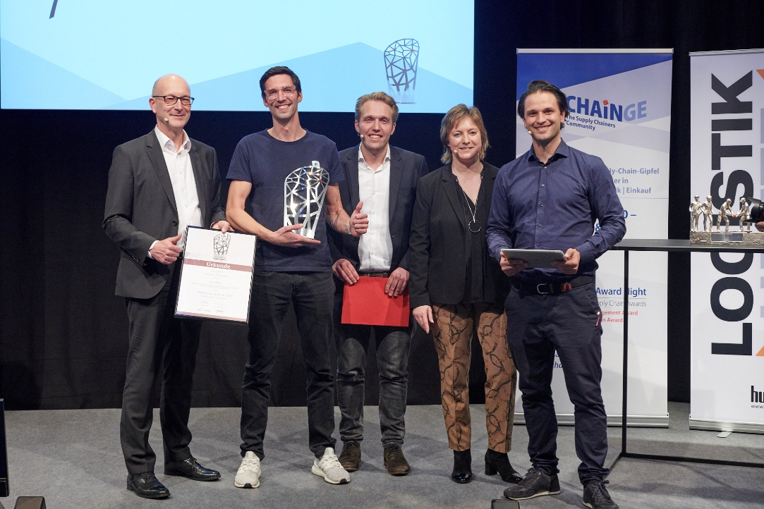
You can see the joy in him: ParcelLab wins the Smart Supply Chain Solution Award 2019 and is received by Tobias Buxhoidt (CEO and Co-founder, parcelLab GmbH, 2nd from left). Dr. Petra Seebauer (Managing Director EUROEXPO Messe- und Kongress-GmbH and Publisher LOGISTIK HEUTE; 2nd from right), Harald Geimer (Partner at PwC Management Consultants; left.) and Maximilian Schäfer (Laudator and Managing Director, InstaFreight, Smart Solution Award-Preisträger 2018, 3rd from right) congratulate on behalf of all jury members.

Finalists Smart Solution Award 2019
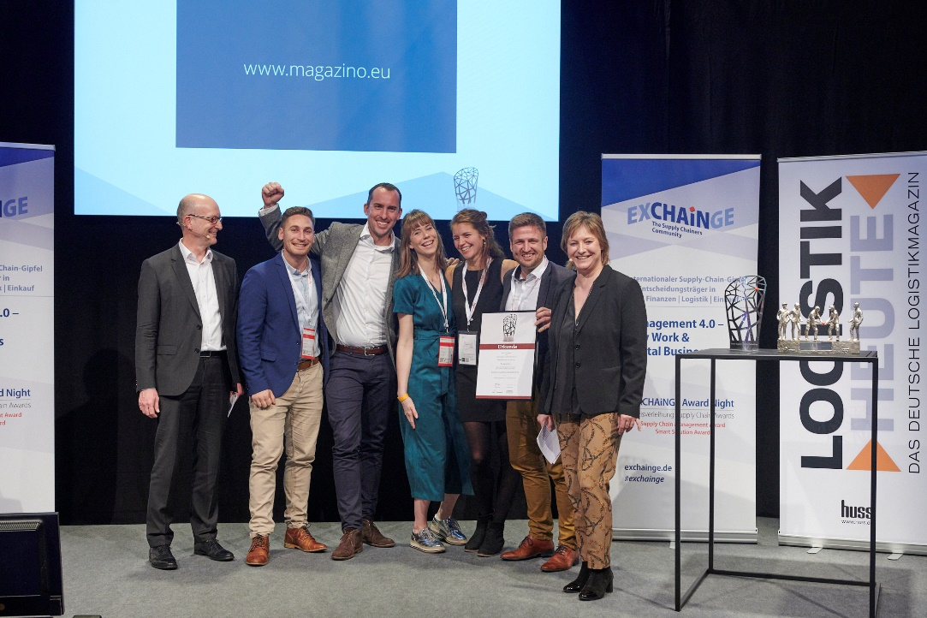
Magazino was also a finalist for the Smart Solution Award 2019. The picture shows Benjamin Sommer (Senior Sales Manager; 2nd from right.) and his team. Dr. Petra Seebauer (Managing Director EUROEXPO Messe- und Kongress-GmbH and Publisher LOGISTIK HEUTE; right) and Harald Geimer (Partner at PwC Strategy&; left.) handed over the deed.

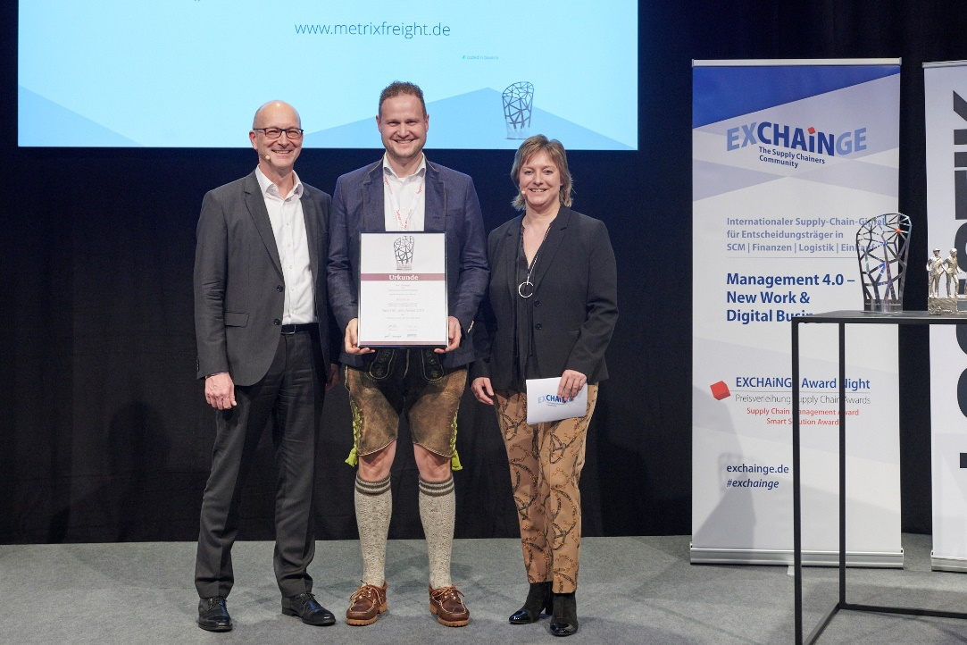

Metrilus GmbH was also among the finalists for the Smart Solution Award 2019. It was represented by Dr.-Ing. Christian Schaller (Founder and CEO; Metrilus GmbH; 2nd from right). Dr. Petra Seebauer (Managing Director EUROEXPO Messe- und Kongress-GmbH and Publisher LOGISTIK HEUTE; right) and Harald Geimer (Partner at PwC Management Consultants; left.) handed over the deed.

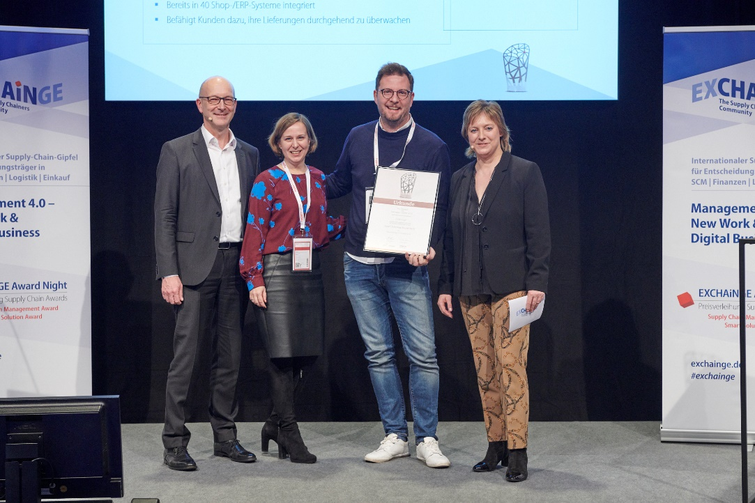
shipcloud was also a finalist for the Smart Solution Award 2019. The picture shows Dr. Martin Kreipl (CFO; shipcloud GmbH; 2nd from right.) and Ivonne Sikoll (CMO; 2nd from left). Dr. Petra Seebauer (Managing Director EUROEXPO Messe- und Kongress-GmbH and Publisher LOGISTIK HEUTE; right) and Harald Geimer (Partner at PwC Management Consultants; left.) handed over the deed.

About EXCHAiNGE
EXCHAiNGE is an annual international supply chain summit that brings together decision makers and thought leaders from the worlds of SCM, finance, logistics, and purchasing. The event attracts a diverse business community ranging from innovation officers to business developers to supply chain operations managers at companies of all sizes. They all gather to talk about the strategic management issues of tomorrow: new mindsets, modern business models, digital integration, and much more.
EXCHAiNGE provides a roadmap for navigating such key issues of digital transformation as sustainability, culture and mindsets, innovation, collaboration, mobility, technology, blockchain, big data, and artificial intelligence. Finalists competing for the Supply Chain Awards offer profound insights into pre-eminent examples of best practice.
Visitors get valuable tips on repositioning their businesses to become drivers of innovation with the goal of generating a critical competitive advantage. EXCHAiNGE stands as an established networking platform where attendees can share in the personal experience of industry leaders, experience illuminating roundtables on forward-looking strategies, be actively engaged, and reflect on new ideas and trends in the supply chain.
The supply chain summit is organized by EUROEXPO Messe- und Kongress-GmbH in Munich.

About HYPERMOTION
Hypermotion—Pioneering Mobility & Logistics | November 26–28, 2019 | Frankfurt am Main

Hypermotion offers a platform for forward-looking issues with a focus on smart systems and solutions for mobility, transport, logistics, and digital infrastructure and features an innovative program mix for the mobility and logistics industries. Taking place for the third time this year, the event brings together the users and providers who are defining new standards for the mobility of tomorrow. The overarching objective is to provide a networking platform that transcends various modes of transport and systems and finds interfaces between mobility and logistics. Hypermotion zeroes in on the following core questions: How will digital technology and decarbonization transform transportation systems? How can we find unique, intermodal solutions for logistics and mobility chains in smart and digital regions?

The agenda blends seven interrelated topics: smart & digital regions, data analytics & security, digital & urban logistics, hypermodality (intermodal, multinational, digital), sustainability, monitoring & transparency, and connectivity. The event includes businesses of all sizes—from startups to large enterprises—together with researchers, policymakers, and representatives of professional associations. Hypermotion’s program mix of expo, conferences, pitches, workshops, and talks offers numerous opportunities to engage and network with seasoned experts from established enterprises and future innovators from the startup scene. The EXCHAiNGE conference is once again offered both as a part of Hypermotion 2019 and as a standalone event.

Learn more about Hypermotion

About EUROEXPO Messe- und Kongress-GmbH
EUROEXPO Messe- und Kongress-GmbH, founded in 1996 and headquartered in Munich, organizes LogiMAT (“the International Trade Show for Intralogistics Solutions and Process Management”) and TradeWorld (“the Professional Platform for Trade Processes”), held each year in Stuttgart, Germany. EUROEXPO has also partnered with Landesmesse Stuttgart since 2014 to present the annual LogiMAT China, first in Nanjing and since 2019 in Shanghai.
EUROEXPO also organizes “EXCHAiNGE—the Supply Chainers Community.” The supply chain summit, now in its seventh year, targets leaders from the areas of SCM, finance, logistics, and purchasing at companies ranging in size from startups to global enterprises. EUROEXPO is also a service provider offering B2C and B2B event management services, such as the organization and implementation of the LOGISTIK HEUTE series.
For more information, please visit www.euroexpo.de.

