Dr. Stefanie Krieger Managing Director of LAUDA Medical

Dual leadership with interim Managing Director Werner Kilb until the end of March 2025

Lauda-Königshofen, December 20, 2024 – LAUDA DR. R. WOBSER GMBH & CO. KG announces that Dr. Stefanie Krieger has been appointed Managing Director of LAUDA Medical GmbH & Co. KG in Würzburg with effect from December 1, 2024.

The 44-year-old biologist with a doctorate, who joined the company on September 1, 2024, brings extensive experience to her new position. Most recently, she worked as an auditor for medical devices in accordance with the Medical Device Regulation (MDR). This EU regulation places strict requirements on medical device manufacturers to ensure the highest level of safety, quality and performance. The knowledge she gained from her time as a senior project manager at a leading company for clinical studies and data management in the pharmaceutical, biotech and medical technology industry, as well as her scientific work at the Julius Maximilian University of Würzburg, form a solid basis for her new role.

Dr. Gunther Wobser, President & CEO of LAUDA, sees her expertise and leadership strength as important success factors for the further expansion of LAUDA Medical: “Dr. Stefanie Krieger brings the professional expertise we need to achieve our ambitious goals. Her know-how in medical technology and her team-oriented leadership are particularly important for the success of the new company.”

LAUDA Medical, founded on 1 March 2021, specializes in the development, production and distribution of medical devices and related services. The subsidiary benefits from the LAUDA Group's almost 50 years of experience in the development and manufacture of hypothermia devices for the leading manufacturer of heart-lung machines. LAUDA Medical is currently concentrating on the development of a completely new type of successor device. This innovation will enable absolutely safe temperature control for patients during heart surgery.

As the new Managing Director, Dr. Stefanie Krieger is responsible for the operational business of LAUDA Medical GmbH & Co. KG at the new Würzburg site. One of her main tasks will be the planned market launch of the new hypothermia device in January 2026. Dr. Krieger can count on the support of an experienced team of currently eight highly qualified employees. Their expertise will make a decisive contribution to further strengthening LAUDA Medical's position as a leading company in medical technology. The interim Managing Director, Werner Kilb, will provide support until the end of the first quarter and then concentrate fully on his core tasks as Director Finance at LAUDA DR. R. WOBSER GMBH & CO. KG.
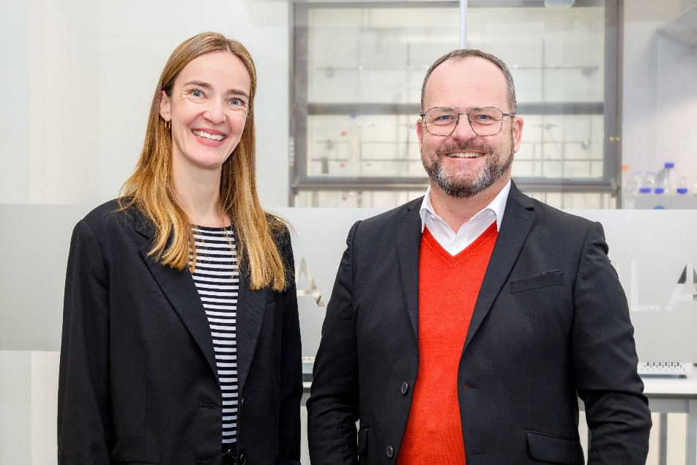

Fig.: The new Managing Director of LAUDA Medical GmbH & Co KG, Dr. Stefanie Krieger, together with Dr. Gunther Wobser. The experienced medical technology expert will be responsible for the development and market launch of the new hypothermia device. © LAUDA

We are LAUDA – the world leader in precise temperature control. Our constant temperature equipment and systems are at the heart of important applications, contributing to a better future. As a complete one-stop supplier, we guarantee the optimum temperature in research, production and quality control. We are the reliable partner for electromobility, hydrogen, chemicals, pharmaceuticals/biotech, semiconductors and medical technology. We have been inspiring our customers for almost 70 years with our expert mentoring and innovative solutions – every day anew and all over the world.

In our company, we always go one step further. We support our employees’ development and are constantly developing ourselves: to create a better future together.

Press contact
We are more than happy to make prepared information about our company, the LAUDA Factory Gallery and our projects in the area of innovation promotion, digitalization and idea management available to the press. We look forward to hearing from you – just give us a call!

CHRISTOPH MUHR
Director Corporate Communications
T + 49 (0) 9343 503-349
christoph.muhr@lauda.de

LAUDA DR. R. WOBSER GMBH & CO. KG, Laudaplatz 1, 97922 Lauda-Königshofen, Deutschland/Germany. Limited partnership: Headquarters Lauda-Königshofen, Registration court Mannheim HRA 560069. General partner: LAUDA DR. R. WOBSER Verwaltungs-GmbH, Headquarters Lauda-Königshofen, Registration court Mannheim HRB 560226. Managing Directors: Dr. Gunther Wobser (President & CEO), Dr. Mario Englert (CFO), Dr. Marc Stricker (COO)

