Hält Verunreinigungen zurück und erleichtert das Atmen: Luftreiniger AF 100

Saubere Raumluft verbessert Lebensqualität

Pressekontakt
Alexander Becker
Pressereferent
Alfred Kärcher GmbH & Co. KG
Alfred-Kärcher-Str. 28-40
71364 Winnenden
T +49 71 95 14-4256
F +49 71 95 14-2193
alexander.becker@de.kaercher.com
Winnenden, im Januar 2018 – Mit dem AF 100 stellt Kärcher ein neues Gerät vor, das die Qualität der Raumluft verbessert. Gerade in der Arbeitswelt, etwa in Büros, öffentlichen und medizinischen Einrichtungen, in Hotels und Restaurants hat saubere und keimfreie Luft eine besondere Bedeutung. In der Praxis beeinträchtigt allerdings gerade an diesen Orten schlechte Luft häufig das Wohlbefinden und kann zu gesundheitlichen Problemen führen. Mögliche Folgen sind nachlassendes Leistungsvermögen und Ausfallzeiten bei Mitarbeitern.
Der AF 100 reinigt die Luft in einen 100 qm großen Raum innerhalb von 20 Minuten und hält bis zu 99,98 % aller Partikel zurück. In Abhängigkeit vom verwendeten Filter – Anwender können zwischen fünf unterschiedlich spezialisierten Versionen mit Aktiv-Kohle und HEPA Technologie wählen – säubert das Gerät die Luft unter anderem von Gerüchen, allergenen Stoffen wie Milben und Pollen, Feinstaub, Bakterien sowie gasförmigen Kohlenwasserstoff-Verbindungen (VOC).
Der Luftreiniger lässt sich ohne technische Kenntnisse bedienen. Einfach die gewünschten Filter paarweise an Vorder- und Rückseite einsetzen, Stecker in die Steckdose stecken und einschalten. Im Inneren des Gerätes überwacht ein Lasersensor den Grad der Luftverschmutzung und passt im Automatikmodus die Reinigungsleistung kontinuierlich an. Während des Betriebes zirkuliert die Luft durch die Filter im Gerät und wird anschließend sauber an die Umgebung abgegeben. Ein Luftstrom ist dabei im Unterschied zu einem Ventilator nur schwach wahrnehmbar.
Das Betriebsgeräusch ist sehr leise, im Nachtmodus wird es noch einmal reduziert. Ein leuchtendes LED-Band am Gehäuse gibt in den Farben rot (schlecht), grün (moderat) und blau (sauber) Auskunft über die Luftqualität. Eine Anzeige informiert, wenn die Filtereinsätze gewechselt werden müssen. Ein Service in einer Werkstatt ist dafür nicht notwendig. Der Vorfilter ist als Dauerfilter ausgelegt und kann mit Wasser ausgewaschen werden.
Der Luftreiniger AF 100 hat ein helles Kunststoffgehäuse mit rechteckiger Form und abgerundeten Kanten. Er ist rund 70 cm hoch, besitzt einen quadratischen Querschnitt mit 38 cm Kantenlänge und kann an vielen Stellen optisch unaufdringlich platziert werden. Dank kleiner Rollen an der Unterseite lässt er sich mühelos zu verschiedenen Standorten bewegen.
Eine Word-Datei und druckfähige Bilder zu dieser Presseinformation liegen für Sie in unserem Newsroom https://www.kaercher.com/presse zum Download bereit.

Kaercher_AF_100_de.docx
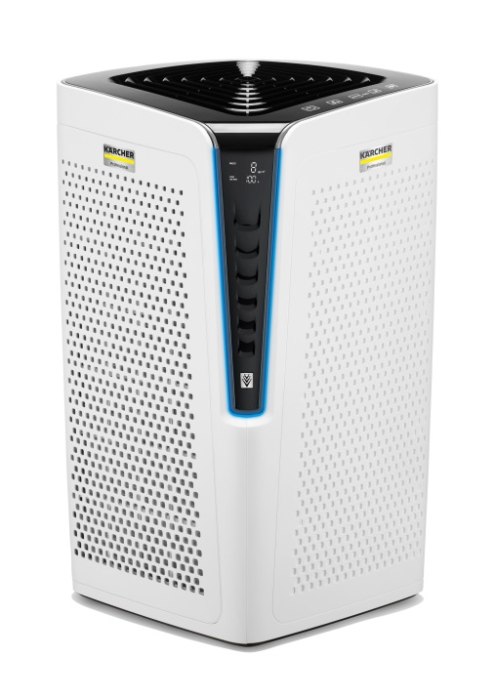
Mit dem AF 100 stellt Kärcher ein neues Gerät vor, das die Qualität der Raumluft verbessert.
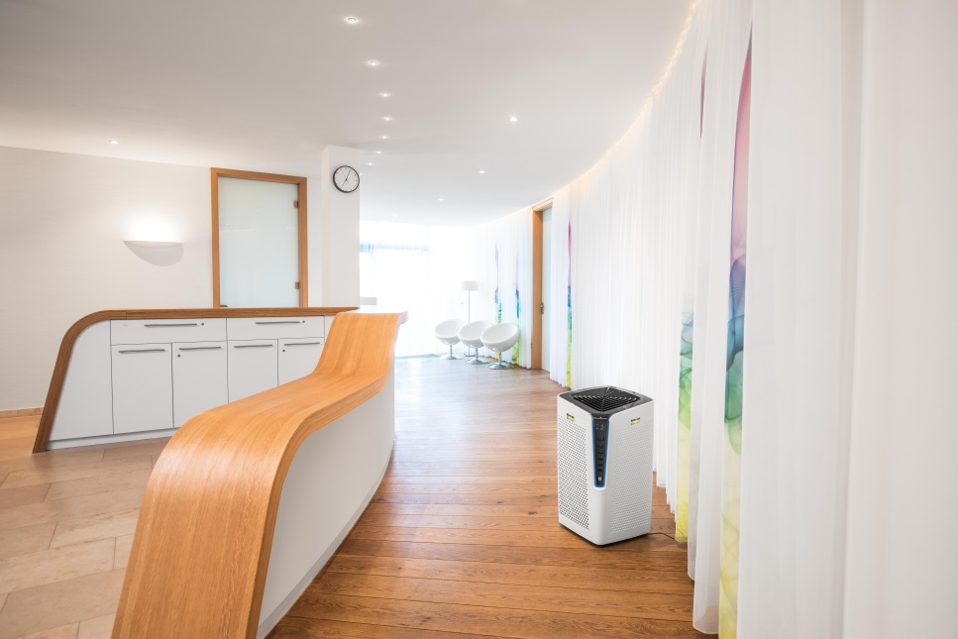
Der Luftreiniger AF 100 verbessert die Raumluft in Gebäuden und trägt so zum Wohlbefinden und vorbeugend zum Schutz der Gesundheit bei.

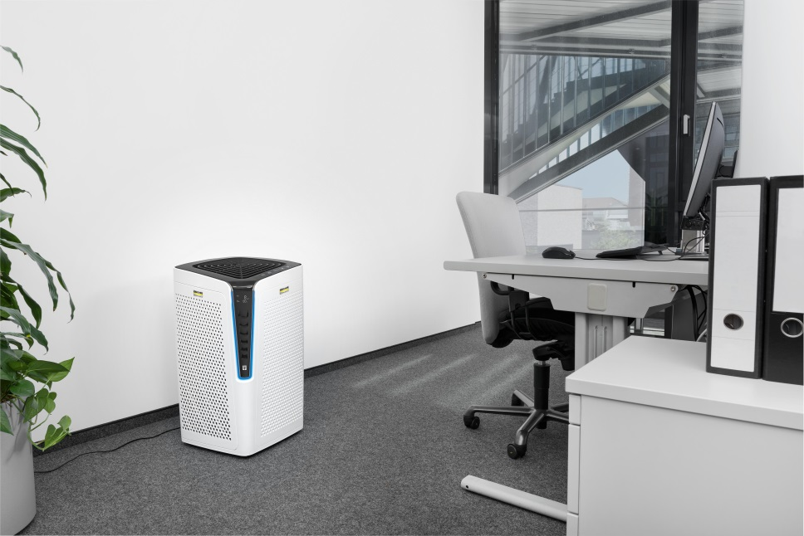
Der AF 100 reinigt die Luft in einen 100 qm großen Raum innerhalb von 20 Minuten und hält bis zu 99,98 % aller Partikel zurück.

