Kunstmuseum St. Gallen hires Melanie Bühler as Senior Curator  Kunstmuseum St. Gallen is pleased to announce the engagement of internationally renowned Swiss curator Melanie Bühler starting in St. Gallen in the summer of 2023. She will join the Kunstmuseum St. Gallen as a freelancer starting this fall to strengthen the museum's curatorial team, develop new content, and help shape the museum's future, in collaboration with the incoming director Gianni Jetzer, who takes office in November, as well as the longtime head of the Kunstverein St. Gallen, Nadia Veronese, who will also take on the role of Senior curator.  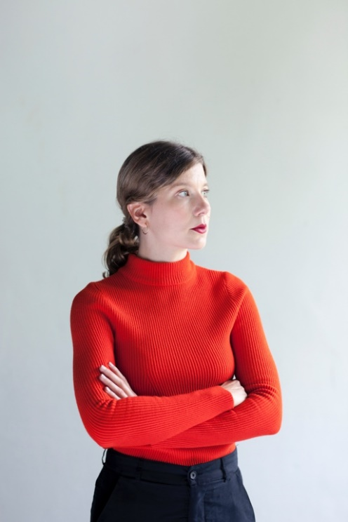  Photo: Anneke Hymmen  Gianni Jetzer, the director in office from November 2022, counts Melanie Bühler as one of the most innovative exhibition makers of her generation: "As a curator, critic, and editor, Melanie Bühler has proven that she recognizes the signs of the times early on. Her book ‘No Internet, No Art’ is a standard work about how the Internet has permanently changed art. At the Frans Hals Museum in Haarlem, Netherlands, she has also brilliantly combined historical works with contemporary art. Her just-published book on institutional critique holds valuable know-how for an evolving institution like the Kunstmuseum St. Gallen."  Melanie Bühler has been curator of contemporary art at the Frans Hals Museum in Haarlem since 2017. She is currently working on The Art of Critique project, which rethinks the art historical movement of institutional critique. Her recent exhibitions include Image Power (2020) and Noise! Frans Hals, Otherwise (2018), both at the Frans Hals Museum, and Private Public Relations, at the Pinakothek der Moderne, Munich (2017).  She is the founder and curator of Lunch Bytes (2010-15), a project on art and digital culture for which she has collaborated with Art Basel; the Institute of Contemporary Arts, London; the Haus der Kulturen der Welt, Berlin; the Hirshhorn Museum; and Sculpture Garden, Washington, DC, among others. She is the editor of The Art of Critique (Lenz Press, Summer 2022), No Internet, No Art (Onomatopee, 2015), and co-editor of The Transhistorical Museum (Valiz, 2018). Her writings have appeared in various exhibition catalogs and art magazines. | Press release  Kunstmuseum St.Gallen,  21 September 2022
Press contact

Gloria Weiss
Head of Communications
Museumstrasse 32
9000 St. Gallen
T +41 71 242 06 84

Sophie Lichtenstern
Communications
Museumstrasse 32
9000 St. Gallen
T +41 71 242 06 85

kommunikation@kunstmuseumsg.ch
www.kunstmuseumsg.ch

