LAMILUX at CV Show Birmingham 2023, Hall 5 Stand B03

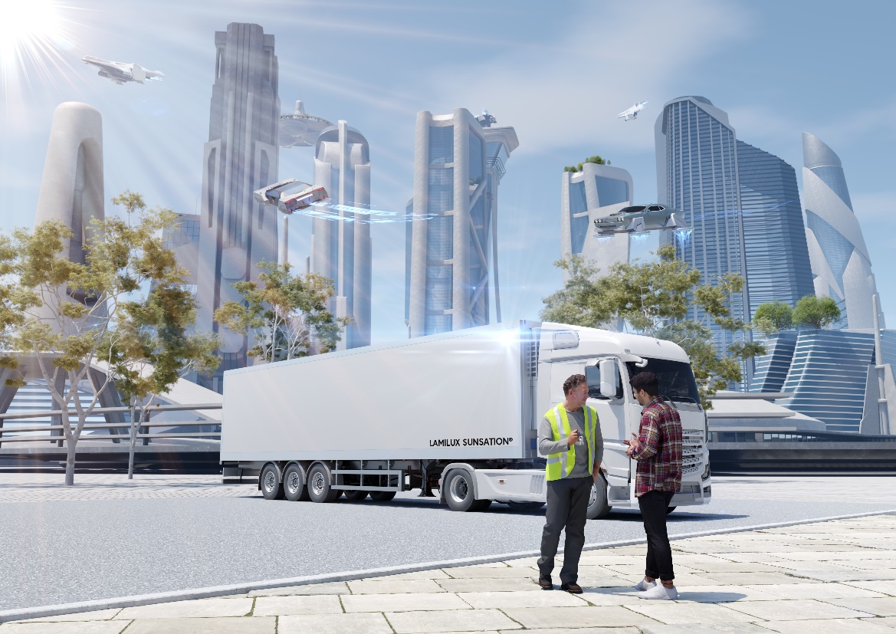
High-tech composites for future lightweight construction & optimized cold chains

Whether commercial or refrigerated vehicle: the automotive industry requires materials that equip vehicles for everyday challenges and make them more stable, lighter and sustainable in the future. LAMILUX Composites, one of the largest producers of fibre-reinforced plastics, will be presenting its product innovations at the CV Show in Birmingham in Hall 5 at Stand B03. This includes the world’s UV-resistant GRP face sheet – LAMILUX Sunsation®.

From 18 to 20 April the GRP specialist LAMILUX Composites is giving the general public a deep insight into the world of glass fibre-reinforced plastics at CV Show Birmingham. Decades of experience in the commercial vehicle and bus industry as well as quality made in Germany characterize the 100-year-old family-owned company. Their GRP solutions pave the way for the sustainable mobility of the future: light, stable and robust. Whether in the side wall, roof or floor: LAMILUX Composites offer a wide range of options for lightweight construction of commercial or refrigerated vehicles, buses and last-mile vehicles.

New products: World’s most UV-resistant GRP face sheet
LAMILUX Sunsation® is the long-awaited revolution in the field of fibre composite plastics, completely redefining the standard for exterior applications, broadening the horizon with regard to image, appearance, care and value, and making investments look like new even after decades in the sun.

Tried and tested in all real applications
For trucks and last-mile vehicles, this is the impact-resistant, robust material High Impact with optional AntiBac surface, the non-slip floor covering AntiSlip for interiors or LAMILUX Super, which protect the underbody from stone chippings. When installed in the side wall and roof, the world’s first LAMILUX Sunsation® reveals the advantages of the innovative gelcoat technology with 20 times better UV resistance than the gelcoats currently available on the market. LAMILUX Composites also enables translucent roofs for daylight intake during loading and unloading.

In the case of buses, LAMILUX demonstrates its flair for design: LAMIfoamtex with its soft-touch surface, Composite Floor, which resembles laminate flooring, and LAMIGraph, for interior cladding, are the proven materials of choice here. The manufacturer also presents a robust and durable material, LAMILUX X-treme, for use on roofs and side walls. LAMILUX AntiSlip non-slip flooring, which is also available as a visually attractive LAMILUX Anti Slip Style variant, once again scores points in the luggage compartment.

Focus on lightweight construction, sustainability, robustness, function and hygiene
Installed in a wide range of vehicle types, LAMILUX Composites saves a considerable amount of weight while still producing extremely robust superstructures. In sandwich or prefabricated constructions, this composite material sustainably reduces the fuel consumption of the vehicles. High strength and stability create robust constructions that ensure that heavy mechanical stress in daily traffic leaves less traces on the composite materials.

The high damage tolerance also leads to a longer value retention of the vehicle, lower repair costs and easier repair and maintenance. Special materials with additional benefits, such as the non-slip LAMILUX AntiSlip or LAMILUX AntiBac with antibacterial nanosilver surface, round off the product portfolio.

…

More information at www.lamilux.com

About LAMILUX Composites GmbH
LAMILUX Composites GmbH has been producing fibre-reinforced plastics for around 70 years. The medium-sized company is a leading European producer thanks to its technologically advanced continuous production process, large manufacturing capacities and wide product range. LAMILUX supplies customers around the globe in a wide range of sectors, such as the building industry, the automotive and recreational vehicle sectors, refrigerated store room and cell construction, and many other industrial sectors. With more than 1250 employees, LAMILUX generated a turnover of 335 million euros in 2021. The family-managed company is based in Rehau, Bavaria.

