PRESS RELEASE
Schwaebisch Hall, January 14, 2020

OPTIMA do Brasil invites to its Barrier Technology Seminar
The event is being held because of the new Anivsa regulations on the use of barrier systems

Optima do Brasil is holding a Barrier Technology Seminar on March 11 and 12 in Vinhedo (São Paulo). The reason for this is the new regulations issued by the Brazilian health monitoring authority Anvisa on the use of barrier systems in pharmaceutical manufacturing. In specialist presentations, experts from Optima Pharma and Metall+Plastic will be providing information on barrier technologies such as isolators and RABS systems. The subjects of "Technology", "Project Handling" and "Real Application" will be discussed in depth in six workshops. Both companies have many years' experience in the fields of barrier technologies and filling technologies for pharmaceutical products.
"The Barrier Technology Seminar means we can provide our customers with the ideal platform, both for obtaining up-to-date information on the new Anivsa regulations and for familiarizing themselves with the latest barrier technologies," says Rolf Geissinger, Managing Director of Optima do Brasil. The seminar, which can be attended on March 11 or 12, covers all the information needed to prepare early for the new Anvisa regulations' requirements. The "RDC 301" regulation requires pharmaceutical companies to use barrier systems such as isolators or RABS to avoid contamination of the products.
Two days full of information and insights
In addition to specialist presentations on Anvisa regulation and the principles of barrier technology, the program will include six workshops in three different areas. The topic of "Technology" covers the introduction of products into the isolator or the RABS system. Matthias Aster, Team Leader Sales at Metall+Plastic, will be providing information about available isolator technologies. In the second unit of the workshop, experts will discuss how Optima Pharma's CSPE process cuts time-to-market. This is particularly important for pharma companies in South America: Using a project example, visitors will also learn how existing filling systems can be upgraded with RABS. The course ends with workshops on handling and cleaning from operating staff as well as procedures for bio-decontamination.
OPTIMA pharma and METALL+PLASTIC advise visitors to the Barrier Technology Seminar
Optima Pharma and Metall+Plastic provide support for upgrading existing filling lines or investment in new barrier systems. Metall+Plastic is a subsidiary of the Optima Pharma Division and has over 60 years of experience in the design, manufacturing, installation, qualification and validation of custom-made isolators. Metall+Plastic's achievements include the new STISO sterility test isolator and the award-winning DECOpulse® bio-decontamination system. Pharmaceutical filling and closing processes are designed and implemented as turnkey solutions in cooperation with Optima Pharma, including all upstream and downstream components.
Those interested can register to participate on March 11 or 12, 2020 at www.optima-packaging.com/barrier-tech.

About METALL+PLASTIC
METALL+PLASTIC is a global leader in the design, manufacture, installation, qualification and validation of custom-designed isolators. The options for integration are extremely varied – whether for the filling of aseptic liquids or powders, in connection with e-beam tunnels, hot air tunnels, lyophilization units, autoclaves and other aseptic processing systems. Our intelligent process equipment markedly reduces process and shutdown times. Together with OPTIMA pharma GmbH, another subsidiary of the Optima Group, pharmaceutical filling and closing processes in turnkey concept are designed and implemented, including all upstream and downstream components.
About OPTIMA pharma
For uncompromising pharmaceutical applications: Optima Pharma develops and manufactures filling, closing and process technology for pharmaceuticals. Highly sophisticated, fully automated systems from Optima Pharma are used to process blood plasma products, vaccines, oncology and biotech products in prefilled syringes, vials, bottles and cartridges. Non-sterile pharmaceuticals and diagnostics are further applications. The company’s extensive technology portfolio includes washing machines, sterilization tunnels, filling and sealing, robotic product handling and other functions. Freeze drying systems and isolator technology are part of turnkey systems by Optima Pharma. The product range comprises machinery for laboratory filling up to high-speed systems. The division guarantees quick, professional service with 19 national and international locations. Optima Pharma is a member of the OPTIMA packaging group GmbH (Schwaebisch Hall), which employs a workforce of more than 2,400 around the globe.

About OPTIMA do Brasil
Optima do Brasil distributes the Optima Group's technology for pharmaceuticals, consumer goods, medical devices and paper hygiene market segments throughout South America and is located in Vinhedo (São Paulo). Founded in 1997 as a service location for customers in Latin America, Optima do Brasil expanded its portfolio within a very short time. Today, spare parts and machine solutions adapted to local market requirements are produced there.
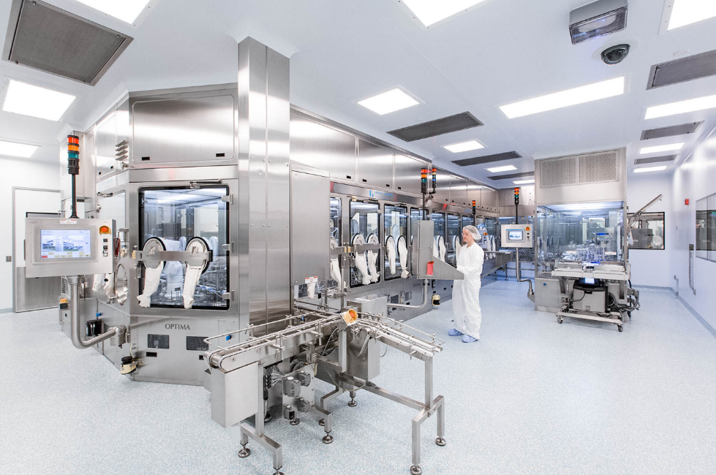
Barrier technologies are indispensable in safe sterile manufacturing. Depending on the customer's circumstances, either RABS or isolators are the right solution.

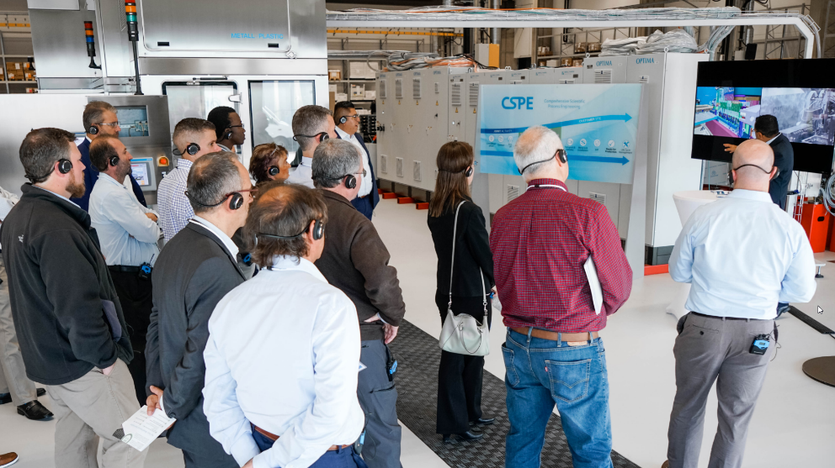
In Optima Pharma and Metall+Plastic, pharmaceutical companies in South America have two experienced partners when it comes to upgrading existing plants or purchasing barrier technologies.

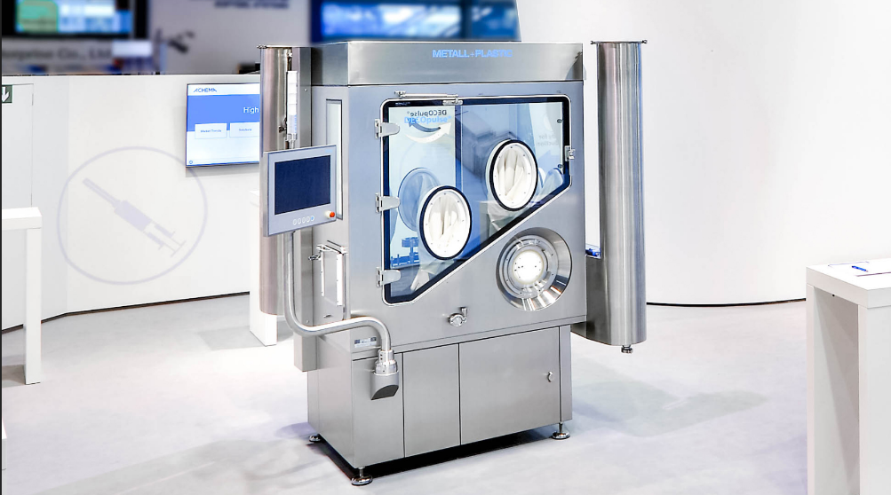
Among other things, the workshops will cover DECOpulse® – a bio-decontamination system that reduces previous cycle times. Metall+Plastic was awarded the Biotech Innovation Award 2019 for this new development.

Characters (incl. spaces): 3,100

Press contact:
OPTIMA packaging group GmbH
Jan Deininger
Editor
+49 (0)791 / 506-1472
jan.deininger@optima-packaging.com
www.optima-packaging.com
Thank you very much for your publication. We look forward to receiving a specimen copy.

