PRESS RELEASE
Schwaebisch Hall, September 08, 2020

A leader in the sustainable packaging of paper hygiene products
AMOTEK at MIAC 2020

At MIAC, Amotek is presenting innovative packaging machines for paper hygiene products. The main focus is on solutions for the most advanced ecological packaging available, made of paper, bio-plastics and other materials which are 100 percent recyclable or biodegradable.
The AMOTEK PB192 is a packaging machine designed to package paper hygiene products in a sustainable and highly efficient way. Rolls of kitchen and toilet paper are packed in materials such as bio-plastics, recycled materials and paper in a fully automated way.
The Amotek developers also attached particular importance to the machine's high energy efficiency. In particular, electricity and compressed air consumption have been significantly reduced. This is the first time that with the AMOTEK PB192 a new, very easy-to-use Human Machine Interface (HMI) has been introduced, which enables interactive, intuitive machine operation. It will also mean that format changes are optimally supported and expedited.
AMOTEK PB192's performance data is persuasive. The machine can be configured for one or two production lines, thereby combining high output with great format flexibility. With a simple format change, more than 100 packaging formats for kitchen and toilet paper rolls can be produced.
Sensors installed in the machine monitor and analyze the packaging processes. The AMOTEK PB192 is available with a new attractive and particularly robust machine frame. Amotek will be presenting these and other exciting features from its range of machines at MIAC.
AMOTEK at MIAC 2020 in Lucca (Italy):
October 14 to 16, booth no. 120A
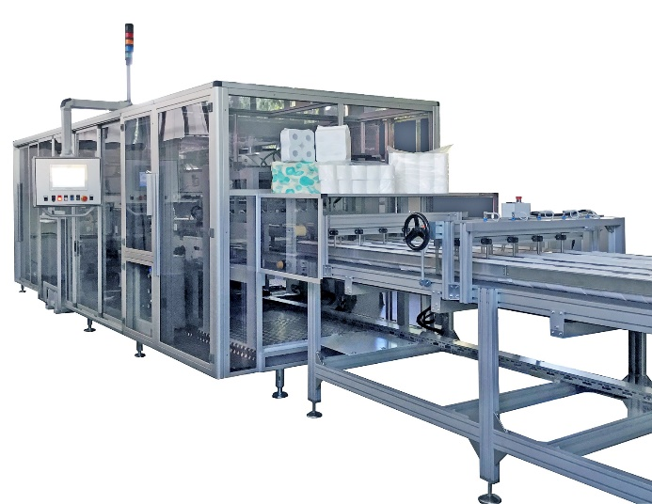
For paper hygiene products: The AMOTEK PB192 delivers highly efficient packaging technology for environmentally friendly packaging of paper, bio-plastics and recycled materials. (Source: Amotek/Optima)

Characters (incl. spaces): 1.527

Press contact:
OPTIMA packaging group GmbH
Jan Deininger
Editor
+49 (0)791 / 506-1472
jan.deininger@optima-packaging.com
www.optima-packaging.com

About OPTIMA
Optima supports companies worldwide with flexible and customer-specific filling and packaging machines for pharmaceuticals, consumer goods, paper hygiene and medical devices markets. As a provider of solutions and systems, Optima accompanies these companies from the product idea through to successful production and throughout the entire machine life cycle. 2,450 experts around the globe contribute to Optima's success. 19 locations in Germany and abroad ensure the worldwide availability of services.

Thank you very much for your publication. We look forward to receiving a specimen copy.

