LAUDA achieves Dualis certification once again

Award for outstanding training quality

Lauda-Königshofen, April 22, 2025 – LAUDA DR. R. WOBSER GMBH & CO. KG has received the prestigious Dualis certification for outstanding training quality for the third time. IHK President Kirsten Hirschmann personally presented the coveted certificate to LAUDA President and CEO Dr. Gunther Wobser during a ceremony at the company's headquarters in Lauda-Königshofen. Training at LAUDA enjoys an excellent reputation in the region and is in high demand among applicants.
The world market leader for precise temperature control is currently training 28 apprentices and dual students, confirming its above-average training rate. “With this outstanding rate, LAUDA is one of the exemplary training companies in our region. However, it is not only the number of junior employees that makes the temperature control specialist an exceptional company, the quality of the training also clearly exceeds the standards,” emphasized Kirsten Hirschmann when presenting the certificate. This is particularly evident in the high regard in which the trainees are held, some of whom are themselves active as training ambassadors at schools.
“Attracting qualified specialists is a particular focus of our activities given the strong regional competition. We are proactively addressing this challenge with our systematic and high-quality training,” highlighted Dr. Mario Englert, CFO at LAUDA, whose area of responsibility also includes human resources. “The Dualis certification is not only an award for us, but also an incentive to further optimize our training concepts and adapt them to changing requirements.”
The family business offers an exceptionally good working atmosphere with collegial cohesion and guarantees intensive support for junior staff. Apprentices and dual students benefit from the wide range of training occupations and courses of study as well as modern workplaces and numerous social benefits. The future-oriented and international focus of LAUDA and the opportunity to work on innovative technologies and processes open up a wide range of perspectives for the professional development of the next generation.
LAUDA has an extensive tradition of excellent training. The company received Dualis certification for the first time on July 30, 2014, followed by recertification in 2017. The 2025 award confirms the continuous development of training quality at the family-owned company.
“For us, training young people is a key component of our corporate philosophy and our strategy for the future,” explained Dr. Gunther Wobser during the certificate presentation. “The renewed Dualis certification confirms our path and motivates us to continuously develop training at LAUDA. Highly trained specialists are the foundation of our global success.”
In the course of past audits, LAUDA has continuously implemented the IHK's suggestions for optimization. For instance, special checklists were introduced for the operational departments based on the factual and temporal structure, and a structured feedback culture with corresponding feedback forms was established. The setting up of contact persons for trainees, regular exchange meetings for those responsible for training and the implementation of projects initiated and carried out by trainees are also based on recommendations from previous certifications.

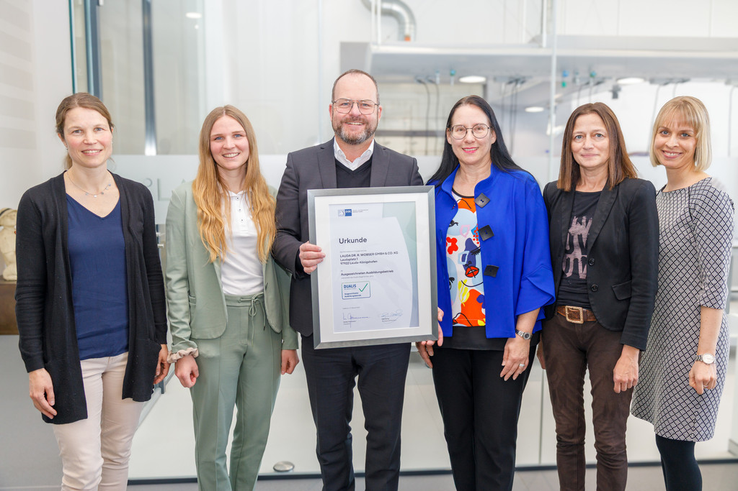

Picture: Dr. Gunther Wobser (third from left), President & CEO of global market leader LAUDA, received the prestigious Dualis certification from IHK President Kirsten Hirschmann (third from right) for outstanding training quality. The project and training managers of LAUDA (from left) Carmen Diez, Selina Ebert and Sandra Braun, Director Human Resources, as well as Lisa Feuchtenbeiner as representative of the Heilbronn-Franken Chamber of Industry and Commerce were present at the award ceremony. © LAUDA

We are LAUDA – the world leader in precise temperature control. Our constant temperature equipment and systems are at the heart of important applications, contributing to a better future. As a complete one-stop supplier, we guarantee the optimum temperature in research, production and quality control. We are the reliable partner for electromobility, hydrogen, chemicals, pharmaceuticals/biotech, semiconductors and medical technology. We have been inspiring our customers for almost 70 years with our expert mentoring and innovative solutions – every day anew and all over the world.

In our company, we always go one step further. We support our employees’ development and are constantly developing ourselves: to create a better future together.

Press contact
We are more than happy to make prepared information about our company, the LAUDA Factory Gallery and our projects in the area of innovation promotion, digitalization and idea management available to the press. We look forward to hearing from you – just give us a call!

CHRISTOPH MUHR
Director Corporate Communications
T + 49 (0) 9343 503-349
christoph.muhr@lauda.de

LAUDA DR. R. WOBSER GMBH & CO. KG, Laudaplatz 1, 97922 Lauda-Königshofen, Deutschland/Germany. Limited partnership: Headquarters Lauda-Königshofen, Registration court Mannheim HRA 560069. General partner: LAUDA DR. R. WOBSER Verwaltungs-GmbH, Headquarters Lauda-Königshofen, Registration court Mannheim HRB 560226. Managing Directors: Dr. Gunther Wobser (President & CEO), Dr. Mario Englert (CFO), Dr. Marc Stricker (COO)

