PRESS RELEASE
March 2022

Available now for BMW M3 (G80) and BMW M4 (G82):
Compression and rebound adjustable KW V3 coilover suspension kit

KW automotive, the suspension manufacturer, introduces more adjustable coilover suspension kits for the latest BMW M3 (G80) sedan and the BMW M4 (G82) coupe. Alongside the KW V4 coilover suspension with three-way adjustable dampers, the two-way adjustable KW V3 coilover suspension kit is now available. Offering a preset sporty and harmonious base setup, the KW V3 can be individually adjusted in compression and rebound damping separately. Depending on the adjustment, this provides the BMW M3 Sedan and the BMW M4 Coupé with a sporty or a more comfortable road behavior. Additionally, the coilover suspension kit enables a seamless lowering at the front axle of 20 to 35 millimeters and at the rear axle of 15 to 30 millimeters in the range of the parts certificate. The KW V3 coilover suspension kit is available for the BMW M3 (G80) and BMW M4 (G82) models with rear-wheel drive. In development already are the KW V5 Clubsport coilover suspension kit as well as the electronically adjustable KW DDC plug&play coilover suspension. The KW V3 will also be available for the xDrive variants of the two BMW M models soon. More at www.kwsuspensions.net

Since its introduction to the market, the KW V3 coilover suspension kit has become the best-selling application of the suspension manufacturer KW automotive. With all KW suspensions coilovers from the "Street Performance" product category, the base suspension setup is always designed to be as stiff as necessary and as comfortable as possible and is pre-set during production to match the best possible suspension setup for the specific vehicle. In the popular KW V3, the suspension manufacturer uses an advanced multi-valve technology to set up this KW coilover suspension. It also allows the customer manually to adjust the KW V3 independently in the Low-speed compression stage with twelve clicks and the Low-speed rebound stage with 16 clicks, if preferred. Immediately, the KW V3 is also available for the BMW M3 (G80) sedan and the BMW M4 (G82) coupe. Within the scope of the parts certificate, the adjustable lowering range of the KW V3 coilover suspension is 20 to 35 millimeters at the front axle and 15 to 30 millimeters at the BMW M3 rear axle.

Customized driving behavior can be set intuitively

"Anyone who wants to make their BMW M even sportier with a KW V3 coilover suspension can adjust the preset setup of their KW V3 in just a few simple steps. Every KW suspension kit always includes adjustment instructions for this purpose," explains Florian Johann from KW Brand Management. "If you want to drive your BMW M even in a sportier way, you can adjust the preset setup of your KW V3 in just a few steps. It's not even complicated." The adjustment wheel at the top end of the piston rod makes it easy to adjust the valve cross-section that influences the low-speed rebound valve in the shock absorber. The rebound stage influences how the body is connected to the road. If the valve cross-section of the rebound stage is closed, the handling in the BMW M3 Sedan and BMW M4 Coupé becomes more direct, which significantly reduces body vibrations. Also, the steering precision improves noticeably without causing any unrest in the chassis. Regardless of the rebound damping, the KW V3 coilover suspension offers the option of adjusting the compression damping forces further to suit individual preferences. Higher compression forces on the front axle ensure even more direct steering, while higher compression forces on the rear axle influence oversteer. During abrupt spring deflection, such as when driving over bumps, the preconfigured high-speed compression damping allows rapid compression and prevents the tire from losing grip. "A BMW M3 (G80) sedan or BMW M4 (G82) coupe with the KW V3 coilover suspension kit has much more direct handling. The advantage with our damper technology is that the suspension does not seem so bumpy and uncomfortable, as is always the case with one or the other sports suspension," continues Florian Johann. "Basically, the KW V3 is similar in its tuning and design philosophy to the BMW M Performance suspension we developed for BMW M for the BMW M3 (F80) and BMW M4 (F82)." In the M3 sedan and M4 coupe, the KW V3 provides a much sportier driving experience, and the typical oversteering of modern vehicles becomes much more neutral and easier to control. Also, the KW coilover suspension kit provides a much sportier ride with convincing remaining ride comfort - and this even at maximum lowering. While the KW V3 is still under development for the xDrive variants of the BMW M3 (G80) and BMW M4 (G82), the KW V4 is available for the sedan and coupe, for example. More at www.kwsuspensions.net

Available now for BMW M3 (G80) and BMW M4 (G82):
Compression and rebound adjustable KW V3 coilover suspension kit

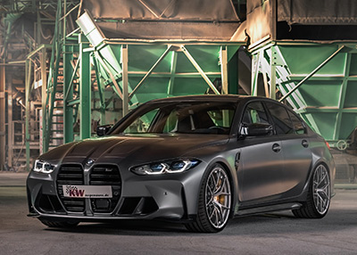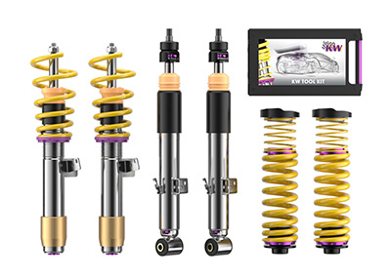

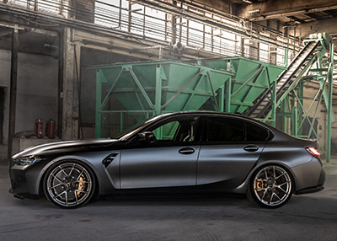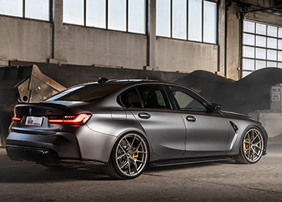

About KW automotive:

The KW entrepreneurial group includes the suspension manufacturer KW automotive with its brands KW suspensions, ST suspensions, ap Sportfahrwerke, as well as the SimRacing brands TrackTime and Ascher Racing. With its immense suspension portfolio, state-of-the-art production technology and its development and test center, KW successfully operates in all markets for more than 25 years. Over the past years, KW automotive has developed over 16 distinct damping technologies in order to fulfill its own requirement of supplying "the perfect suspension for every demand". Beside its core business, the development and production of manually and adaptively adjustable coilover kits and other suspension components for the aftermarket as well as the range of accessories of various automobile manufacturers in the premium segment, the business field of original equipment for special models and super sports cars of the automotive industry is developing tremendously positively for the German suspension manufacturer. Since KW is a development partner of sophisticated controlled suspension systems, the manufacturer disposes of the entire product portfolio of hydraulics, electronics, sensor technology, control units and damper control systems as well as the necessary know-how for the application and tuning of complex vehicle performance systems from a single source. KW has become an indispensable part of customer motor sports throughout the past years and produces homologated racing dampers and suspensions for a constantly growing number of racing cars of several manufacturers. Worldwide, successful racing teams rely on the patented valve technology of KW Competition suspensions. The entrepreneurial group has subsidiaries in the most significant markets, such as Belgium, Great Britain, China, Japan, Switzerland, Taiwan and the USA. 360 employees from the 1200 employees worldwide of the Group are located at the headquarters in Fichtenberg. Software and hardware solutions are further business segments as well as events for virtual motor sports in the scope of the brand RaceRoom. Equally, the suspension manufacturers AL-KO Damping Unit, Belltech and Reiger Suspension as well as the alloy wheels manufacturer BBS are brands of the KW entrepreneurial group.

Publication for free / copy requested

This press release can also be found at www.tuningpress.com

Contact und Copy Address:
MediaTel Communication & PR, Haldenweg 2, 72505 Krauchenwies-Ablach, Germany
Tel.: +49/7576/9616-12, E-Mail: presse@mediatel.biz

Press Contact:
Christian Schmidt, E-Mail: Christian.Schmidt@kwautomotive.de, Tel. +49/7971/9630-547
KW automotive GmbH, Aspachweg 14, 74427 Fichtenberg, Germany, Web: www.kwsupensions.net
Facebook: www.facebook.com/KWsuspensions.net, KW suspensions at the KW Blog: http://blog-de.kwautomotive.net/

