Award for new gelcoat technology with 20 times better UV resistance

LAMILUX Sunsation® wins the AVK Innovation Prize 2022

The industry association Verstärkte Kunstoffe (Reinforced Plastics), or AVK for short, awards innovations in the field of fibre-reinforced plastics (GRP)/composites every year. The winners of the coveted and highly recognised innovation prize were selected on 29 November 2022 in Augsburg during the JEC Forum DACH. Among the winners: LAMILUX Sunsation®. LAMILUX Composites takes first place in the "Innovative Products and Applications" category with its novel gelcoat technology.

The top-class expert jury, comprising engineers, scientists and specialist journalists, honoured three composite innovations for 2022 in each of the three categories "Products and Applications", "Processes and Procedures" and "Research and Science". LAMILUX Composites GmbH received first place in the "Innovative Products and Applications" category with LAMILUX Sunsation®.

LAMILUX Sunsation®, the new gelcoat technology, has been officially available since 1 August 2022. With LAMILUX Sunsation®, the manufacturer of glass fibre-reinforced plastics (GRP) is showcasing the world's most colour- and gloss-resistant GRP face sheet and one of the most revolutionary developments in the world of glass fibre-reinforced plastics.

LAMILUX Sunsation® offers up to 20 times better UV resistance for exterior applications, including in the caravan, commercial vehicle, container and trailer sectors. The UV protection technology incorporated into the GRP material is therefore much more durable, requires less care and also thereby increases the resale value. In addition, the jury of the AVK Innovation Prize were convinced that LAMILUX attaches great importance to production carried out in a resource- and energy-efficient as well as environmentally friendly manner.

"LAMILUX Sunsation® is not a polish, cream or wax, but an UV protection technology that is firmly integrated into the GRP material. This means that nothing has to be applied at a later stage," explains Senior Product Manager Sascha Oswald. He continues: "LAMILUX Sunsation® sets new standards in the quality of glass-fibre-reinforced plastics, because even after years in the sun, the surface still looks like new. Reaching first place in the AVK Innovation Prize 2022 confirms our developments and encourages us to continue to put the customer benefit at the heart of our actions."

About the AVK Innovation Prize
One goal of the Innovation Prize is to promote new products and applications made of fibre-reinforced plastics (GRP) and to promote new processes and procedures for the manufacture of these GRP products. In all categories, particular importance is attached to the topic of sustainability. An important goal is to honour the innovations and the companies/institutions behind them and thus to showcase the capacity of the entire composites industry to the broader public. The submissions are evaluated by a top-class jury of experts from the field of composites.

…

www.lamilux.com

About LAMILUX Composites GmbH
LAMILUX Composites GmbH has been producing fibre-reinforced plastics for around 70 years. The medium-sized company is a leading European producer thanks to its technologically advanced continuous production process, large manufacturing capacities and wide product range. LAMILUX supplies customers around the globe in a wide range of sectors, such as the building industry, the automotive and recreational vehicle sectors, refrigerated store room and cell construction, and many other industrial sectors. With more than 1250 employees, LAMILUX generated a turnover of 335 million euros in 2021. The family-managed company is based in Rehau, Bavaria.

Image description
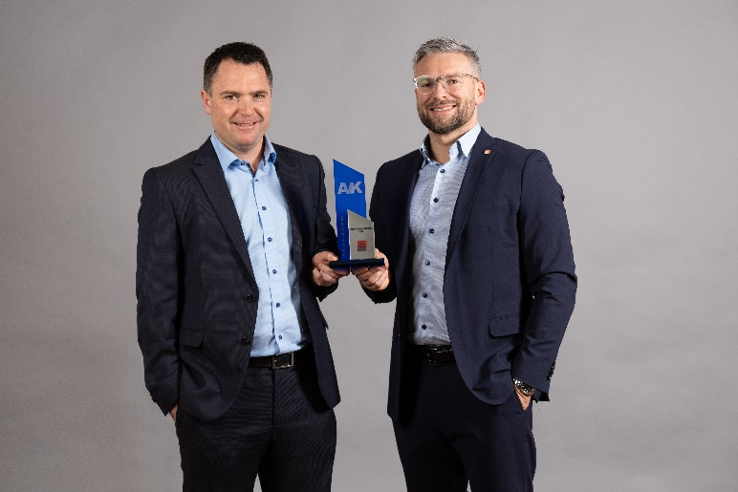
f.l.t.r.: Markus Bächer, Marketing Manager at LAMILUX Composites GmbH, and Sascha Oswald, Senior Product Manager at LAMILUX Composites GmbH, received the award 29 November 2022 in Augsburg.

