**PRESS INFORMATION**

November 2022

**KW automotive group presents a broadly based motorsport**

**and accessory program at the Essen Motor Show 2022**

**For the 30th anniversary, the medium-sized company presents its latest accessory and motorsport program and many more aspects of its brands KW suspensions, ST suspensions, ap Sportfahrwerke, Reiger Suspension, BBS light-alloy wheels, and their SimRacing products at the Essen Motor Show. Highlights at the BBS and KW fair booth (hall 3, booths 3A47 and 3B46) is a VW ID. Buzz which is equipped with a KW coilover kit and BBS wheels. Moreover, the BMW M4 GT3 with KW V6 Racing dampers from incumbent DTM champion Sheldon Van der Linde can be marveled at. From December 3 to December 11, 2022 (Preview Day on December 2, 2022) KW automotive gives an overview of its OE activities, motorsport program, and newest product developments. Especially the new and customizable BBS Unlimited wheel system will be in the spotlight. At the Essen Motor Show, BBS also presents the new BBS RT Unlimited which is a part of the Classic design line. More information at** [**www.kwautomotive.net**](http://www.kwautomotive.net)

In 2022, the KW automotive group celebrated its 30th anniversary. Since 1995, the coilover manufacturer is an exhibitor at the Essen Motor Show. For KW, the fair in the German Ruhr area is one of the most important events of the year. “To us, the EMS is the most important industry get-together to meet both retailers and customers at one place” Bernd Lauton, KW head of sales for Germany and Austria says. “At our BBS and KW fair booth, we show our latest projects and give a preview of the KW products that will be released soon such as the BBS Unlimited wheel system, the KW Clubsport coilovers with MacPherson upside-down struts and inverted monotube, KW V3 Leveling, and many more products.”

The success of the motorsport year for the KW automotive group is illustrated by the displayed BMW M4 GT3 which was driven in the DTM 2022 by the DTM champion Sheldon Van der Linde. For several years, the KW automotive group is a pioneer in the development of individual coilover systems for street and motorsport usage. With its brands BBS, KW, and Reiger Suspension, the medium-sized company from the German Fichtenberg is globally active. In almost every DTM motorsport series, several brand trophies, NASCAR, and the World Rally Championship, KW motorsport components were used. In 2022, Rallye- and Rally Raid vehicles were equipped with Reiger Offroad motorsport coilovers in the WRC, W2RC and Dakar. The new Reiger suspension street & trail dampers celebrate their premiere at the Essen Motor Show 2022 as well. Those are special offroad dampers for SUVs and off-road vehicles with street permission. The exhibition appearance of the KW automotive group is completed by excerpts of the OE program as well as many small and large product highlights at ap Sportfahrwerke, ST suspensions, Ascher Racing, and Track Time. More information at [www.kwautomotive.net](http://www.kwautomotive.net)

**Publication for free / copy requested**

This press release can also be found at www.tuningpress.com

**Contact und Copy Address:**

MediaTel Communication & PR, Haldenweg 2, 72505 Krauchenwies-Ablach, Germany

Tel.: +49/7576/9616-12, E-Mail: presse@mediatel.biz

**Press Contact:**

Christian Schmidt, E-Mail: Christian.Schmidt@kwautomotive.de, Tel. +49/7971/9630-547

KW automotive GmbH, Aspachweg 14, 74427 Fichtenberg, Germany, Web: www.kwsupensions.net

Facebook: www.facebook.com/KWsuspensions.net, KW suspensions at the KW Blog: http://blog-de.kwautomotive.net/

**KW automotive group presents a broadly based motorsport**

**and accessory program at the Essen Motor Show 2022**

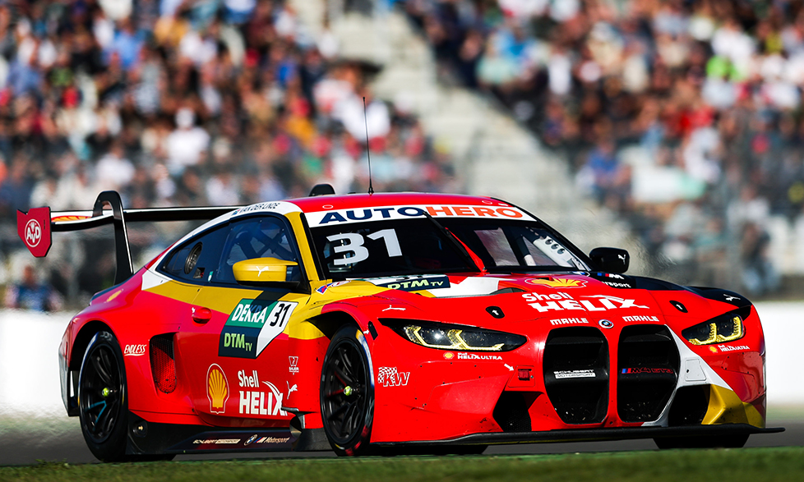 Ein Bild, das drinnen enthält.

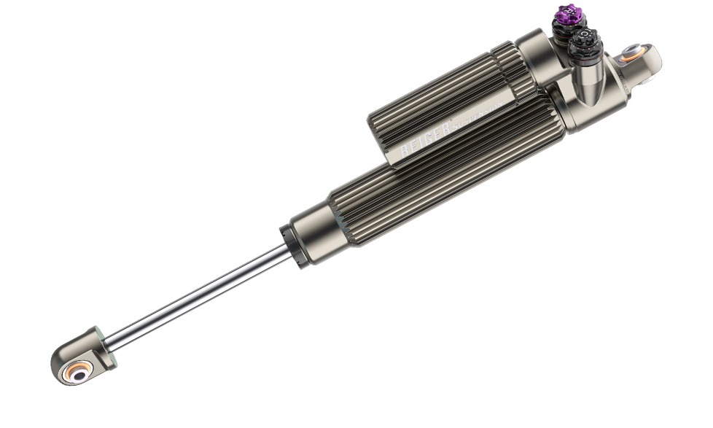 Ein Bild, das Rad enthält.

**About KW automotive**

The KW entrepreneurial group includes the suspension manufacturer KW automotive with its brands KW suspensions, ST suspensions, ap Sportfahrwerke, as well as the SimRacing brands TrackTime and Ascher Racing. With its immense suspension portfolio, state-of-the-art production technology, and development and test center, KW successfully operates in all markets for more than 25 years. Over the past years, KW automotive has developed over 16 distinct damping technologies to fulfill its requirement of supplying "the perfect suspension for every demand". Besides its core business, the development and production of manually and adaptively adjustable coilover kits and other suspension components for the aftermarket as well as the range of accessories of various automobile manufacturers in the premium segment, the business field of original equipment for special models and super sports cars of the automotive industry are developing tremendously positively for the German suspension manufacturer. Since KW is a development partner of sophisticated controlled suspension systems, the manufacturer disposes of the entire product portfolio of hydraulics, electronics, sensor technology, control units, and damper control systems as well as the necessary expertise for the application and tuning of complex vehicle performance systems from a single source. KW has become an indispensable part of customer motorsports throughout the past years and produces homologated racing dampers and suspensions for a constantly growing number of racing cars from several manufacturers. Worldwide, successful racing teams rely on the patented valve technology of KW Competition suspensions. The entrepreneurial group has subsidiaries in the most significant markets, such as Belgium, Great Britain, China, Japan, Switzerland, Taiwan, and the USA. 360 employees from the 1200 employees worldwide of the Group are located at the headquarters in Fichtenberg. Software and hardware solutions are further business segments as well as events for virtual motorsports in the scope of the brand RaceRoom. Equally, the suspension manufacturers KW Damping Unit, S.A. (AL-KO Damping Unit), Belltech, and Reiger Suspension as well as the alloy wheels manufacturer BBS are brands of the KW entrepreneurial group. [www.kwsuspensions.net](http://www.kwsuspensions.net)

**Publication for free / copy requested**

This press release can also be found at www.tuningpress.com

**Contact und Copy Address:**

MediaTel Communication & PR, Haldenweg 2, 72505 Krauchenwies-Ablach, Germany

Tel.: +49/7576/9616-12, E-Mail: presse@mediatel.biz

**Press Contact:**

Christian Schmidt, E-Mail: Christian.Schmidt@kwautomotive.de, Tel. +49/7971/9630-547

KW automotive GmbH, Aspachweg 14, 74427 Fichtenberg, Germany, Web: www.kwsupensions.net

Facebook: www.facebook.com/KWsuspensions.net, KW suspensions at the KW Blog: http://blog-de.kwautomotive.net/