GEA partner in the EU project “Exquisheat”: Decarbonization of the food industry through heat pump technology

Duesseldorf (Germany), November 20, 2025 – GEA, a leader in industrial heat pump technology, is an official partner of the European Union's “Exquisheat” project (EU). The three-year EU-funded project aims to accelerate the decarbonization of the European food and beverage industry by developing standardized heat pump solutions. Over a period of three years, eight other partners will join GEA in analyzing industrial processes and developing solutions for key applications in the food industry, such as pasteurization, evaporation, and cooling.

The consortium includes players from the food and heat pump industries, as well as energy experts and auditors who are very familiar with the market situation. Associations will serve as multipliers to disseminate the project findings within their networks, thus enabling direct market introduction. Furthermore, a roundtable platform will be established for concrete cooperation between players from the food and beverage industry and suppliers of heat pump technology.

Important contribution to achieving the goals of the European Union's Net Zero Industry Act

By connecting technology providers and end users, the project makes a direct contribution to the EU's Strategic Energy Technology Plan (SET Plan) and supports the goals of the Net Zero Industry Act (NZIA, Regulation 2024/1735 on net-zero technologies), which aims to increase production capacity for net-zero technologies in the EU. These technologies are intended to drive forward the energy transition. By 2030, the EU should be able to cover at least 40 percent of its annual demand for net-zero technologies (NNT) itself. This will make the EU's climate and energy targets for 2030 and the climate neutrality target for 2050 more achievable. This should make the European economy more competitive, create high-quality jobs, and reduce the EU's energy dependence.

Already GEA's third EU heat pump project

Isabel Osterroth, GEA Senior Director Sustainable Engineering Solutions, and Kenneth Hoffmann, GEA Heat Pump Application Director, have been appointed by the EU to the expert panel of the “Exquisheat” project. For GEA, this is already the third high-profile EU project following the development of a heat pump using the natural refrigerant ammonia (2017) and the development and commissioning of a high-temperature heat pump for Südzucker subsidiary Tiense Suiker in 2025 (EU Spirit project) for the economical use of industrial waste heat. “The respective expert commissions for all three projects have selected GEA as a partner because we are an experienced manufacturer of customized high-temperature heat pumps for optimized efficiency and a wide temperature and performance range,” says Kenneth Hoffmann. He adds: “Germany is set to be climate neutral by 2045, and the European Union by 2050. These are goals and associated challenges that require profound changes in heating and overall energy supply, especially for industrial companies. GEA heat pump solution is an important technology enabler here.”

Use of heat pumps in the food and beverage industry very promising

"The food and beverage industry is one of the most promising sectors for the integration of heat pumps due to its high heat demand, waste heat potential, and continuous production cycles. We are convinced that sustainable heat from heat pumps that use industrial waste heat will make an important contribution to the decarbonization of the European food industry," continues Isabel Osterroth, "Thanks to our GEA NEXUS approach, which combines our in-house food & beverage processing expertise with advanced heat pump and cooling solutions, we are already helping a wide range of food and beverage customers decarbonize their processes. This demonstrates that heat pumps are a proven technology for heat decarbonization."

Clear roadmap for 36 months “Exquisheat”

Isabel Osterroth and Kenneth Hoffmann explain the roadmap for the next 36 months. "It will ensure effective coordination between all partners while analyzing industrial processes to determine where the integration of heat pumps can have the greatest impact. Based on this work, the consortium will develop standardized solutions for four main areas of application: sanitary hot water, pasteurization, evaporation and cooling." In parallel, the partners will carry out awareness-raising and stakeholder engagement activities and organize workshops and interviews with representatives of the food industry and heat pump suppliers. This exchange will help identify market barriers and jointly develop solutions that meet actual industrial requirements. To ensure long-term impact, the project will also develop business models, replication studies, and user-friendly tools, including practical guides and an online checklist to help companies assess the feasibility of integrating heat pumps into their processes. Comprehensive dissemination and communication measures will ensure that the project's results reach a wide audience across Europe, raising awareness of industrial heat pump technologies and promoting their adoption.

Background information

Nine partners in the Exquisheat project

The Exquisheat project partners are GEA, Veolia, Dr. Jacob Energy Research GmbH & Co. KG, European Heat Pump Association, National Energy Conservation Agency, AIT Austrian Institute of Technology GmbH, Food-Processing Initiative e.V., Asociacion Cluster Alimentario de Galicia, Clivet S.p.a.

https://ehpa.org

The EU's Net-Zero Industry Act (NZIA) – a tool for manufacturing clean technologies

The EU's Net-Zero Industry Act (NZIA) is a regulation that aims to increase the manufacture of clean technologies within the EU to cover at least 40% of annual demand by 2030. Key measures include simplifying approval procedures for strategic projects, promoting innovation through regulatory sandboxes, encouraging public procurement of sustainable products, and attracting investment through platforms such as Net-Zero Europe. The goal is to strengthen Europe's competitiveness, create jobs, and improve energy security by reducing dependence on external supply chains.
“Exquisheat” on social media

LinkedIn: https://www.linkedin.com/company/exquisheat/about/?viewAsMember=true
- X (Twitter): https://x.com/exquisheat_eu
- YouTube: https://youtube.com/@exquisheateuproject?si=wkEqKc-hBLs7eIZC

Photos:

Photo 1:

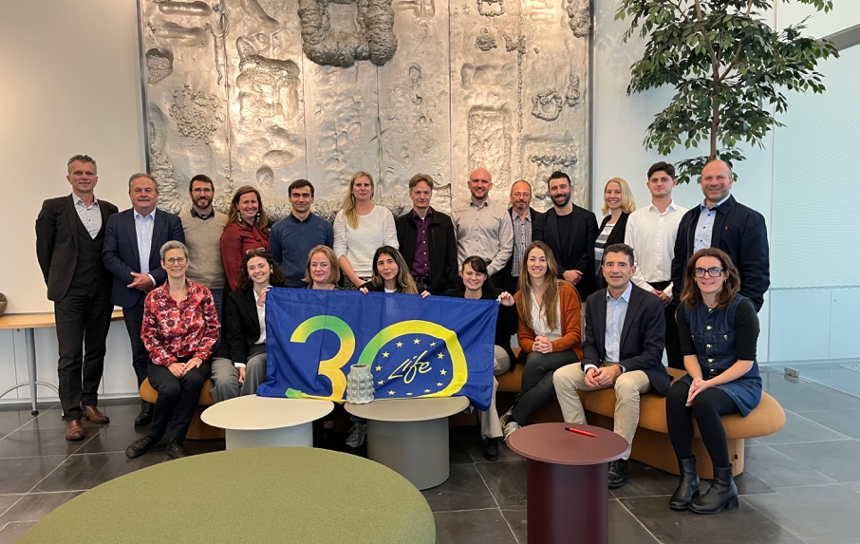

Photo 1, caption: The EU project “Exquisheat” was launched in Brussels in October 2025. Nine partners from six European countries are working on the 36-month project to determine where heat pumps can achieve the greatest efficiency gains in the food and beverage sector and to develop reproducible and market-ready solutions. (Photo: EU project Exquisheat)

Photo 2:

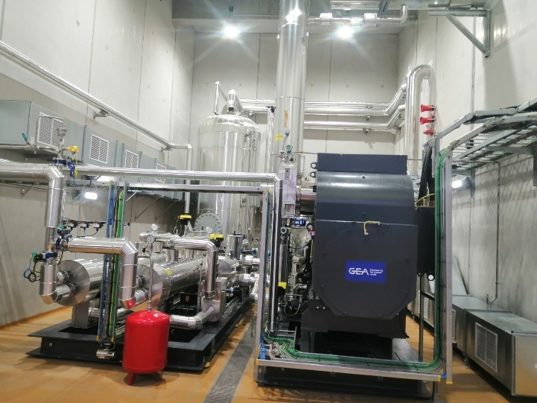

Photo 2, caption: For GEA, this is already the third high-profile EU project following the development of a heat pump using the natural refrigerant ammonia (2017) and the development and commissioning of a high-temperature heat pump for Südzucker subsidiary Tiense Suiker in 2025 (EU Spirit project, photo) for the economical use of industrial waste heat. (Photo: GEA)

Graphic:

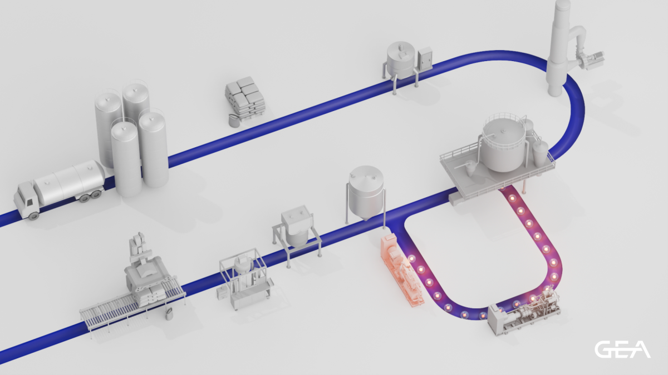

Graphic: Caption: Heat pump: a key enabler in GEA NEXUS Holistic Engineering Solutions, driving decarbonization across food & beverage production.(Graphic: GEA)

About GEA
GEA is one of the world’s largest suppliers of systems and components to the food, beverage and pharmaceutical industries. The international technology group, founded in 1881, focuses on machinery and plants, as well as advanced process technology, components and comprehensive services. For instance, every second pharma separator for essential healthcare products such as vaccines or novel biopharmaceuticals is produced by GEA. In food, every fourth package of pasta or every third chicken nugget are processed with GEA technology. With more than 18,000 employees, the group generated revenues of about EUR 5.5 billion in more than 150 countries in the 2024 fiscal year. GEA plants, processes, components and services enhance the efficiency and sustainability of customers’ production. They contribute significantly to the reduction of CO2 emissions, plastic usage and food waste. In doing so, GEA makes a key contribution toward a sustainable future, in line with the company’s purpose: ”Engineering for a better world.”

GEA is listed on the DAX, the STOXX® Europe 600 Index and is also a constituent of the leading sustainability indices DAX 50 ESG, MSCI Global Sustainability and Dow Jones Best-in-Class World.

More information can be found online at gea.com.
If you do not want to receive any further information from GEA, please send an e-mail to pr@gea.com.

NOTE TO EDITORS

- Further information about GEA
- To the GEA Press page
- To the GEA Media Center
- Background information on current topics can be found at Features
- Follow GEA on  

GEA
Media Relations GEA
Dr. Michael Golek
Ulmenstraße 99, 40478 Düsseldorf
Phone +49 211 91361505
Tel. +491736205746
michael.golek@gea.com

