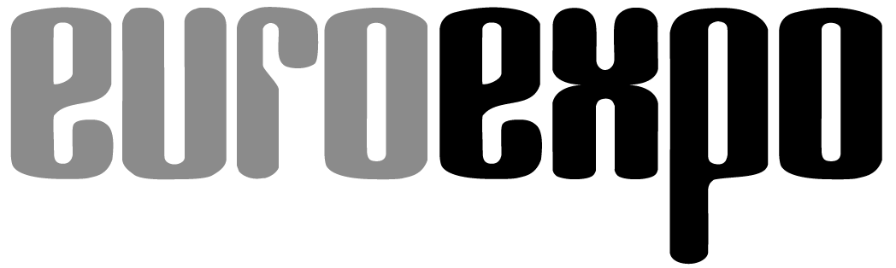
Messe- und Kongress-GmbH
Joseph-Dollinger-Bogen 7
D-80807 Munich, Germany
Phone: +49 89 32 391 259
Fax: +49 89 32 391 246
www.euroexpo.de
www.logimat-messe.de
www.logimat.digital

Munich, March 17, 2021

Press Release

LogiMAT now with digital intralogistics community

Munich-based EUROEXPO Messe- und Kongress-GmbH—which organizes LogiMAT, the International Trade Show for Intralogistics Solutions and Process Management—is bringing exhibitors and industry professionals together online at its new digital matchmaking platform. LogiMAT.digital serves as a bridge until the next live LogiMAT in Stuttgart, March 8–10, 2022.

Munich, March 17, 2021—The organizer of the LogiMAT trade show, EUROEXPO Messe- und Kongress-GmbH, is providing its exhibitors and visitors with a professional information and communications platform. Instead of a virtual event, EUROEXPO has opted for a year-round interactive solution. “Our exhibitors have made it very clear to us that in this day and age, they want to use digital solutions—but they’ve made it equally clear that they reject a virtual trade show,” explains Michael Ruchty, Exhibition Director of LogiMAT in Stuttgart. “That's why we decided to think big and develop a year-round LogiMAT platform for participants to network and generate new business—a forum that breaks new ground with interactive formats addressing exciting core issues of intralogistics.”

The LogiMAT.digital platform is available to participants from April 2021 through March 2022 and will feature regular expert talks, workshops, presentations, and lecture series during this time. “Supported by subject matter experts, we’ll be offering the digital LogiMAT community a range of exciting content each month,” explains Peter Kazander, Managing Director of EUROEXPO.

More than 1,200 exhibitors from around the world have already registered for the LogiMAT live trade show in March and will be able to use the LogiMAT.digital platform for their company and networking profiles, presentations, roundtables, workshops, lectures, information, and press conferences. At the heart of the platform, Kazander explains, is AI-powered interactive matchmaking with an integrated chat feature and livestreaming, so exhibitors can generate leads through direct, real-time connections to prospective business partners.

“Media representatives and our long-standing business and academic partners can also feature their own content,” Ruchty says. This helps them reach LogiMAT visitors from previous events and other interested parties during the entire period of up to twelve months.

All livestreaming and matchmaking features on the LogiMAT.digital platform will go live by April 2021. April 22 is the launch date. “On that day we will open the virtual gates to industry professionals from around the world. The first sessions are scheduled for May 3 and 4,” says Kazander.

For detailed information about the platform and the various registration packages, please visit: www.logimat.digital

Organizer: EUROEXPO Messe- und Kongress-GmbH
Joseph-Dollinger-Bogen 7 | 80807 Munich, Germany
Phone: +49 89 32 391 259 | Fax: +49 89 32 391 246
www.logimat-messe.de | NEW: www.logimat.digital

2,764 characters (with spaces)

Munich, March 16, 2021—This text may be reprinted free of charge, but please send a copy to EUROEXPO Messe- und Kongress-GmbH, Press and Public Relations Department, 80912 Munich.

