PRESS RELEASE
Schwaebisch Hall, December 15, 2022

Annual Review 2022

A successful year for OPTIMA
The OPTIMA group can look back on an anniversary year full of highlights and exciting developments

In 2022, the Optima Group celebrated its 100th anniversary with numerous guests including Minister President Winfried Kretschmann. Headquartered in Schwaebisch Hall, Germany, the company is looking back on a century of innovation, expansion, partnership and responsibility.
For Optima, 2022 was all about the company's 100th anniversary year with the tagline "100 Years of Future". This was accompanied by a number of activities and events that were held throughout the year. As part of this, the new pharma division facility was inaugurated in Schwaebisch Hall's Solpark industrial park. The production facility featuring cutting-edge technology represents another milestone for Optima and provides the ideal conditions for assembling, commissioning, qualifying and approving pharmaceutical filling systems.
Expansion: OPTIMA is investing in the Schwaebisch Hall headquarters
"This investment is once again reaffirming our commitment to the Schwaebisch Hall site and, even in uncertain times, we are creating the conditions for continued growth and new jobs with confidence," says Hans Buehler, Managing Director/CEO of the Optima Group. The Baden-Wuerttemberg Minister President, Winfried Kretschmann, made a special trip to the company's 100th anniversary celebrations to see for himself the facilities that are so crucial in the fight against the COVID-19 pandemic. "Companies like Optima are beacons. They embrace every challenge, are constantly reinventing themselves and continue to put their heart and soul into their work – and have done so for 100 years. When it comes to the process of transformation that is so profoundly shaping our economy, digitalization and sustainability, they have taken up the reins, and in doing so have given Baden-Wuerttemberg a boost as a location for innovative companies," said the Minister President in his address.
The Consumer Business Unit also received a lot of big orders in 2022, which requires a lot of space for the complex systems needed. To do this, additional space has been leased, including the former solar factory in Schwaebisch Hall's Solpark industrial park. To handle a historically large order in the food sector with several filling and packaging assembly lines, Optima specially refurbished the building extensively and created optimal working conditions.
Expansion: Expanding the service coverage in North America
In addition, Optima is continuing to expand its service coverage around the world. One example of this is Optima Pharma's new service hub, which opened mid-year in Raleigh, North Carolina. The company is offering comprehensive on-site services, equipment and spare parts sales as well as comprehensive training programs. With these measures, Optima offers customers even better and faster support, both remotely and directly on site.
Responsibility: In 2022, OPTIMA underscores its sustainability ambitions
As part of the company's 100th anniversary, the sustainability strategy entitled "We care for tomorrow" was published in mid-2022. It centers on three pillars – developing genuine packaging for a fully functioning circular economy together with customers, using sustainable machinery and systems to manufacture efficiently and preserve resources, and becoming excellent in the areas of environment, social affairs and corporate governance. Optima has also entered into a strategic partnership with the company Weyhmueller – for more sustainable packaging development and production. This means that Optima can offer its customers complete solutions in order to package products more sustainably.
In late 2022, the EcoVadis rating agency awarded Optima the silver medal for this overall commitment. This places the Optima Group in the top 25 percent of the companies rated by EcoVadis. The areas assessed were the environment, labor and human rights, ethics and sustainable commitment. Optima's sustainability strategy is assessed annually by EcoVadis to identify new potential initiatives and promote existing activities.
Responsibility: Local solidarity through youth development
Optima is also aware of its responsibility to the region where it is located. That is why the Optima kit deal was created to mark the milestone anniversary. Optima raffled off 100 complete sets of kit to youth teams from all sporting disciplines from the Schwaebisch Hall and Hohenlohe areas. At a Schwaebisch Hall Unicorns soccer match, the kits were ceremoniously handed over. The event brought in almost 700 players from regional youth teams and their coaches to Schwaebisch Hall.

Optima is offering young people future-proof, multi-faceted apprenticeships and student placements. On average, Optima employs over 150 trainees and students every year.

Innovation: OPTIMA is continuing to develop fuel cell manufacturing technology and is receiving state funding
Optima 2022 has also invested boldly in research and development and launched innovative solutions. This year, research has continued into the automated production of fuel cells. This also makes Optima a provider of complete solutions for manufacturing fuel cells. As a consequence of climate change, hydrogen-powered fuel cells are being hailed as the climate-neutral drive technology of the future. The German state of Baden-Wuerttemberg is funding the construction of a new test facility in Schwaebisch Hall with money from the Future Hydrogen Program BW. Baden-Wuerttemberg is looking to become a pioneer in hydrogen and fuel cell technologies.
Outlook: Embracing change as an opportunity
In many respects, people are currently talking more than ever about a turning point in history that is presenting a challenge to the entire economy and all of society. "Today it's all about continuing to work together to shape the future – whether in terms of new markets and issues like digitalization and sustainability or our highly valued, trust-based cooperation with our customers and across the entire Optima Group. With all the opportunities and risks globalization brings, it continues to be in a state of constant flux. Many things that were taken for granted until now are beginning to falter, and we are becoming aware that everything happening in this world has diverse ramifications for each and everyone of us. We will continue together to do everything in our power to shape Optima's future in a safe, flexible and innovative way," says Hans Buehler.
For more information on Optima's 100th anniversary visit: www.100-years-of-future.com

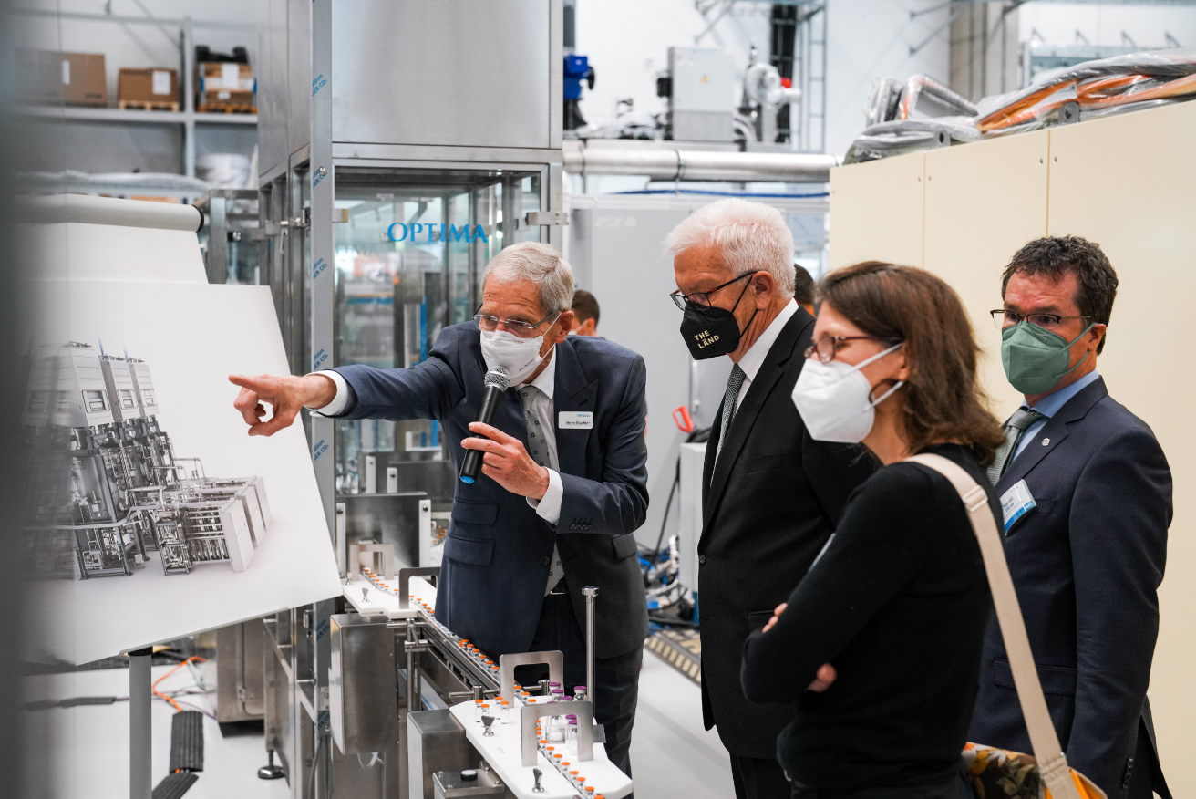
100 Years of Optima: From left to right: Hans Buehler, Managing Director/CEO of the Optima Group, explains the operation of a pharmaceutical filling line to Baden-Wuerttemberg Minister President, Winfried Kretschmann, Jutta Niemann (Member of the State Parliament, Buendnis 90/Die Gruenen) and Harald Ebner (Member of the Federal Parliament, Buendnis 90/Die Gruenen). (Source: Optima)

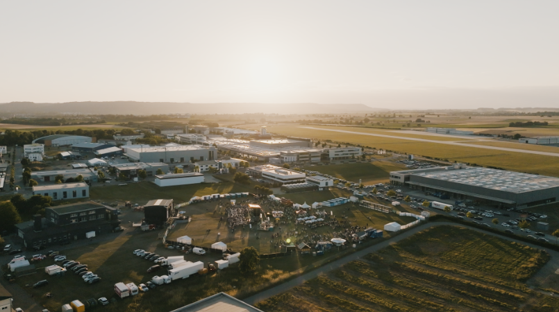
100 years of Optima: The anniversary was celebrated over two days in early July with an open air event and a family day in a fitting setting in Schwaebisch Hall. (Source: Optima)

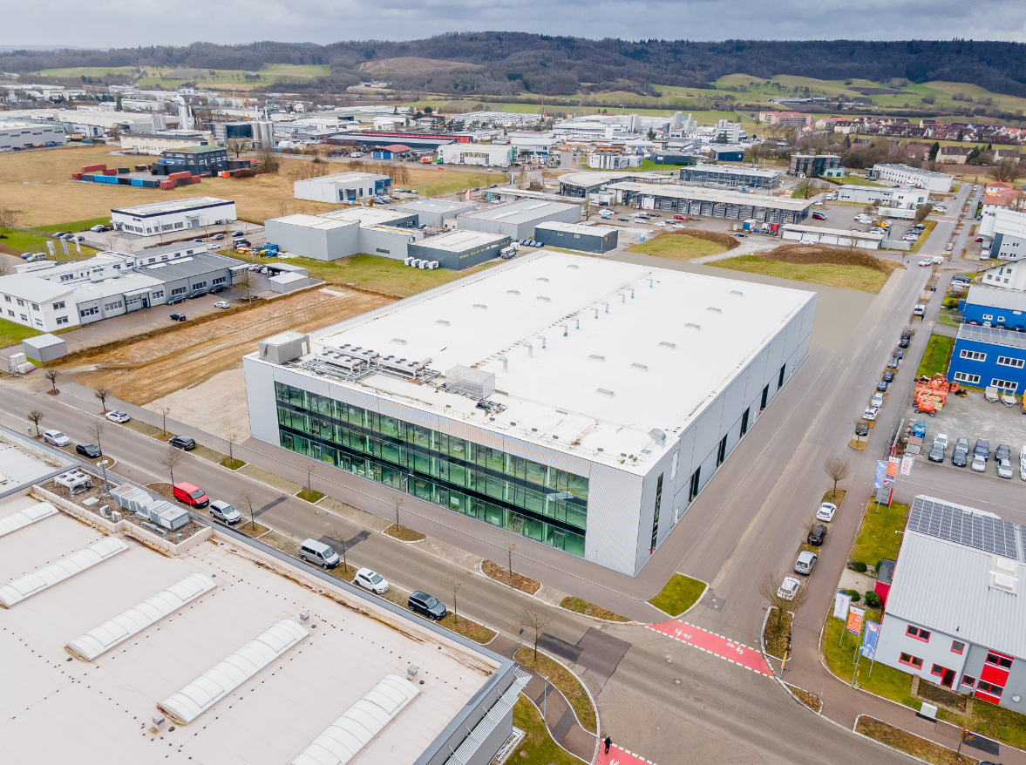
Expansion: The opening of the new CSPE Center II (center) means that Optima Pharma is growing its production area in the Schwaebisch Hall industrial park. (Source: Optima)

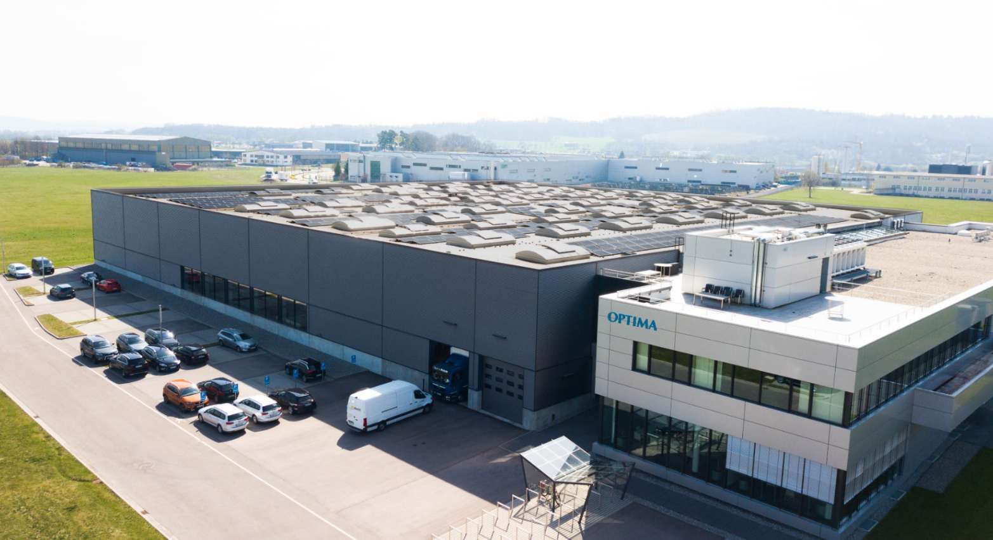Responsibility: Optima has been using green electricity since 2009 and has already managed to reduce its climate footprint by 40 percent as a result of other measures, like investing in photovoltaic systems. A further package of measures will reduce this by an additional 25 percent by 2030. (Source: Optima)

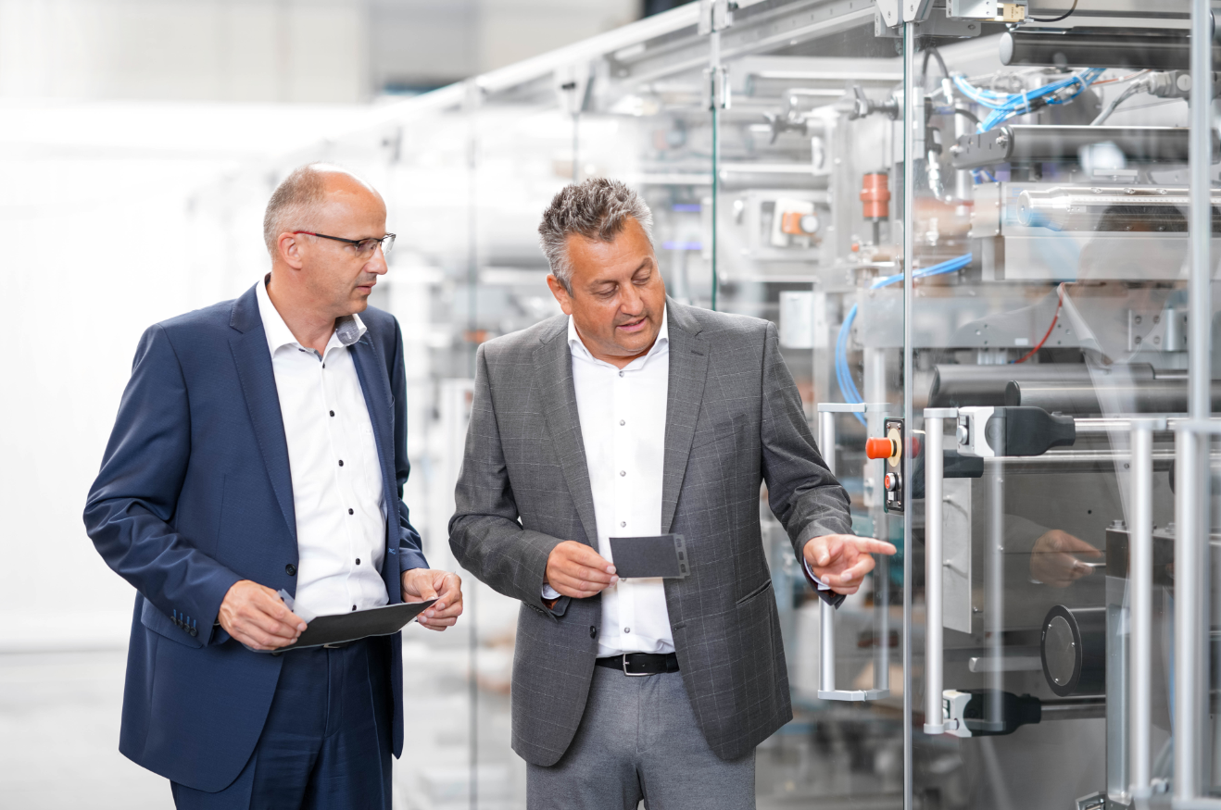
Innovation: Werner Volk, Business Development Manager at Optima Life Science (left) and Juergen Bareiss, Head of Optima Life Science, in front of a fuel cell production facility which is currently under construction. (Source: Optima)

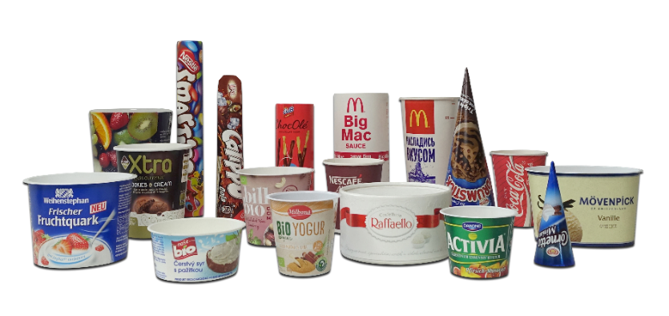
Partnership: As a result of Optima's cooperation with the company Weyhmueller, Optima is able to offer turnkey lines with inline packaging production, filling and packaging that process environmentally friendly paper packaging solutions for consumer goods. (Source: Optima)

Characters (incl. spaces): 6,596

Press contact:
OPTIMA packaging group GmbH
Jan Deininger
Group Communications Manager
+49 (0)791 / 506-1472
jan.deininger@optima-packaging.com
www.optima-packaging.com

About OPTIMA
Optima supports companies worldwide with flexible and customer-specific filling and packaging machines for pharmaceuticals, consumer goods, paper hygiene and medical devices markets. As a provider of solutions and systems, Optima accompanies these companies from the product idea through to successful production and throughout the entire machine life cycle. Over 3,000 experts around the globe contribute to Optima's success. 20 locations in Germany and abroad ensure the worldwide availability of services. In 2022, Optima celebrates the company's 100th anniversary.
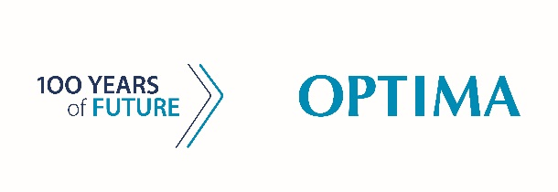
Exciting stories from 100 years of Optima: www.100-years-of-future.com

Thank you very much for your publication. We look forward to receiving a digital specimen copy.

