PRESS RELEASE
Schwaebisch Hall, November 08, 2018

OPTIMA pharma at Pharmtech Russia 2018
MultiUse Machines and Outstanding Engineering

At Pharmtech Russia, Optima Pharma will present the MultiUse concept. The fully automated and very flexible machinery can process different types of containers. Another key feature of the company’s exhibition presence will be the modern engineering technologies that enable Optima Pharma to complete complex turnkey projects on budget and on schedule.
Vials, pre-filled syringes, and cartridges can be processed in one machine: Optima Pharma will present the MultiUse Filler as the ideal solution for small batch sizes and different container types. This type of machine can be used for production in a laboratory for up to medium-sized batches. The MultiUse Filler is fully automated and highly flexible. It can be adjusted quickly for different format sizes and container types.
Comprehensive Scientific Process Engineering (CSPE) has revolutionized the planning and implementation of pharmaceutical filling machines. A combination of scientific methods and technological processes ensures that the time from the order being placed to the start of production is as short as possible. At Pharmtech Russia, Optima Pharma will present CSPE together with the latest engineering technologies for turnkey projects. The turnkey experts will inform visitors about complex projects involving filling and sealing, isolator technology, and freeze-drying. Optima Pharma takes overall responsibility for developing and implementing projects of this kind, from online planning and design through integrated factory acceptance tests (iFATs), building site management, site acceptance tests (SATs), and a comprehensive range of services using the latest engineering technologies such as flow visualizations, which will be also presented at Pharmtech Russia.
Experts from Metall+Plastic – a company of Optima Packaging Group – will inform customers about the portfolio of isolators and latest technologies. Extremely reduced cycle times as well as the user friendly, modular STISO sterility test isolator are among them.
Cost-effective freeze-drying in a small space
Optima Pharma is also known as a technology leader within pharmaceutical freeze-drying. One of the company's most recent developments is the CS freeze-dryer. It is designed for products that are new on the market and are initially being produced in small and medium-sized batches. The CS freeze-dryer is ideal for installation in existing buildings and can easily be configured to ensure an efficient overall layout for the production system. Its space-saving design also makes it highly cost-effective.
Optima Pharma at Pharmtech 2018 (Moscow, Russia),
November 20 to 23, 2018: Pavilion 2 Hall 8, Stand B107

Characters (incl. spaces): 2,731

Contact:
OPTIMA packaging group GmbH
Jan Deininger
Editor
jan.deininger@optima-packaging.com
www.optima-packaging.com

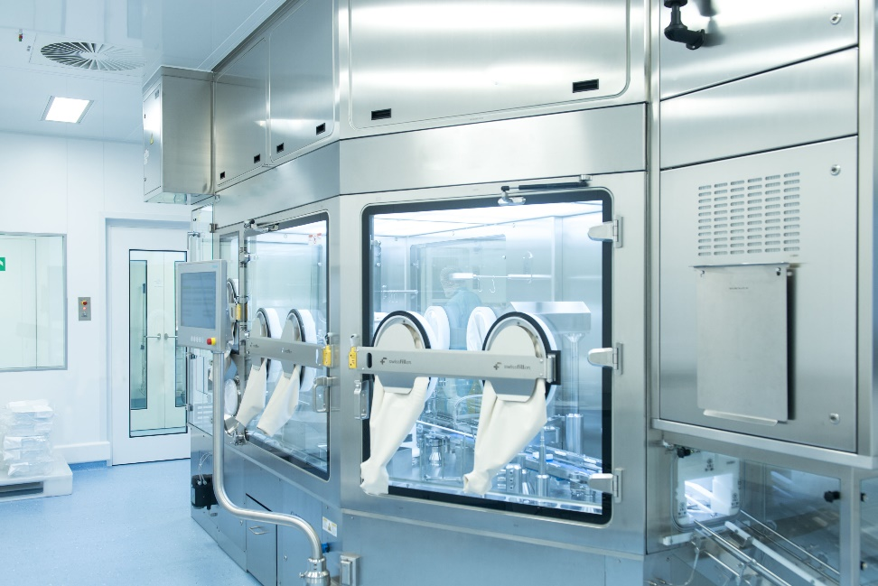 The MultiUse filler is one of Optima Pharma's most recent developments.

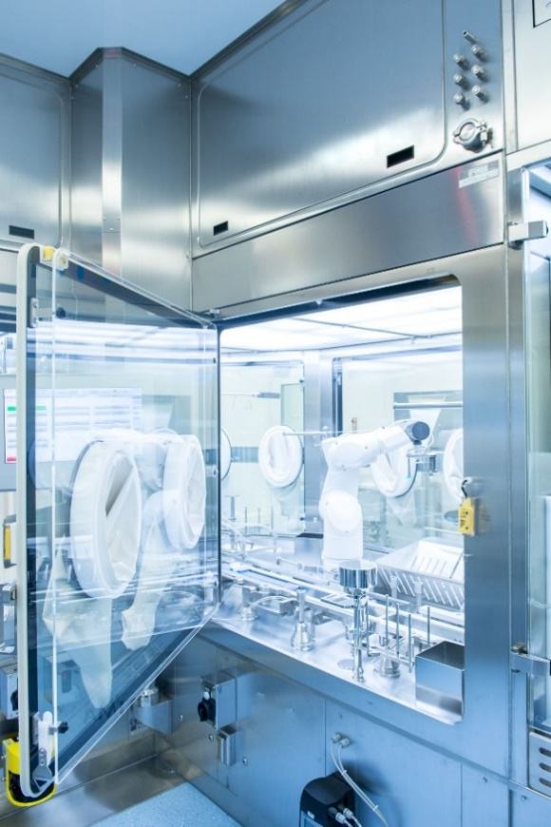
The MultiUse concept allows for the flexible production of small batches in a wide range of different format sizes and container types.

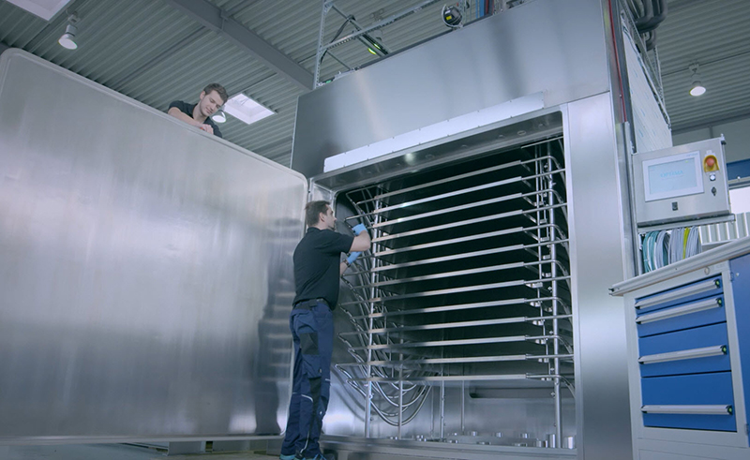
At Pharmtech Russia, Optima will inform about the new, flexible and compact freeze dryer OPTIMA CS.

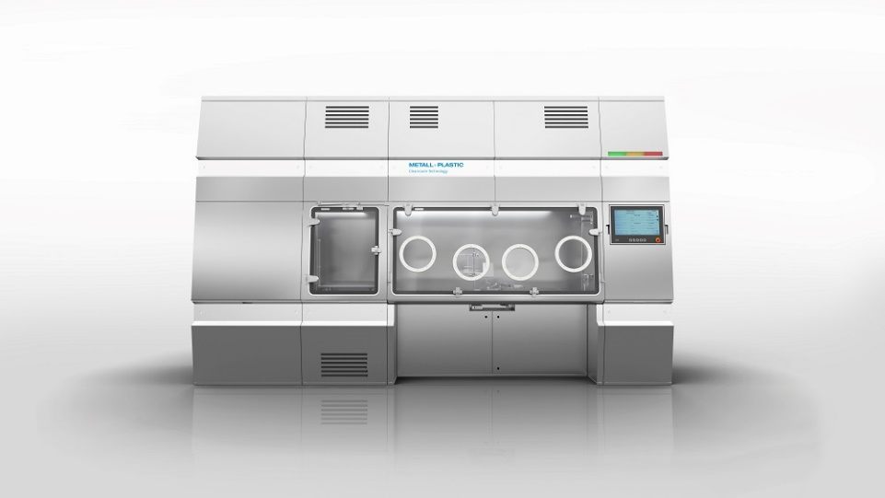
The sterility test isolator STISO from Metall+Plastic comes with a variety of new user-friendly developments including a well-designed operator ergonomic concept.

Thank you very much for your publication. We look forward to receiving a specimen copy.

About Optima Pharma
For uncompromising pharmaceutical applications, Optima Pharma develops and manufactures filling, sealing and process technology for pharmaceutical products. Highly sophisticated, fully automated systems from Optima Pharma are used to process blood plasma products, vaccines, oncology and biotech products in prefilled syringes, vials, bottles and cartridges. Non-sterile pharmaceuticals and diagnostics are further applications. The company’s extensive technology portfolio includes washing machines, sterilization tunnels, filling and sealing, robotic product handling and other functions. Freeze drying systems and isolator technology are part of turnkey systems by Optima Pharma. The product range includes machinery for laboratory filling up to high-speed systems. The division guarantees quick, professional service with 14 international locations. Optima Pharma is a member of OPTIMA packaging group GmbH (Schwaebisch Hall), which employs a workforce of 2,250 around the globe.

