RM  ANUS HORRIBILIS  August 24 – November 10, 2024  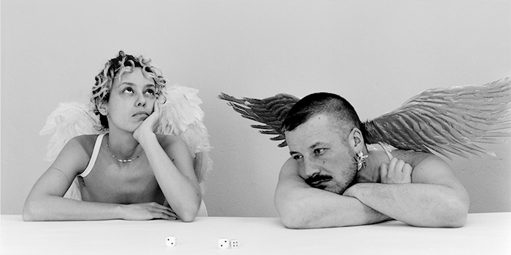  RM, Angels, photo: Mathilde Agius  Kunstmuseum St.Gallen proudly presents Anus Horribilis, the first museum exhibition of the artist duo RM (formerly Real Madrid), which will feature works specifically created for the LOK, the Kunstmuseum St.Gallen’s second venue. The practice of this artist collective, founded in 2015 in Geneva, is situated at the intersection of sexuality, consumption, and identity. With previous large-scale sculptures and installations, RM has investigated social and political reactions to stigmatized sexually transmitted diseases and infections. For Anus Horribilis the duo is now taking this thematic exploration further, right up to the last stigma – that of dying.  Melanie Bühler, Senior Curator Kunstmuseum St.Gallen, on RM: RM is one of the most interesting Swiss artists of their generation. RM was originally named Real Madrid, after the successful mega football club, arguably one of the best-known brands in the world. The choice of this name was motivated by an interest in how information spreads and what it might mean for an artist collective to be untraceable on the internet under this name. They had to shorten the name for legal reasons – Real Madrid became RM – but an interest in transmission, virality and the parasitic is still central to their work. RM's practice has addressed bedbugs, AIDS, sexually transmitted diseases and drug addiction – and now death. In Anus Horribilis they approach dying as a physical transformation in which bowel movements play a central role. As such, the exhibition is also an examination of excrement as a paradoxical cultural object that sits awkwardly between taboo, liminal experience and embarrassment. Social stigmas and the fears associated with them are often starting points for RMs work, which is characterized by a precise formal language, pop-cultural references and humor, despite the gravity of the topics addressed.  RM was founded as Real Madrid by Bianca Benenti Oriol and Marco Pezzotta in Geneva in 2015. Benenti Oriol (1987, Turin) received her master's degree from HEAD – Haute école d'art et de design (Geneva) in 2016. Pezzotta (1985, Seriate) studied at the Brera Academy of Fine Arts (Milan) and the Kunsthochschule Berlin-Weißensee. RM has had solo exhibitions at Auto Italia, London (2023); Centre d'édition contemporaine (CEC), Geneva (2023); Swiss Institute, New York (2022); and Centre culturel suisse, Paris (2021). Their work has also been included in numerous group exhibitions, such as Buoyancy, AyeAye, Copenhagen (2022); Trovate Ortensia, ICA Milano (2021); Hotline, Forde, Geneva (2021); FUORI, Quadriennale Roma, Rome (2020); Bacco Malato, Plymouth Rock, Zurich (2019); United by AIDS, Migros Museum, Zurich (2018); and Further Thoughts on Earthy Materials, GAK, Bremen (2018). RM has won the Swiss Art Award twice, in 2023 and 2018. RM lives and works in Geneva and Berlin.  This exhibition is additionally supported by Pro Helvetia, the Canton of Geneva and Philaneo. Philaneo is a non-profit association, which promotes contemporary art ideologically and financially. The association supports the production of new works as well as exhibition projects and purchases for public collections. | Exhibition dates  August 24 –November 10, 2024  LOK by Kunstmuseum St. Gallen  Press Conference  August 23, 2024  11:00 a.m.  Exhibition Opening  August 23, 2024  6:30 p.m.  Opening Hours  Mon – Sat: 1:00 p.m. – 8:00 p.m.  Sun: 11:00 a.m. – 6:00 p.m.
Press Contact

Nadine Sakotic
Head of Communications
Kunstmuseum St. Gallen
Museumstrasse 32
9000 St.Gallen
T +41 71 242 06 84

kommunikation@kunstmuseumsg.ch
kunstmuseumsg.ch

Factsheet

RM
ANUS HORRIBILIS

Exhibition Dates | August 24 –November 10, 2024
Exhibition Dates | LOK by Kunstmuseum St.Gallen, Grünbergstrasse 7, 9000 St. Gallen
Press Conference | August 23, 2024, 11:00 a.m. with director Gianni Jetzer, senior curator Melanie Bühler, and RM
Exhibition Opening | August 23, 2024, 6:30 p.m.
Curator | Melanie Bühler
Opening Hours | Mon – Sat: 1:00 p.m. – 8:00 p.m.  Sun: 11:00 a.m. – 6:00 p.m.
Press Contact | Nadine Sakotic  T +41 71 242 06 84  kommunikation@kunstmuseumsg.ch
Website | kunstmuseumsg.ch
Press | kunstmuseumsg.ch/en/press

