PRESS RELEASE
Schwäbisch Hall, 12/20/2019

Precision and flexibility: Assembly machines for pen and auto injectors
OPTIMA automation at Pharmapack 2020

At Pharmapack 2020, OPTIMA automation will provide information about its current technologies for pen and auto injectors as well as paste dispensers for cannulae. These machines are characterized by their high process flexibility and precision. Semiautomatic machines can be converted into fully automatic systems and supplemented with additional features.
During assembly, pen and auto injectors undergo a wide range of process steps that OPTIMA automation combines flexibly with one another in its systems, depending on the customer’s needs. Generally speaking, the assembly of sensitive components requires the highest precision, which is why it is done using force/displacement measurement, i.e. a controlled application of force. The positions of flanges and plugs are directly monitored during the process. This also includes printing and labeling with all of the related control processes.
With respect to auto injectors, this process may also include disassembly steps as well as an inspection of the needle guard on the pre-filled syringe before it is used in the injector. Machines like the OPTIMA AIM for auto injectors and the OPTIMA PIM for pen injectors can be adapted for use with injection systems from various manufacturers.

OPTIMA automation will also provide information on its cannulae paste dispensers at Pharmapack. Extensive inspections are carried out here as well in order to, for example, verify the alignment of the needle edge or needle height, or to check the needle for damage. This process also includes a siliconizing station for the needles.
Depending on the required capacity and application, OPTIMA automation machines, as rotary transfer machines, can be set up in modular or linear configurations. These machines can be set up for semi-automatic, lower performance machines from the beginning, as is typically required during the qualification phase, in order to then scale up to full automation for production.
From the beginning of the project, OPTIMA automation follows a cooperative advisory approach. Transparency over the entire course of the project is key here. Qualification and validation processes are carried out in accordance with regulatory provisions. OPTIMA automation is headquartered in Germany and undertakes projects and provides services around the world. The company is part of the Optima Packaging Group, which employs more than 2,400 people at 19 locations in Germany and abroad.
OPTIMA automation at Pharmapack (Paris Expo): February 5/6, 2020: Booth no. B18

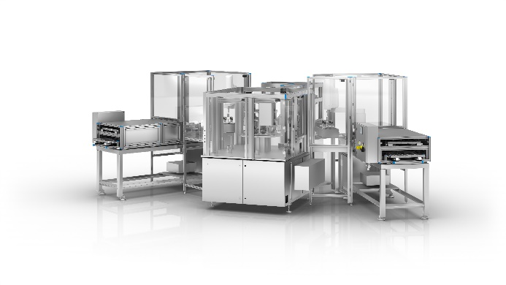
Auto injector systems like the OPTIMA AIM from OPTIMA automation can subsequently be scaled from semi-automatic to fully automatic processes. They are flexible enough to use for injectors from various manufacturers.

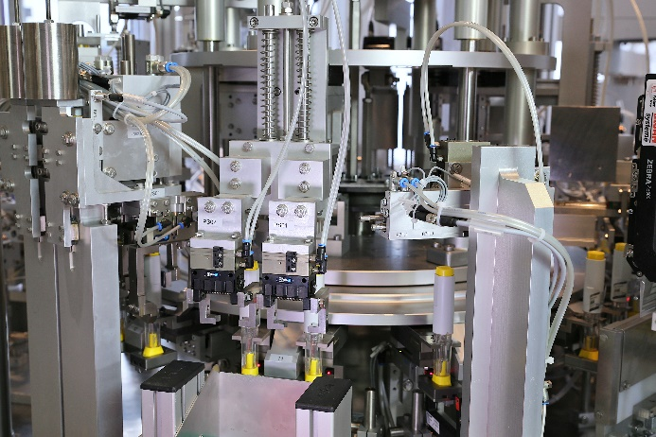
For the OPTIMA AIM, all process steps for the assembly of auto injectors are carried out and monitored with the highest precision.

Characters (including spaces): 2,629

Press contact:
OPTIMA packaging group GmbH
Jan Deininger
Editor
+49 (0)791 / 506-1472
jan.deininger@optima-packaging.com
www.optima-packaging.com
Thank you for publishing this information. We would be pleased to receive a file copy.

