**PRESS RELEASE**

Schwäbisch Hall, 20/10/2023

**Optima Pharma hosts industry forum in Schwäbisch Hall, Germany**

The specialist in pharmaceutical system technology, filling lines, isolators and freeze-dryers invited 250 experts and industry representatives from around the world for the eighth Pharma Forum in Schwäbisch Hall, Germany.

**This year’s Pharma Forum in Schwäbisch Hall, again, had first-rate guest speakers with captivating lectures. The main conference topics were the potential of cell and gene therapies, the optimization of systems and production processes, and discussions about current industry trends. The forum also provided the opportunity to exchange ideas, a tour through the manufacturing floors of Optima Pharma, which gave an insight into ongoing developments and innovations.**

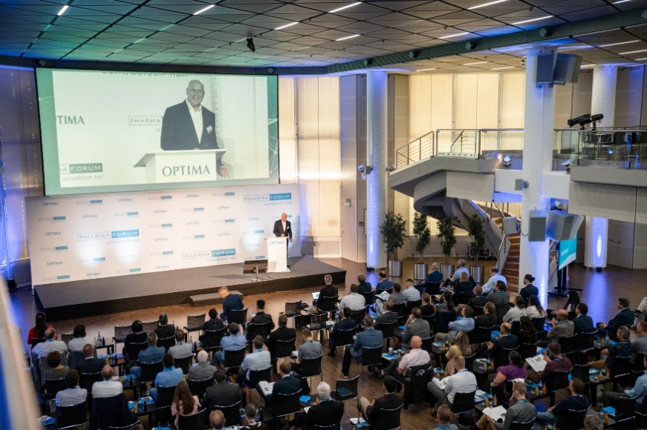

Chairman Gerhard Breu welcomed 250 guests from all over the world at this year's Pharma Forum. (Photo: Optima)

Around 250 guests from all around the world took the opportunity to participate in this year's Pharma Forum in Schwäbisch Hall. The two-day forum offered interesting technical presentations, discussions with experts, and the latest machine technologies, which could be viewed in action at the assembly floors. The evening event presented the opportunity for more face-to-face discussions with Optima experts and the guest speakers.

Research and industry experts provided insights into current issues, such as approaches to reduce glove intervention and the development and use of cell and gene therapies. Other topics included flexible production solutions, the impact of regulatory requirements like Annex 1, and virtual qualification solutions.

**Outlook and insight into the pharmaceutical industry**

Jochen Maas (Sanofi) addressed developing trends in the pharmaceutical industry. Patients of the future want not only a universal drug, but also an individualized medical solution, including diagnostics. Another trend is digitalization and customizing certain treatments. “These developments will also impact production processes, moving away from broad spectrum treatments towards niche formulations," said Maas.

Christa Meyers (CRB) also presented an outlook on trends in the pharmaceutical industry. She identified an apparent progress in cell therapy. The market for mRNA is undergoing a paradigm shift. She predicts significant growth in personalized medicine in the coming years.

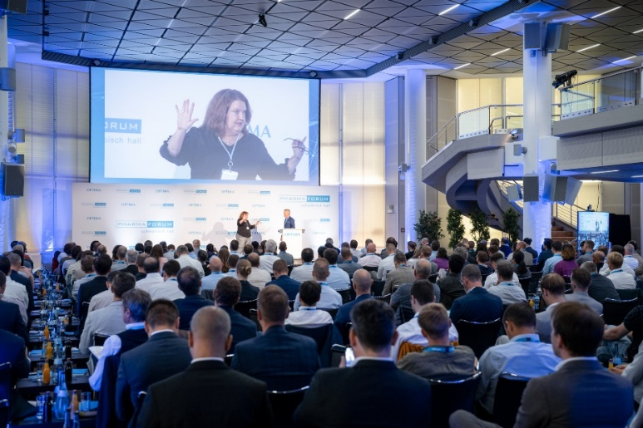

Christa Meyers (CRB) provided information on trends in the pharmaceutical industry. (Photo: Optima)

Richard Lee (Lotte Biologics) demonstrated the demographics of aging in Asia. He explained how the elderly population drives automation and advanced therapies. Biological medicines and the introduction of innovative therapies are playing a crucial role in meeting the changing needs of the population.

**Current challenges for production**

Thomas Lemazurier (ten23) explained a successfully scale-up of freeze-drying systems from laboratory to production. Proven methods for scaled-up freeze-drying processes include thorough product and equipment characterization. It is also essential to implement process analysis and understand critical parameters and properties.

Prof. Wolfgang Friess (Coriolis) explained trends in lyophilized formulations of biologics. He sees interesting challenges and opportunities in the complex interaction between process, formulation and packaging material.

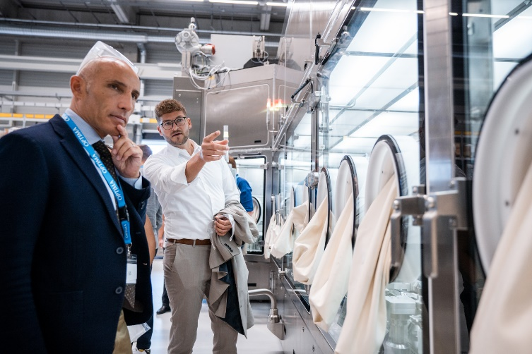

How can glove interventions be minimized? This was one of the questions during the Pharma Forum. During the facility tour, the attendees saw possible solutions first hand. (Photo: Optima)

Digital simulations are an efficient solution for optimizing the commissioning and qualification process. Francesco Signorini and Addison Williams (Eli Lilly) provided valuable insights using simulations to expedite delivery of equipment. Their view is that machine simulations can significantly improve operational efficiency and speed-up the design process for cutting-edge equipment.

The main cause of contamination in an isolated aseptic production is human intervention and therefore, should be replaced by alternative solutions. This was the topic of the lecture presented by Henrik Herrmann and Anders Magnusson (Fujifilm Diosynth Biotechnologies). They shared their experiences how to overcome the challenge of glove minimization or gloveless solutions, from small systems to high-output commercial systems.

Novo Nordisk is faced with a similar problem: To coordinate the authorities' expectations and supply the growing market, Novo Nordisk aims to combine the highest level of contamination control with maximum productivity. Henrik Friese presented several projects pursued by Novo Nordisk to reduce glove interventions in existing high-output systems with isolators in the short-term, as well as developing gloveless high-output systems, in the long-term.

Roland Rocafort and Vincente Ventura explained how Moderna overcame the enormous challenge of mass-producing its Covid-19 vaccine so rapidly. With an in-house production line and working with several CMOs/CDMOs Moderna ensured global supply.

Prof. Michael Schmitt (Heidelberg University Hospital) reported on the current cancer research treatment status. Over the last five years, 200 CAR-T cell therapies have been administered at Heidelberg University Hospital. Now the objective is to significantly reduce the cost for this therapy. He believes it is possible to cut the cost by half using robot supported production processes.

Schmitt's vision could become reality with the Optima ProCell production isolator: The attendees were able to examine the production unit for cell therapeutics during the tour of the Pharma facility. Optima is building the system in collaboration with Heidelberg University Hospital and Robert Bosch Hospital.

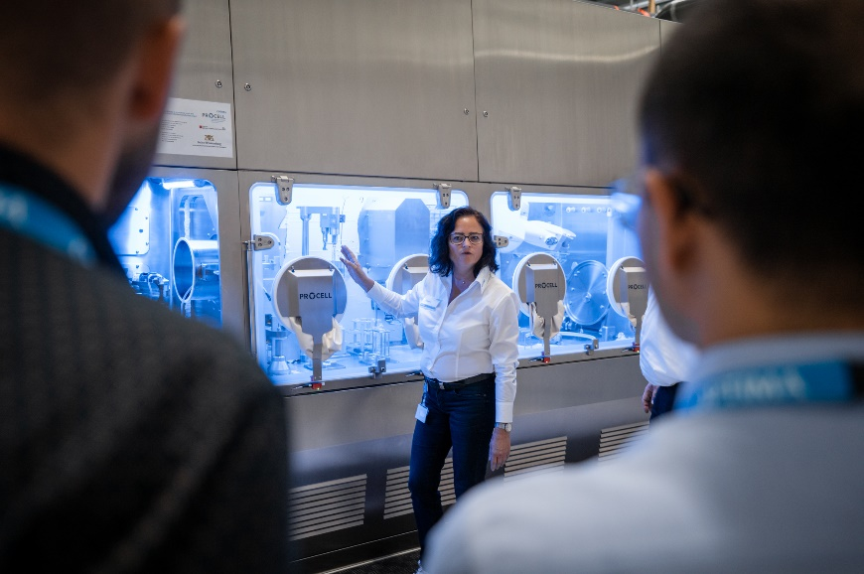

Future cell therapies will be much more cost-effective with the Optima ProCell system. (Photo: Optima)

The new training center, which had been completed in time for the Pharma Forum, was another highlight of the tour. It provides customer and Optima employees the physical hands-on opportunity to broaden their machine knowledge.

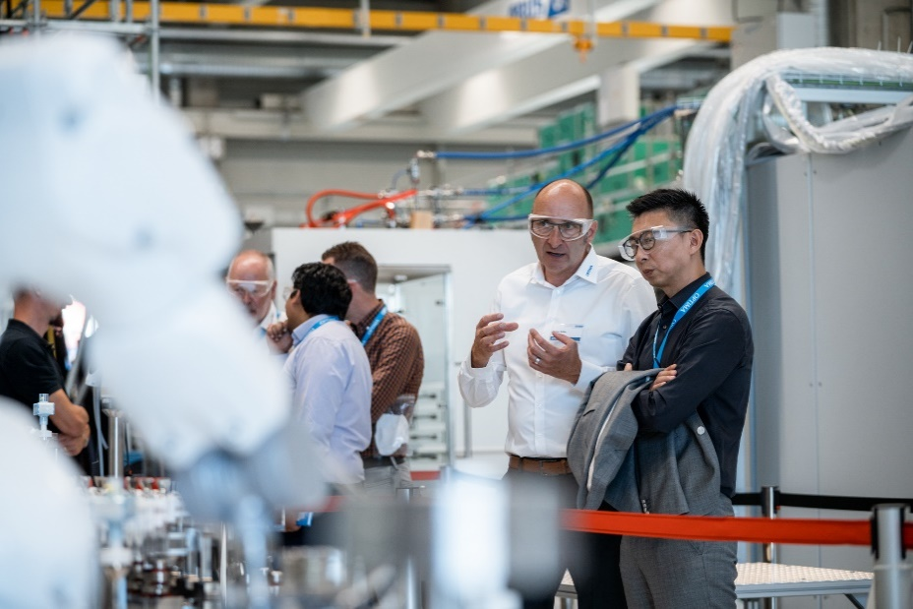

During the tour of the assembly halls, guests were able to talk directly with the Optima Pharma experts. (Photo: Optima)

The trend towards fully integrated systems in the pharmaceutical industry was another topic at the Pharma Forum.

This year, Optima has refined its status as a turnkey supplier: The subsidiary Metall+Plastic GmbH from Radolfzell has transformed into Optima Pharma Containment GmbH. This means that the integrated overall filling solution systems with isolators, and freeze dryers is available from a one-stop shop. The new slogan "Your home for turnkey" emphasizes this approach even more.

Overall, the eighth Pharma Forum, with 13 presentations, live machine demonstrations during the facility tour, and a joint evening program, received a very positive feedback from the 250 participants from 25 countries.

Characters (incl. spaces): 6,500

Press contact:

OPTIMA packaging group GmbH

Denise Fiedler

Group Communications Manager

+49 (0)791 / 506-1472

pr-group@optima-packaging.com

www.optima-packaging.com

**About OPTIMA**

Optima supports companies worldwide with flexible and customer-specific filling and packaging machines for pharmaceuticals, consumer goods, paper hygiene and medical devices markets. As a provider of solutions and systems, Optima accompanies these companies from the product idea through to successful production and throughout the entire machine life cycle. Over 3,000 experts around the globe contribute to Optima's success. 20 locations in Germany and abroad ensure the worldwide availability of services.

Thank you very much for your publication. We look forward to receiving a digital copy.