PRESS RELEASE
Schwaebisch Hall, December 2, 2019

OPTIMA pharma and gmp-experts are training Pharma companies' employees
The practical seminar "Modern Filling" was held in Schwaebisch Hall.

The practical seminar "Modern Filling" was held at Optima Pharma from November 25 to 27, 2019 in Schwaebisch Hall. It was organized by gmp-experts BeratungsGmbH together with Optima Pharma. The seminar was aimed at the staff of pharmaceutical companies, suppliers and consulting companies. The participants completed the practical part in Optima Pharma's assembly halls.
The more smoothly liquid and powdered pharmaceuticals can enter sterile containers, the greater the added value for pharmaceutical companies. A high level of dosing accuracy and product quality are needed – modern filling technology can do this, so it plays a strategic role in a company's production process. This is why gmp-experts, a consulting company serving the pharmaceutical industry, joined forces with Optima Pharma to offer a practical seminar in Schwaebisch Hall. GMP stands for "Good Manufacturing Practice" and therefore for guidelines for quality assurance in producing pharmaceuticals; these are defined in national and international regulations. Those benefiting from the seminar were employees from the pharmaceutical industry who plan, qualify, validate and operate filling plants.
Axel Wagner, Technical Sales Manager, coordinated the Optima Pharma event and presented the company to the visitors. In particular, he emphasized the importance of complete installations that can be purchased in the new CSPE Center. The CSPE process cuts delivery times and significantly speeds up the start-up of pharmaceutical plants. Alongside the basic theory of filling technology, in the CSPE Center the participants learned, among other things, how the "first shot" of a real mock-up, a wooden model, works much better with the help of a virtual mock-up (a 3D representation in the Virtual Reality Center). By doing so, it is possible to realistically determine early on whether all locations within pharmaceutical plants are accessible to the operators and whether adjustments need to be made in the design. The virtual system can also be used for training purposes.
At three workstations, the visitors also learned everything about isolator technologies, filling machines, hygiene requirements, measurement technology, filter tests and learned about the advantages and disadvantages of a variety of dosing systems.

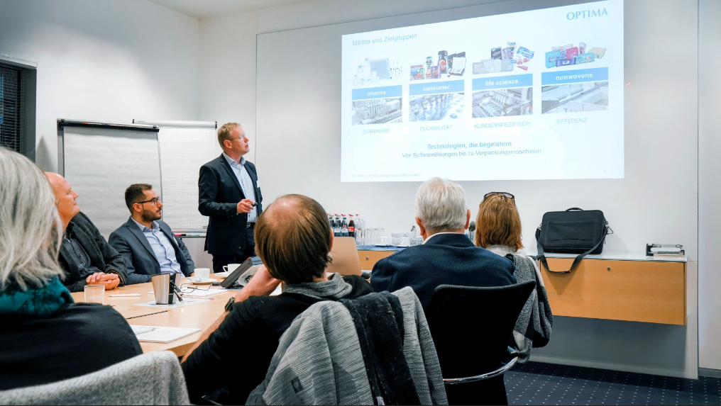
As Technical Sales Manager at Optima Pharma, Axel Wagner is responsible for sales in the DACH region. Wagner was responsible for coordinating the seminar program at Optima Pharma.

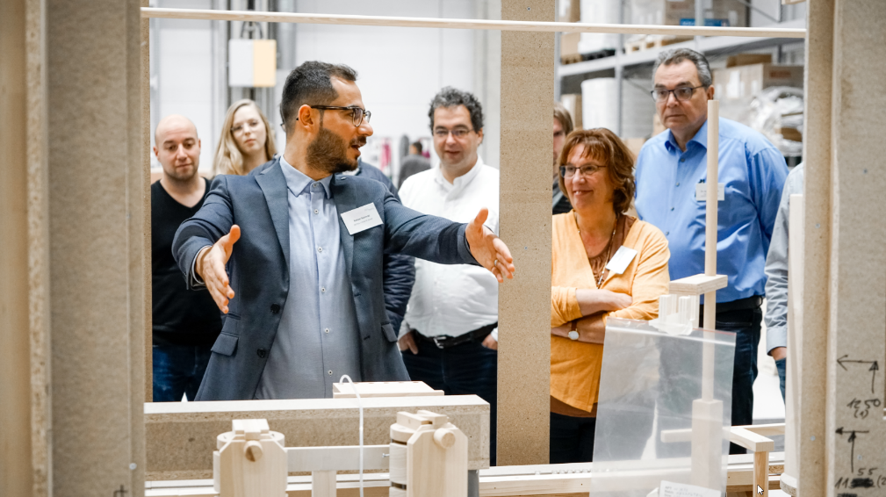
Kenan Kanmaz, Technical Sales Manager at Metall+Plastic, explained to the seminar participants how important it is to have easy accessibility to pharmaceutical filling systems.

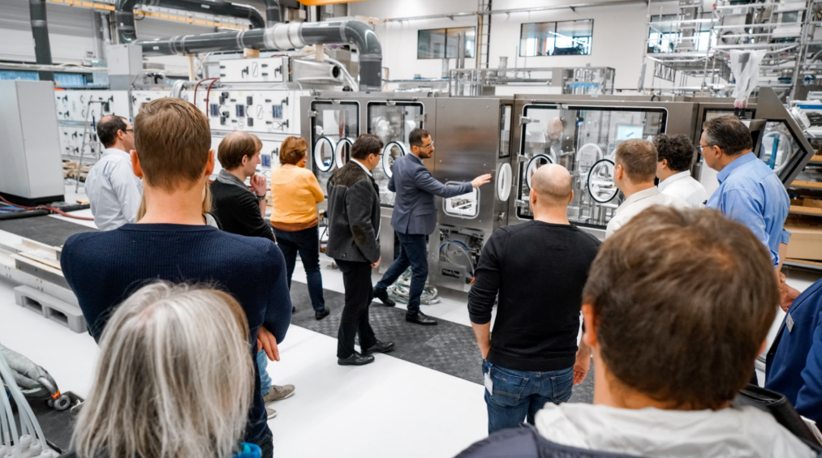
The seminar participants were impressed by the filling systems, which are usually connected to an isolator. The purpose of isolators is to decontaminate the machine interior.

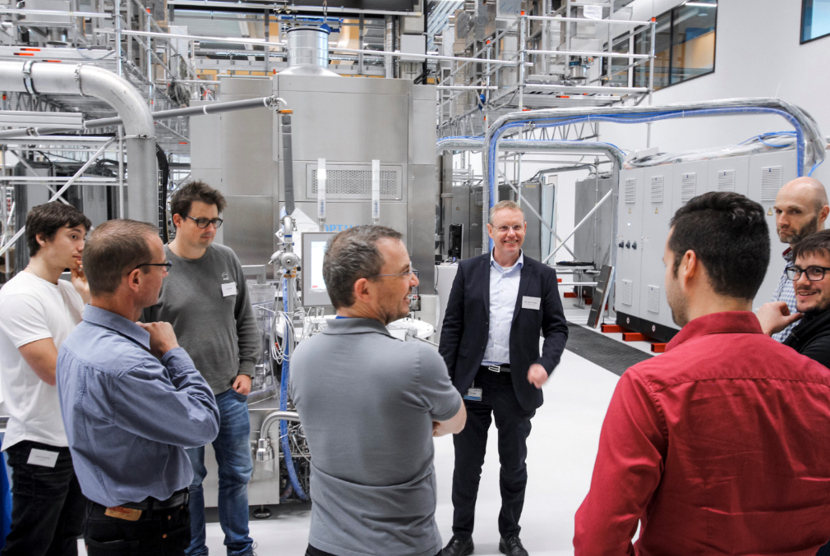
Axel Wagner demonstrated to the seminar participants the different cleaning needles while the vials system washing machine was running.

Characters (incl. spaces): 2,438

Press contact:
OPTIMA packaging group GmbH
Jan Deininger
Editor
+49 (0)791 / 506-1472
jan.deininger@optima-packaging.com
www.optima-packaging.com
Thank you very much for your publication. We look forward to receiving a specimen copy.

