**PRESS RELEASE**

Schwaebisch Hall, January 20, 2022

**Packaging for the future**

At IDEA, OPTIMA is presenting solutions for attractive, sustainable packaging design

**IDEA will be held in Miami from March 28 to 31, 2022. It is one of the most important industry meetings of the year for Optima's Nonwovens business unit. Here, visitors will have the opportunity to use a wide variety of materials to design the packaging concepts of the future. There will also be a welding station on display that will further improve the packaging design of hygienic products. Another focus is on sustainable packaging solutions for a functioning circular economy. Optima's experts can be found at booth no. 4416. Because of the neighboring FiltXPO, specialists in the production and packaging of filters will also be on hand for the first time.**

"We are very glad to once again be able to exchange ideas in person with interested parties and customers at IDEA," says Oliver Rebstock, the Managing Director of OPTIMA nonwovens GmbH. Personal interaction is essential in special machine construction. “Today's consumers make high demands on packaging. It is expected to be unique, high quality, customized, and sustainable. Oliver Rebstock says, "At IDEA, we'll be showing how we can help producers with these trends."

**Safe and aesthetically pleasing sealing of packaging**

This can be achieved by means of an innovative welding station developed by Optima Nonwovens, for example. This has a positive effect on the quality of the packaging. Packaging can be closed safely and welded in an appealing way. As the packaging systems by Optima Nonwovens are able to engage in “machine learning”, changes to the packaging can be detected automatically and the machine users can respond immediately. An automatic, precise adjustment to each packaging format ensures that even the first package after each format change is perfect. This avoids start-up and readjustment.

**Interactive packaging experience**

Differentiation in the marketplace is achieved both with improved packaging and with new packaging concepts. Optima Nonwovens is open to working collaboratively to develop new packaging solutions. Here, the options include alternative materials such as paper or starch films, new types of packaging such as cardboard packaging, or packaging with a new added value, such as the opportunity to customize. However, there is also potential for completely new concepts, which Optima would like to discuss with visitors. Hence, visitors at the event will be able to interactively view and discuss packaging with different materials and customizations by means of the "Hypebox" gamification element.

**Green packaging, not greenwashing**

“Particularly in terms of sustainable solutions, we are now addressing this issue collectively and at a much earlier stage, from the packaging material to the machines, and to the entire life cycle of the packaging material and the machines,” explains Dominik Broellochs, Group Sustainability Manager of the Optima Group. This is now only possible by working as a network. As a result, project run times would be massively shortened, risks minimized, and results improved. Taking diaper packaging as an example, Broellochs is presenting a solution that does justice to both marketing and ecology: the sleeve bag – 100 percent recyclable mono-polyethylene (PE) packaging for paper hygiene products such as diapers, sanitary napkins, and even toilet paper.

**The prospect of a functioning circular economy**

The sleeve bag offers the prospect of a functioning circular economy according to the Cradle to Cradle principle. The safe installation of the paper inserts and the encasing of the products is a new, innovative process by Optima. This process can be retrofitted for existing packaging machines, which also contributes to sustainability. “With the sleeve bag, Optima has developed honest packaging. In terms of sustainability, honest packaging is the only way that we want to go forward with our customers. The sleeve bag shows that it's not always a matter of having to develop complex new materials, but the boldness in simplicity of package is often just the beginning," says Broellochs. This packaging has been certified as "excellent, 100 % recyclable" by the cyclos-HTP Institute.

**Flexible conversion of packaging material**

Optima is not only active in the area of packaging development; machine technology also provides optimal conditions for a flexible conversion from PE to paper and vice versa. All machine solutions by the Nonwovens business unit are flexibly adaptable. Conversion takes no longer than a normal format change. This means ad hoc tests with paper or bioplastics, for example, can be run. Further optimizations in terms of efficiency and output are possible at any time.

Whether paper, PE, or bio-PE – it is essential to integrate product protection, sustainability, and marketing successfully with one another. The machine technologies required for this are available at Optima. This ensures the new packaging solutions have a successful future.

**Optima Nonwovens at IDEA** **2022**: **March 28 to 31, 2022, Miami Beach Convention Center, Miami Beach, Florida, booth No. 4416**

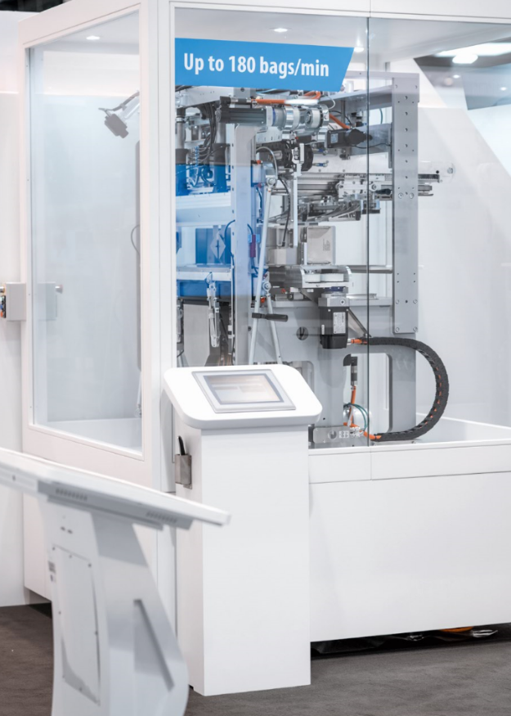

Packaging for paper hygiene products can be securely sealed and attractively welded using an innovative welding station. (Source: Optima)

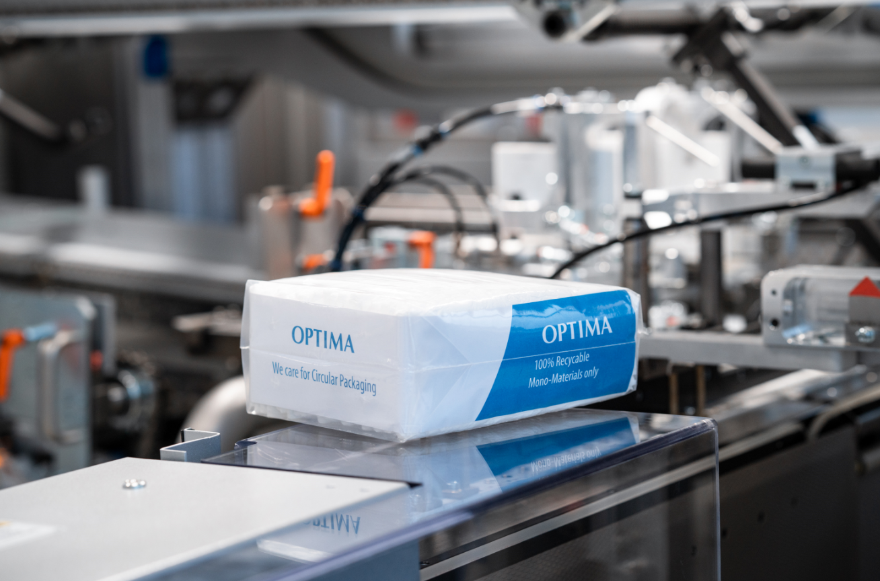

The sleeve bag is an example of a solution that fulfills the demands of both marketing and ecology. The 100 percent recyclable packaging solution has been developed by Optima and certified as "excellent, 100 percent recyclable" by the cyclos-HTP Institute. (Source: Optima)

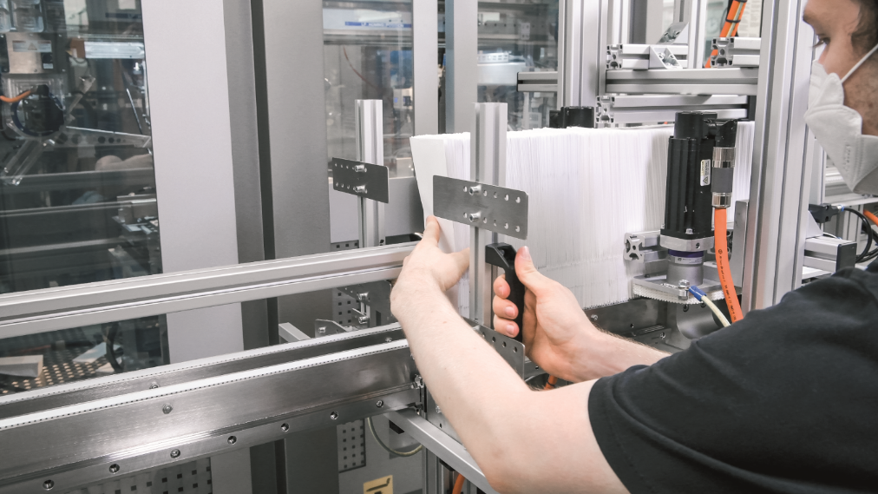

All machine solutions from Optima Nonwovens can be flexibly adapted to different packaging materials. Here, paper bags for packaging sanitary napkins are loaded into the machine. (Source: Optima)

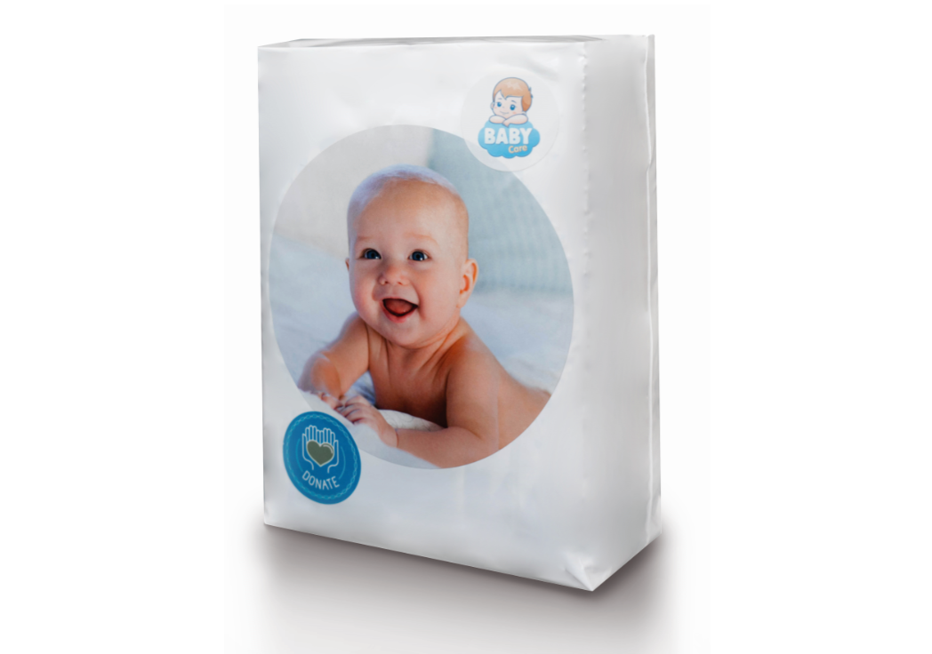

New technical solutions enable Optima Nonwovens to produce aesthetically appealing packaging for paper hygiene products – a PE bag for baby diapers is shown here. (Source: Optima)

Characters (incl. spaces): 5,008

Press contact:

OPTIMA packaging group GmbH

Jan Deininger

Group Communications Manager

+49 (0)791 / 506-1472

jan.deininger@optima-packaging.com

www.optima-packaging.com

**About OPTIMA**

Optima supports companies worldwide with flexible and customer-specific filling and packaging machines for pharmaceuticals, consumer goods, paper hygiene and medical devices markets. As a provider of solutions and systems, Optima accompanies these companies from the product idea through to successful production and throughout the entire machine life cycle. Over 2,650 experts around the globe contribute to Optima's success. 19 locations in Germany and abroad ensure the worldwide availability of services.

Thank you very much for your publication. We look forward to receiving a digital specimen copy.