PRESS RELEASE
Schwaebisch Hall, August 2, 2021

OPTIMA is back
The OPTIMA Group presents its solutions at four key US trade shows

The Optima Group will present its solutions for the consumer goods, pharmaceuticals and medical technology industries at four trade shows in the USA. The company is participating at Pack Expo and Healthcare Packaging Expo in Las Vegas, held at the same time from September 27 to 29. Interphex in New York and ICE in Orlando are also bringing a sense of normality back to trade show operations between October 19 and 21. Also present at the booth is Optima Machinery Corporation (Green Bay, WI), providing optimal services to Optima's US customers and producing its own machine solutions specifically for the US market.
“We are delighted that trade show meetings are possible again and we can communicate directly with customers and prospective customers,” says Ulrich Unterriker, Managing Director of Optima Machinery Corporation in Green Bay, WI. The main topics of the Optima Group vary depending on the focus on the trade show. At Pack Expo in Las Vegas, everything revolves around highly flexible filling and packaging machines for cosmetics and single-serve products. Sales experts are available to answer questions in so-called TechTalks.
Sustainable and digital solutions
Further main focuses are the current trend topics of sustainability and digitalization. Adopting the slogan “Circular Packaging” Optima works flat out to develop sustainable packaging solutions that embrace the principles of the circular economy and fit seamlessly into sustainability initiatives. Examples of this include recyclable sleeve bags made from mono-materials and paper packaging for paper hygiene products. The extensive digital Intelligent Production Assistance Services offer valuable instruments for better machine availability, higher line efficiency and optimal operator assistance. The real-time communication system Remote Assist for fast troubleshooting, for example, has made commissioning possible for customers in times of travel restrictions.
Accelerated implementation of turnkey projects
At the sister trade show Healthcare Packaging Expo and Interphex in New York, it’s all about the topics that affect the pharmaceutical companies: the smooth running of complex turnkey projects including filling, closing, isolator and freeze-drying technologies. Optima Pharma ensures this with the CSPE process. Right from the design phase, the process makes systematic use of the possibilities offered by digital engineering and reduces the time span between designing the system and the start of production. In addition, the smallest batches of valuable pharmaceuticals need to be filled in different containers in a flexible way. Optima meets this requirement with the OPTIMA MultiUse systems. The turnkey portfolio of the Pharma business unit is rounded off with innovative bio-decontamination systems and clean room technologies of Metall+Plastic and freeze-drying technologies. The safe and efficient production and filling of cell and gene therapies has also become possible recently. There are high hopes in medical circles for cell and gene therapy as personalized medicine. Optima Pharma has automated the production and filling steps.
At ICE Orlando, the focus is on the web converting solutions offered by the business unit Optima Life Science. Transdermal plasters and orally disintegrating films with a pharmaceutical ingredient, for example, can be produced and packed optimally with Optima Life Science machine solutions.
Pack Expo Las Vegas: September 27 to 29, 2021, Las Vegas Convention Center, hall C, booth 1641
Healthcare Packaging Expo Las Vegas: September 27 to 29, 2021, Las Vegas Convention Center, hall SL, booth 6748
Interphex New York:​ October 19 to 21, 2021, Javits Center, booth 3103
ICE Orlando​: October 19 to 21, 2021, Orange County Convention Center, booth 424

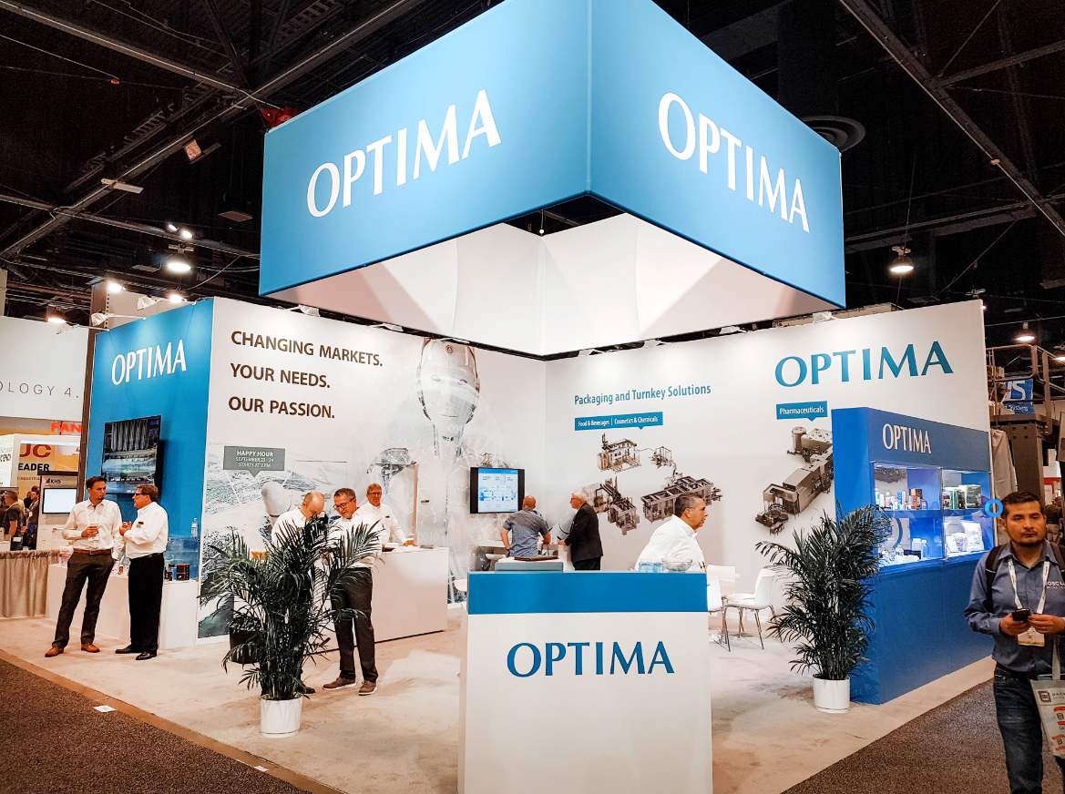
The Optima booth at the Pack Expo 2019. The US market is an important target market for Optima. (Source: Optima)

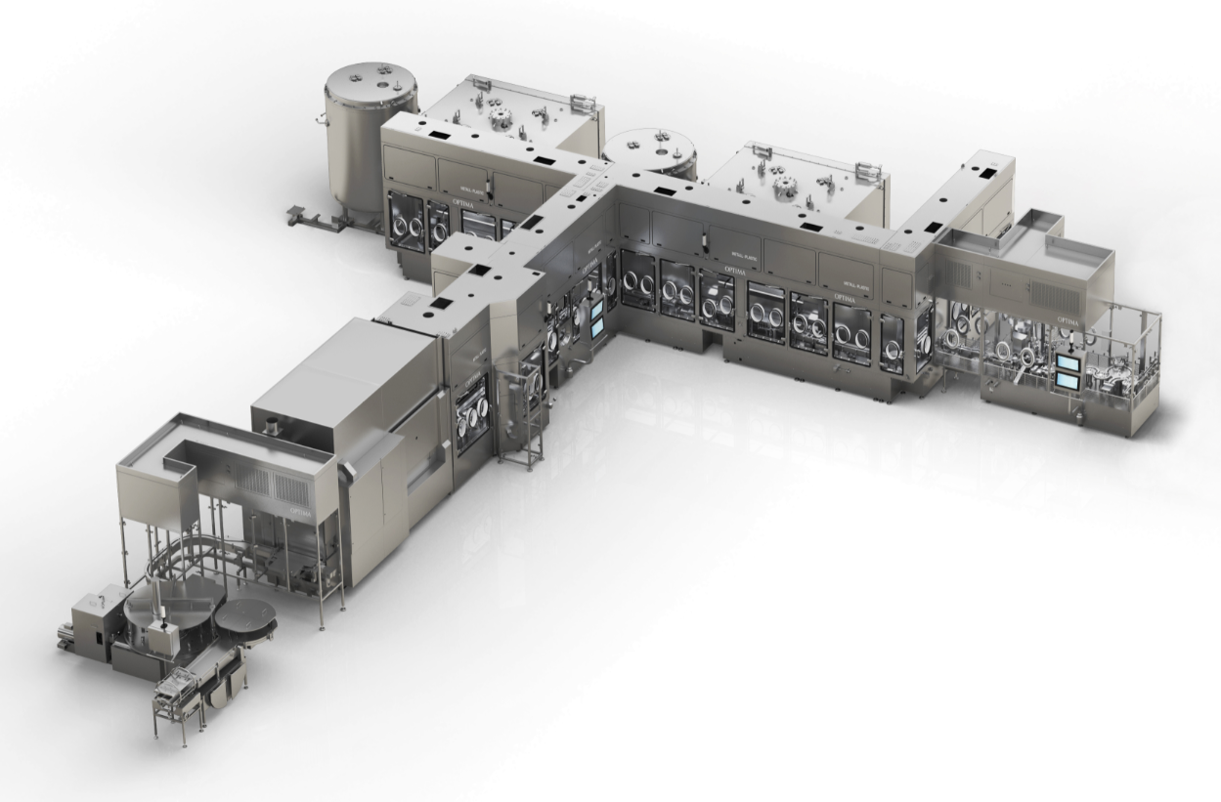
Optima Pharma’s strengths are optimally integrated turnkey lines with filling and closing machines, isolator and freeze-drying technology. (Source: Optima)

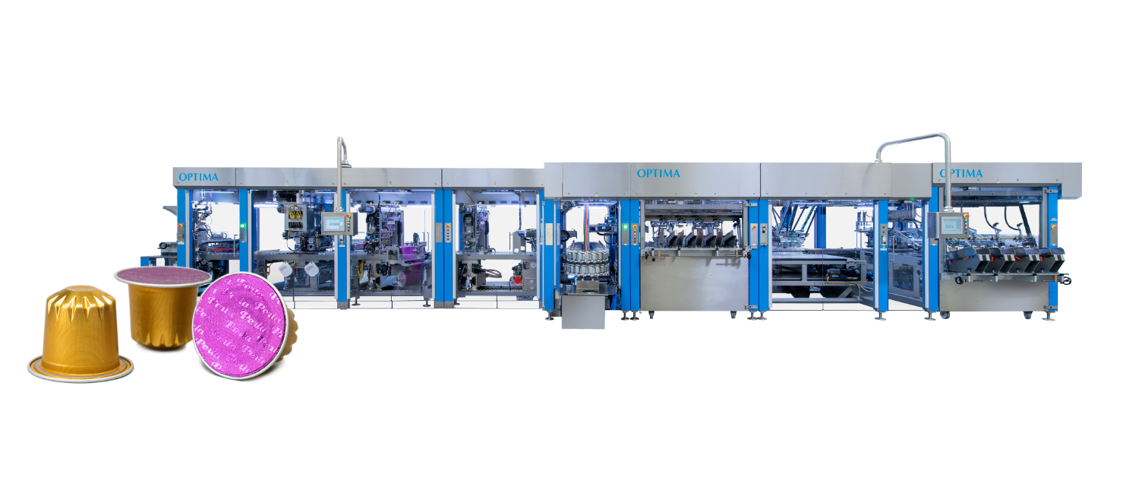
The business unit Optima Consumer offers leading machine technologies with a small footprint for portion packaging. This enables individual setting patterns of capsules to be produced at maximum speed. (Source: Optima)

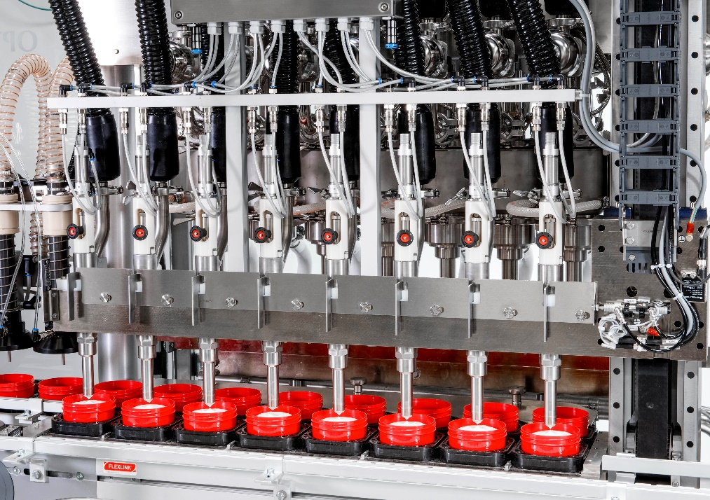
The cosmetics sales area of Optima Consumer develops and produces flexible filling systems for cosmetics with precise dosing systems. (Source: Optima)

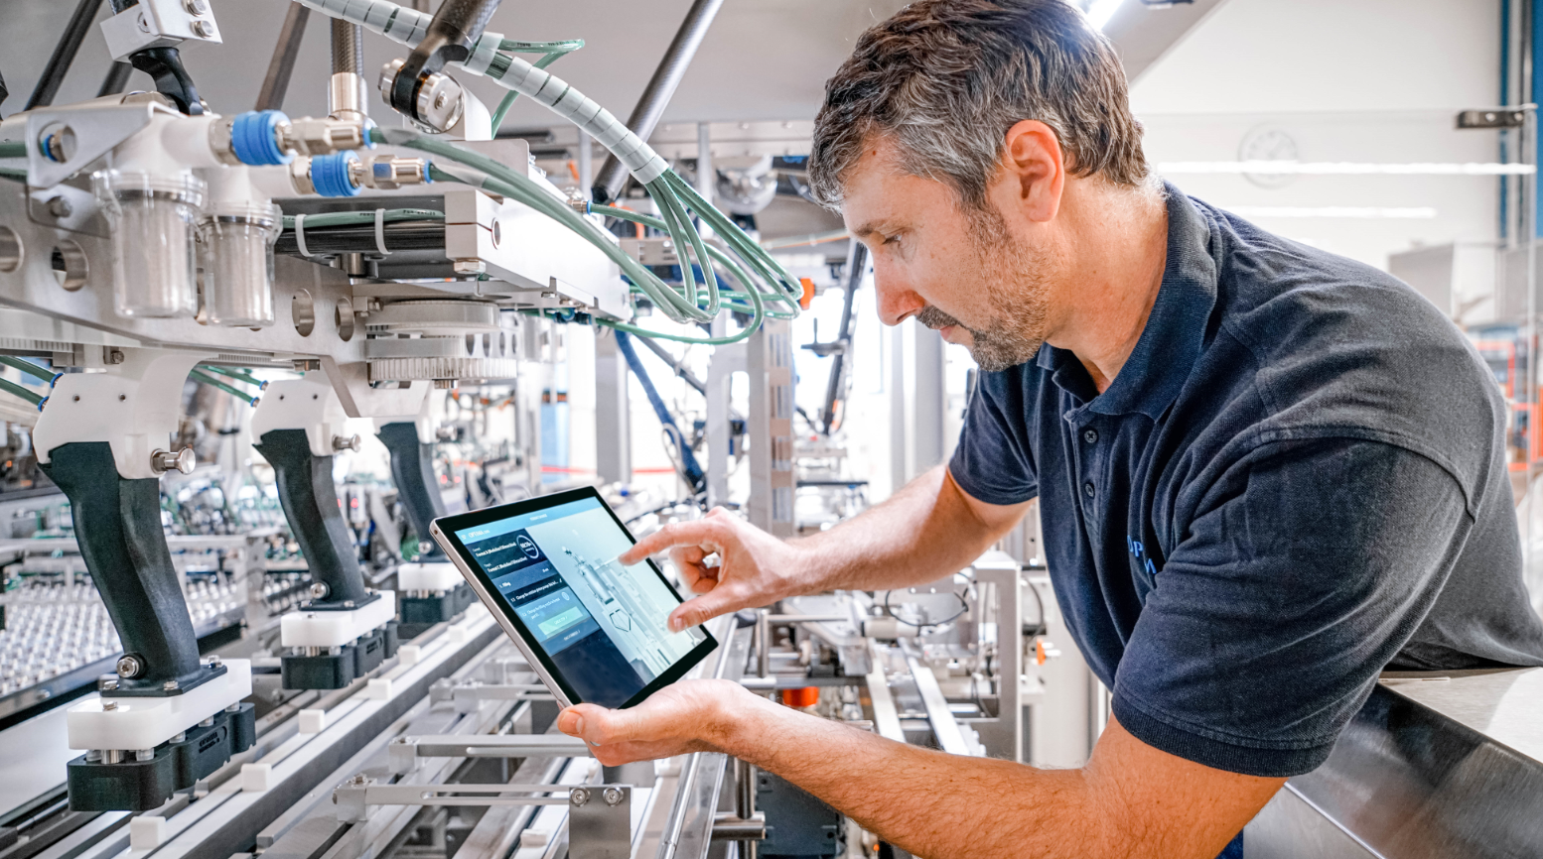
The Industrial IT department at Optima develops digital solutions. Shown here is a format change assistant providing helpful instructions on how to exchange format parts properly. (Source: Optima)

Characters (incl. spaces): 3,510

Press contact:
OPTIMA packaging group GmbH
Jan Deininger
Group Communications Manager
+49 (0)791 / 506-1472
jan.deininger@optima-packaging.com
www.optima-packaging.com

About OPTIMA
Optima supports companies worldwide with flexible and customer-specific filling and packaging machines for pharmaceuticals, consumer goods, paper hygiene and medical devices markets. As a provider of solutions and systems, Optima accompanies these companies from the product idea through to successful production and throughout the entire machine life cycle. Over 2,650 experts around the globe contribute to Optima's success. 19 locations in Germany and abroad ensure the worldwide availability of services.

Thank you very much for your publication. We look forward to receiving a specimen copy.

