PRESS RELEASE
Schwaebisch Hall, November 09, 2022

John Groth is the new Vice President Pharma
at OPTIMA Machinery Corporation
OPTIMA pharma is continuing to strengthen its market position in the USA

As of September 26, 2022, John Groth took over as Vice President Pharma at Optima Machinery Corporation. His appointment at the U.S. subsidiary based in Green Bay, Wisconsin further strengthens the Optima Group's pharmaceutical position in the USA, and sets the stage for continued growth.
"It feels like coming home," says Groth, who after seven years with another manufacturer, returns to Optima as Vice President Pharma USA. North America is an important and growing market for Optima, especially for the pharmaceuticals business unit. Reflecting the sustained high demand in the sector for machines, systems, and services, Optima is pressing ahead with the strategic expansion of its regional organizations.

"We are very pleased to have John Groth, an experienced manager who is very familiar with the specific needs of the pharmaceutical industry and Optima," says Gerhard Breu, Chairman of the Optima Pharma Division. "It shows that we take our partnership with our customers seriously and that we are doing all we can to continue to expand our market leadership in North America," says Breu.

Enabling growth through legacy and vision

John Groth will be responsible for managing all areas of Optima's Pharma Business Unit in the U.S. "I am very eager to be leading a group of highly talented experts and friends toward new success," says Mr. Groth. "We continue to grow our presence and lay the foundations for expanding our portfolio." For him, empowerment of a great team is the prerequisite for achieving great results.

With more than 13 years of experience in aseptic processing, Mr. Groth also brings more than 20 years of commercial finance experience. He recently completed his Master’s degree in Law from Northwestern University Law School and has degrees in Business Administration and Finance. "I understand our history and see the future, which for Optima is indeed very bright.”
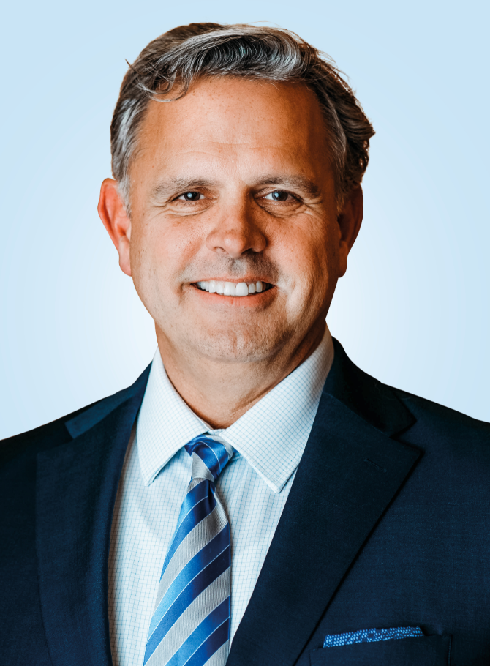
As of September 26, 2022, John Groth took over as Vice President Pharma at Optima Machinery Corporation. (Source: Optima)

Characters (incl. spaces): 2,040

Press contact:
OPTIMA packaging group GmbH
Jan Deininger
Group Communications Manager
+49 (0)791 / 506-1472
jan.deininger@optima-packaging.com
www.optima-packaging.com

About OPTIMA
Optima supports companies worldwide with flexible and customer-specific filling and packaging machines for pharmaceuticals, consumer goods, paper hygiene and medical devices markets. As a provider of solutions and systems, Optima accompanies these companies from the product idea through to successful production and throughout the entire machine life cycle. Over 2,800 experts around the globe contribute to Optima's success. 20 locations in Germany and abroad ensure the worldwide availability of services. In 2022, Optima celebrates the company's 100th anniversary.
Exciting stories from 100 years of Optima: www.100-years-of-future.com
Thank you very much for your publication. We look forward to receiving a digital specimen copy.

