LAUDA honors Theo Schlegelmilch for 40 years with the company

Reliable commitment to a wide range of tasks

Lauda-Königshofen, 25 February 2025 – LAUDA DR. R. WOBSER GMBH & CO. KG honored Theo Schlegelmilch on the occasion of his 40th anniversary with the company. In the presence of the management team, managing directors and other guests of honor, the long-serving employee was celebrated for his commitment and loyalty to the family-owned company.
Theo Schlegelmilch began his career at LAUDA on February 4, 1985, in parts production. In the following decades, the trained glazier worked in various departments of the company, including dispatch and powder coating. Since 2010, he has been working in the foaming shop, where he makes an important contribution with his expertise. Perfect insulation of the temperature control units is a decisive quality factor for precise temperature control.
In his laudatory speech, Dr. Gunther Wobser, President & CEO, paid tribute to the jubilee's outstanding achievements: “Theo Schlegelmilch is as versatile as a Swiss army knife. Over four decades, he has distinguished himself in various positions through his flexibility and willingness to learn. His continuous training and his many years of experience in setting up and dismantling trade shows make him a valuable employee.”
Sebastian Weißmann, Manager Production Refrigeration, emphasized the jubilarian's exemplary work ethic: “Theo is characterized by his clean and dedicated way of working. As an early riser, he always organizes his working day independently and reliably. As an experienced veteran of the foaming plant, he has contributed to the growth and current standing of LAUDA for over four decades – making him an important role model for the younger generation. His expertise will leave a big gap.”
Deputy Works Council Chairman Uwe Stastny paid tribute to Theo Schlegelmilch as a helpful, committed and friendly colleague who had also been a member of ‘IG Metall’ (Industrial Union of Metalworkers) for 40 years.
Dr. Wobser added: “Although the foaming department often works behind the scenes, it is indispensable for the quality of our appliances. Employees like Theo Schlegelmilch, who fulfill their tasks with dedication and precision, are the foundation of our family business.” In recognition of his many years of service, the jubilarian received the LAUDA certificate of honor.
Marco Hess, Deputy Mayor of the town of Lauda-Königshofen, conveyed the town's congratulations and emphasized the importance of long-standing employees in his speech: “If everyone sees themselves as an important cog in the company, as Mr. Schlegelmilch does, then the sum of all contributes to the big picture. LAUDA ensures growth, prosperity and jobs in our city and the region.” The official representative honored the jubilarian with a gift of wine and a certificate from the state of Baden-Württemberg, signed by Minister President Winfried Kretschmann.
For Theo Schlegelmilch, the transition to a new phase of life will begin on July 1, 2025, with the start of the partial retirement phase. The passionate hiker will then have more time for his hobby.

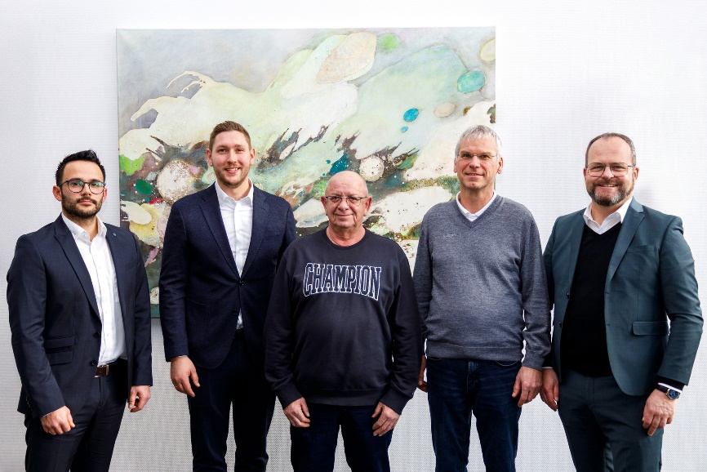

Picture: Theo Schlegelmilch (center) was honored for 40 years of service at LAUDA by President & CEO Dr. Gunther Wobser (right). Sebastian Weißmann (Manager Production Refrigeration, left), Marco Hess (Deputy Mayor of Lauda-Königshofen, 2nd from left) and Uwe Stastny (Deputy Chairman of the Works Council, 2nd from right) joined in the congratulations. © LAUDA

We are LAUDA – the world leader in precise temperature control. Our constant temperature equipment and systems are at the heart of important applications, contributing to a better future. As a complete one-stop supplier, we guarantee the optimum temperature in research, production and quality control. We are the reliable partner for electromobility, hydrogen, chemicals, pharmaceuticals/biotech, semiconductors and medical technology. We have been inspiring our customers for almost 70 years with our expert mentoring and innovative solutions – every day anew and all over the world.

In our company, we always go one step further. We support our employees’ development and are constantly developing ourselves: to create a better future together.

Press contact
We are more than happy to make prepared information about our company, the LAUDA Factory Gallery and our projects in the area of innovation promotion, digitalization and idea management available to the press. We look forward to hearing from you – just give us a call!

CHRISTOPH MUHR
Director Corporate Communications
T + 49 (0) 9343 503-349
christoph.muhr@lauda.de

LAUDA DR. R. WOBSER GMBH & CO. KG, Laudaplatz 1, 97922 Lauda-Königshofen, Deutschland/Germany. Limited partnership: Headquarters Lauda-Königshofen, Registration court Mannheim HRA 560069. General partner: LAUDA DR. R. WOBSER Verwaltungs-GmbH, Headquarters Lauda-Königshofen, Registration court Mannheim HRB 560226. Managing Directors: Dr. Gunther Wobser (President & CEO), Dr. Mario Englert (CFO), Dr. Marc Stricker (COO)

