Jiajia Zhang  22 April – 27 August 2023, Kunstmuseum St. Gallen  The Kunstmuseum St. Gallen presents the first solo museum exhibition of Jiajia Zhang (*1981 Hefei, China). Working primarily with found footage, Zhang creates elegiac, emotive and often personal photographic series and film collages. These works deal with the questions about how platforms like YouTube, Instagram, and TikTok with their constant stream of images shape our reality.  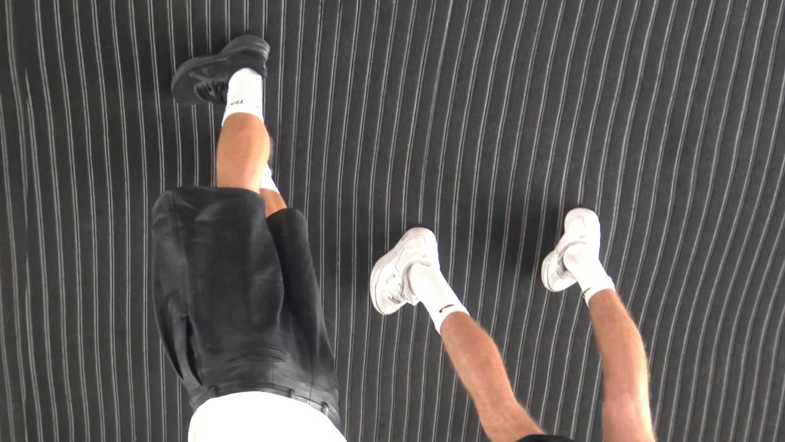  Jiajia Zhang, Beautiful Mistakes (after LB), 2022, Videostill, HD Video, 08:58, 16:9, Color, Sound, Courtesy the artist  At the Kunstmuseum St. Gallen, Zhang will show new site-specific photographic and sculptural works commissioned for the exhibition. In addition, selected artworks from the collection of the Kunstmuseum St. Gallen will be shown alongside these new works.  Staged in the lower level exhibition space of the Kunstmuseum St. Gallen, the exhibition uses the architecture of the galley to explore relationships between public and private space. With its exposed concrete walls and prominent ramp, this gallery is reminiscent of public or semi-public infrastructure such as a train station underpass or an empty shopping arcade: spaces that connect and blur inside and outside.  The artist is interested in the tension between these opposing spaces within architecture as well as the context of social media. Zhang’s work considers how a public sphere is permeated with personal images, private narratives, and vulnerable moments presented to a shared audience of millions. Yet this audience is far from public and consists of individual viewers, consuming content alone – in bed, on the sofa, in the privacy of one's home.  Zhang’s exhibition emphasizes the peculiar atmosphere of the exhibition space as a transitional space populated by elements taken from public space. At the same time, the artist incorporates artworks and installation elements that refer to the domestic sphere, such as warm lighting and furniture to create an – at times immersive – exhibition that oscillates between cold, anonymous infrastructure and intimate, private moments. A kind of "inner public" emerges, whose emotionality and experience are central to Zhang's art.  Jiajia Zhang studied architecture at ETH Zurich from 2001-2007 and photography at the International Center of Photography, New York from 2007-2008. She graduated with a Master of Fine Arts degree from Zurich University of the Arts (ZHdK) in 2020. Her work has been part of various group exhibitions including Swiss Art Awards, Basel (2022); Werkstipendium Zürich (2022); FriArt, Fribourg (2022); Kunsthaus Glarus (2021); Fondation d'entreprise Pernod Ricard, Paris (2021); Haus Wien (2020); Kunsthalle Zürich (2020); Kunst Halle Sankt Gallen (2019). In 2021, COALMINE, Winterthur hosted her solo exhibition “If Every Day Were a Holiday, Towns Would Be More Mysterious”, and in the fall of 2022, she received the Shizuko Yoshikawa Grant. Zhang is currently completing a six-month residency at the Istituto Svizzero in Milan. | Exhibition dates  22 April – 27 August 2023  Kunstmuseum St. Gallen  Press conference  Friday, 21. April 2023  11 am  Exhibition opening  Friday, 21. April 2023  6.30 pm  Opening hours  from March 1, 2023  Tue-Sun 10am-5pm  Thu 10am-8 pm

Factsheet
Jiajia Zhang

Exhibition dates | 22. April – 27. August 2023
Location | Kunstmuseum St. Gallen
Press conference | Friday, 21 April 2023, 11 am, Kunstmuseum St. Gallen
Exhibition opening | Friday, 21 April 2023, 6.30 pm, Kunstmuseum St. Gallen
Curator | Melanie Bühler
Opening hours, as of March 1, 2023 | Tuesday-Sunday 10am-5pm  Thursday 10am-6pm
Admission | Single admission  AHV/IV recipients  Reduced admission  Members of the Kunstverein St.Gallen | CHF 12.–  CHF 10.–  CHF 5.–  Free
Press contact | Gloria Weiss  Head of communication  T +41 71 242 06 84  Sophie Lichtenstern  Communication  T +41 71 242 06 85  kommunikation@kunstmuseumsg.ch
Website | www.kunstmuseumsg.ch

