Special mention for the world's most UV-resistant GRP face sheet

LAMILUX SUNSATION® wins German Innovation Award

LAMILUX SUNSATION®, the innovative gelcoat technology, has impressed the renowned jury of the German Innovation Awards for the second time. After last year's "Winner" award, LAMILUX SUNSATION® has now also won the "Special Mention" in the "Excellence in Business to Business - Materials & Surfaces" category.

In 2022, Europe's leading manufacturer of fibre-reinforced composites, LAMILUX Composites, presented LAMILUX SUNSATION®, the world's most UV-resistant GRP face sheet and one of the most revolutionary developments in the world of glass fibre-reinforced plastics.

Remarkable innovation
Extreme colour and gloss retention and no colour difference when removing decals from surfaces: LAMILUX SUNSATION® sets a new benchmark in the quality standard of glass fibre-reinforced plastics. In artificial weathering tests, such as according to DIN EN ISO 4892-2, LAMILUX SUNSATION® demonstrates absolute resistance. Even after 15 to 20 years of real weathering, LAMILUX SUNSATION® retains its rich colours and maximum gloss. The results of the tests confirm the revolutionary development for GRP exterior applications.

The ultimate plus: LAMILUX SUNSATION® significantly reduces the care requirements of exterior applications. Surfaces that do not dull and do not lose their gloss do not need to be waxed for preventive protection or subsequent repair. In figures, this means: 90 percent less effort and expense for waxing, thanks to the use of LAMILUX SUNSATION®. The German Innovation Award honours LAMILUX SUNSATION® for this remarkable innovation with the "Special Mention" in the category "Excellence in Business to Business - Materials & Surfaces".

About the German Innovation Award
The German Innovation Award honours innovation achievements whose added value breaks new ground. The focus is always on the user experience: solutions that make life better and contribute to a better future.

…

www.lamilux.com

About LAMILUX Composites GmbH
LAMILUX Composites GmbH has been producing fibre-reinforced composites for around 70 years. The medium-sized company is a leading European producer thanks to its technologically advanced continuous production process, large manufacturing capacities and wide product range. LAMILUX supplies customers around the globe in a wide range of sectors, such as the building industry, the automotive and recreational vehicle sectors, refrigerated store room and cell construction, and many other industrial sectors. With more than 1,300 employees, LAMILUX generated a turnover of 392 million euros in 2022. The family-managed company is based in Rehau, Bavaria.

Image caption
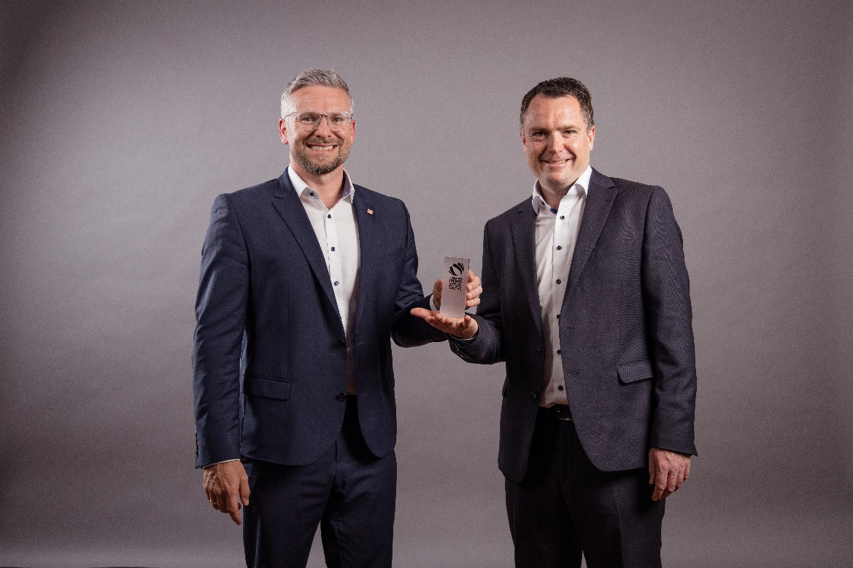
Product Manager Sascha Oswald and Marketing Officer Markus Bächer are delighted with the award for LAMILUX SUNSATION®.

