LAMILUX offers a wide range of variants for fire protection safety

**LAMILUX Fire Resistance range of skylights withstands heat and fire**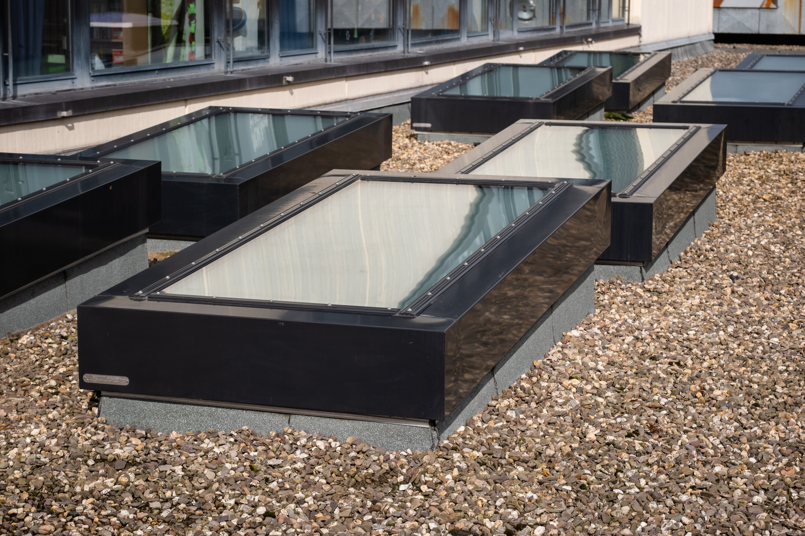

*Caption: LAMILUX Glass Skylights Fire Resistance REI90*

### Fire resistant skylights withstand fire and heat for a certain period of time, thus protecting lives, property and possessions. Skylight manufacturer LAMILUX from Rehau offers a wide range of variants for optimum fire safety. The LAMILUX Fire Resistance series is available in two different skylight variants and three different fire resistance classes. The LAMILUX Glass Skylights Fire Resistance withstand fire and heat for 30, 60 or 90 minutes. The LAMILUX Glass Roofs Fire Resistance for 30 or 60 minutes.

Fire resistant skylights are mainly used in public buildings where a large number of people are present, such as educational establishments, shopping centres and cultural facilities. The time period for which the fire resistant skylight must withstand fire and heat is specified in the requirements for the skylight. LAMILUX Fire Resistance Skylights are protected by heat and fire resistant glazing, which has been tested under additional load.

**LAMILUX Glass Skylights Fire Resistance**

The product LAMILUX Glass Skylight Fire Resistance in the fire resistance classes REI 30 and REI 60 has already proven itself on the market for several years. With the new Glass Skylight Fire Resistance REI 90, the skylight manufacturer LAMILUX has succeeded in extending this protection even further: For at least 90 minutes, the Glass Skylight Fire Resistance REI 90 withstands fire and heat and prevents flames from spreading to other parts of the building in case of fire. Regardless of the fire resistance period, the fire protection glass skylight can be installed on roofs with a pitch of up to 15 degrees. In addition to preventing the spread of fire, it also offers optimised water and dirt drainage thanks to the 5° inclination of the skylight.

**LAMILUX Glass Roof Fire Resistance**

In the two fire resistance classes REI 30 or REI 60, the LAMILUX Glass Roof Fire Resistance guarantees 30 or 60 minutes of load-bearing capacity in case of fire and prevents the spread of fire. It can be designed as a monopitch roof with an inclination of 2 to 80 degrees. Thanks to filigree cover strips, it is indistinguishable from classic LAMILUX glass roofs from the outside and requires no additional support elements due to its self-supporting construction.

LAMILUX Heinrich Strunz Group, Rehau

Continuous rooflights, glass roofs or rooflights: the LAMILUX Heinrich Strunz Group is one of the leading manufacturers of skylights in Europe. The skylights ensure efficient use of natural daylight in a wide variety of buildings. In addition, special smoke and heat extraction systems provide safety in case of fire and are therefore essential components of fire protection concepts. LAMILUX is also known for its solutions for object smoke extraction. Furthermore, the medium-sized family business founded in 1909 is one of the world's largest producers of carbon and glass fibre reinforced plastics. These composite materials provide stability, lightweight construction and impact resistance for instance in roof, wall and floor linings in commercial vehicles. LAMILUX strives to be the innovation and performance leader in all areas relevant to its customers. The family-owned company, based in Rehau, Germany, is managed by Johanna and Dr. Alexander Strunz in the fourth generation, currently employs around 1,300 people, and in 2023 generated sales of around 354 million euros.

[www.lamilux.com](http://www.lamilux.com)