PRESS RELEASE
Schwaebisch Hall, November 7, 2018

P-MEC India 2018

Tapping into synergy effects
R+E Automation showcases assembly machines for pen and auto-injectors and blood collection tubes

In addition to Optima Pharma, one of the newest members of the Optima Group will also be exhibiting at P-MEC: R+E Automation, based in Fellbach near Stuttgart (Germany). The company manufactures assembly machines for products including pen and auto-injectors and blood collection tubes, and complements the portfolio of the Optima Pharma division.
“Anything with a needle is a matter for R+E,” says Eugen Wanner, Director International Sales. The company is presenting its portfolio at P-MEC in the Indian city of Delhi from December 12 to 14, 2018. Not only does this include assembly machines for pen and auto-injectors and blood collection tubes, it also incorporates feed systems. The machines fit syringes that have been filled by Optima Pharma’s systems in the pen and auto-injectors used by diabetes patients, for example. This means that customers receive complete systems that integrate technologies and expertise from both R+E and Optima Pharma.
Assembly solutions for this application are the main focus at the trade fair, as is the company’s latest innovation: an assembly system for blood collection tubes that can be used to process all common additives.
Further information is available at: www.re-automation.de.
R+E and Optima Pharma at P-MEC India 2018 in Greater Noida, Delhi: December 12-14, 2018: Hall 11, Booth no. D07

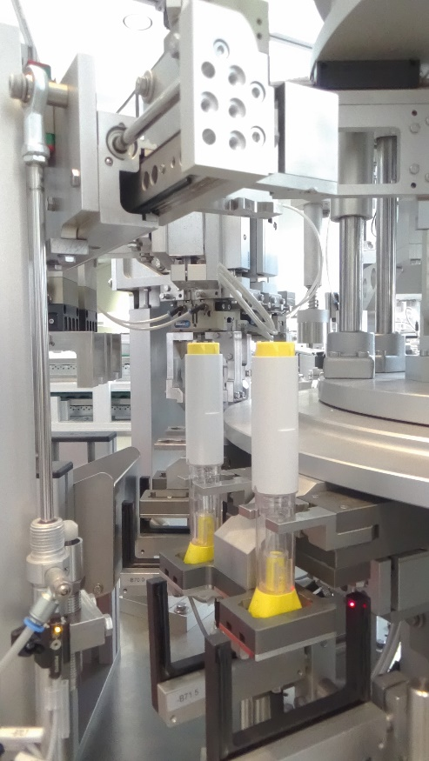
Assembly systems for pen and auto-injectors are one of R+E Automation’s strengths.

Characters (incl. spaces): 1,365

Press contact:
OPTIMA packaging group GmbH
Jan Deininger
Editor
+49 (0)791 / 506-1472
jan.deininger@optima-packaging.com
www.optima-packaging.com
Thank you very much for your publication. We look forward to receiving a specimen copy.

