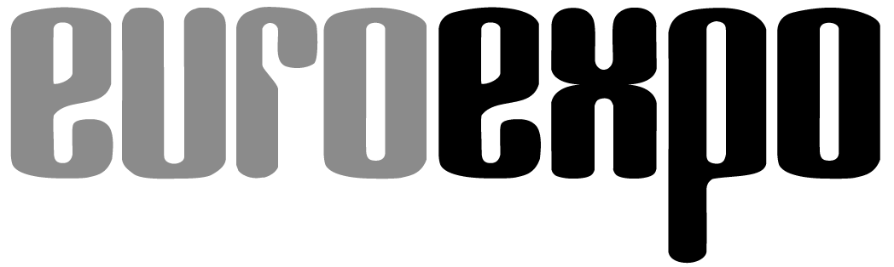
Messe- und Kongress-GmbH
Joseph-Dollinger-Bogen 7
D-80807 Munich, Germany
Phone: +49 (0)89 32391-259
Fax: +49 (0)89 32391-246
www.euroexpo.de/en
www.logimat-messe.de/en
www.tradeworld.de/en

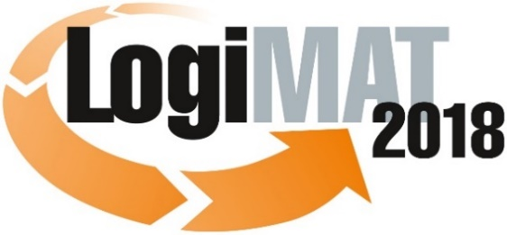

The 16th International Trade Show for
Intralogistics Solutions & Process Management
March 13–15, 2018 | Messe Stuttgart

Also featured at LogiMAT:
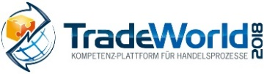

Munich, January 29, 2018

Invitation to PRESS EVENT at 16th LogiMAT
Tuesday, March 13, 2018 | Messe Stuttgart

Dear press representative,

We are proud to present LogiMAT 2018 with this year’s theme “Intralogistics from the Source: Digital—Connected—Innovative,” featuring over 1,500 international exhibitors filling 117,000 square meters in all exhibit halls of the Stuttgart Messe convention center. Regarded as the world’s premier trade show for intralogistics solutions and supply chain management, LogiMAT gives industry professionals insights into winning ideas and emerging trends and a sneak peek at exciting innovations, many never before seen anywhere else in the world.

LogiMAT 2018 focuses on the key drivers and challenges of intralogistics—Industry 4.0, human-to-machine communication, big data, end-to-end digitization of supply chain processes—along with the integration of intralogistics, production, and trade.

Visitors benefit from an excellent accompanying program, making LogiMAT a trade show with the added value of an industry conference. Over 100 speakers from the business and academic communities will offer a program of 33 presentations in forums held right in the exhibitor halls. Live events also offer real-world insights into trends and solutions on the issues that move today’s markets.

For the fifth time, LogiMAT will also host TradeWorld, featuring innovative solutions for the development and deployment of e-commerce processes. The exhibitors—especially those participating in the TradeWorld expert forum with its own series of presentations in Hall 6—will focus on the design, control, and integrated digitization of procurement, software, online shops, fulfillment, parcel services, and returns.

We would be delighted if you would join us to experience the many brand-new innovations debuting at LogiMAT 2018 and celebrate the winners of the BEST PRODUCT award to be presented at the opening ceremony.
– Page 2, press invitation to LogiMAT/TradeWorld 2018 –

We would like to personally invite you to three special events:

Opening ceremony of LogiMAT 2018
followed by presentation of BEST PRODUCT awards

Tuesday, March 13, 2018 | 9:30–10:30 a.m. | Forum A, Hall 1 (German/English)

Opening remarks: Peter Kazander, Director of LogiMAT 2018, Managing Director of EUROEXPO Messe- und Kongress-GmbH, Munich

Keynote:
“Digitization: The three most important questions nobody is asking”

Ömer Atiker, author, digital transformation expert

Presentation of award for BEST PRODUCT 2018 in three categories:
1. Software, communications, IT
2. Order picking, conveying, lifting, and storing technology
3. Identification, packaging and loading technology, load securing

Presenter: Prof. Johannes Fottner (Dr.-Ing.), Chair of the Institute for Materials Handling, Material Flow, Logistics at the Technical University of Munich

PRESS EVENT at LogiMAT 2018

When: Tuesday, March 13, 2018 | 1:00–2:00 p.m.

Moderator: Peter Kazander, Director of LogiMAT 2018,
Managing Director, EUROEXPO Messe- und Kongress-GmbH

Featuring industry representatives and the winners of the BEST PRODUCT award

Where: Press Center at Messe Stuttgart, East Entrance

Get-Together 2018

Tuesday, March 13, 2018 | 5:00 p.m. | ATRIUM, East Entrance

Join the exhibitors to wind down at the end of day one at our traditional get-together featuring free beer and finger food.

We look forward to your visit!

Best regards from Munich,
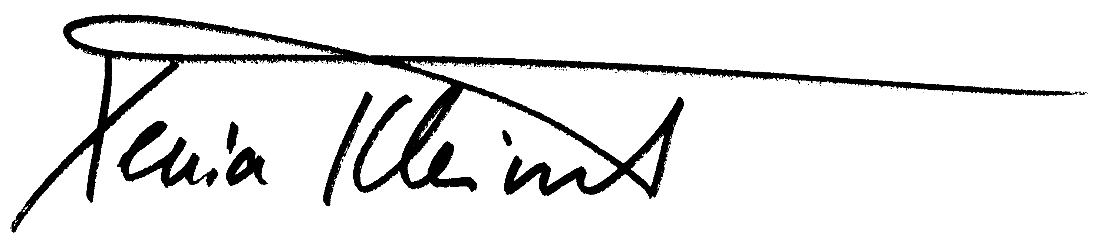

Xenia Kleinert
Head of Press and Public Relations

