PRESS RELEASE
Schwaebisch Hall, June 15, 2020

OPTIMA is investing in its headquarters
1,600 square meters of additional assembly space

Optima has invested 3.5 million euros in renovations at its headquarters in Schwaebisch Hall, thereby reinforcing its commitment to operations at this location. A new 1,600 square meter assembly area has been created along with the corresponding infrastructure. This means that machines can now be assembled even more efficiently. Employees benefit from an ultra-modern infrastructure and optimized air-conditioning.
As part of the restructuring of Optima Materials Management and the opening of the Optima Logistics Center in July 2019, the high-bay warehouse at the Steinbeisweg site was no longer needed and has been dismantled. The new assembly area “Nonwovens West” measuring 1,600 square meters has now been erected at this site. This was gradually brought into operation in March 2020 and has been in full use since May 2020. As a result, the Optima Nonwovens business unit now has a total assembly area of 5,200 square meters. The facility is equipped with the latest gigabit network cabling. This means that Optima Nonwovens has been ideally prepared for virtual acceptance tests. Cranes capable of bearing loads of up to 5 metric tons facilitate the relocation of assemblies and machine modules.

Pleasant working conditions
The statics as well as the light domes were also renewed in the course of this project, which now allow considerably less heat into the building, provide brightness and enable better air circulation. The working conditions for the staff in the warehouse, in parts production, and assembly have significantly improved as a result. A porch with a special air lock and three high-speed doors in the goods receiving area also protects the staff inside the building against draughts. Dimmable LED lighting strips have been fitted to the walls for optimal lighting. A catering area for the staff has also been included. The entire site including the administrative block is supplied with district heating.

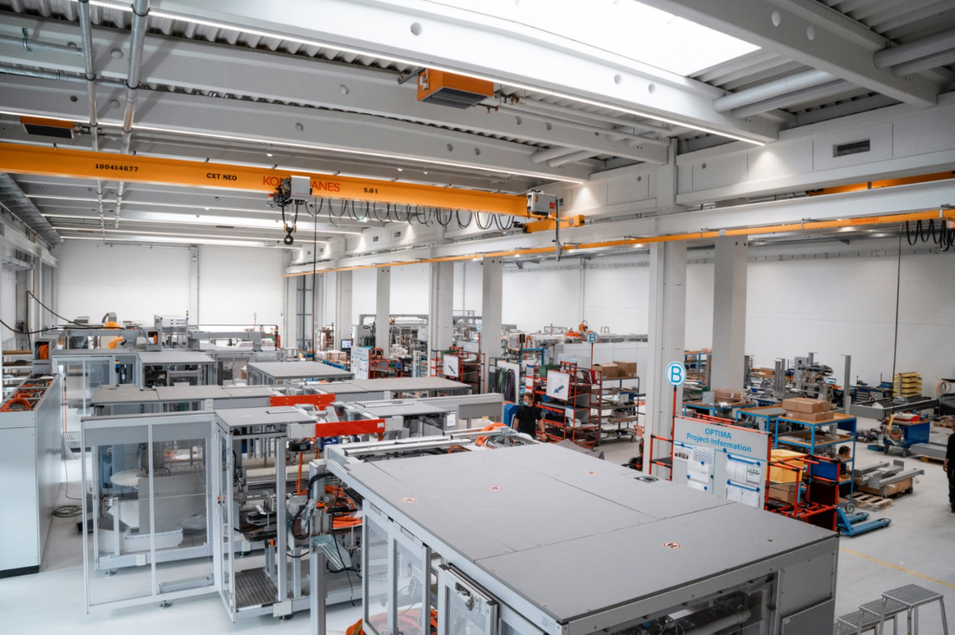
The Optima Nonwovens business unit has had an additional 1,600 square meters of assembly space since the beginning of this year. (Source: Optima)

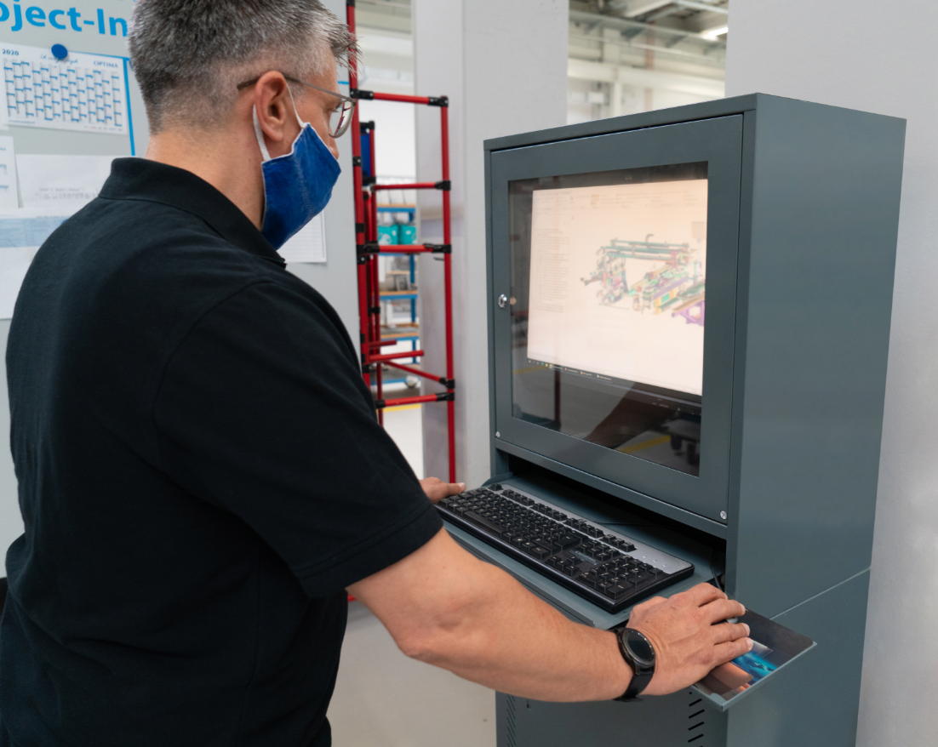
Particular attention was paid to the digital infrastructure during the design phase. Computer terminals provide access to information about the systems at any time. (Source: Optima)

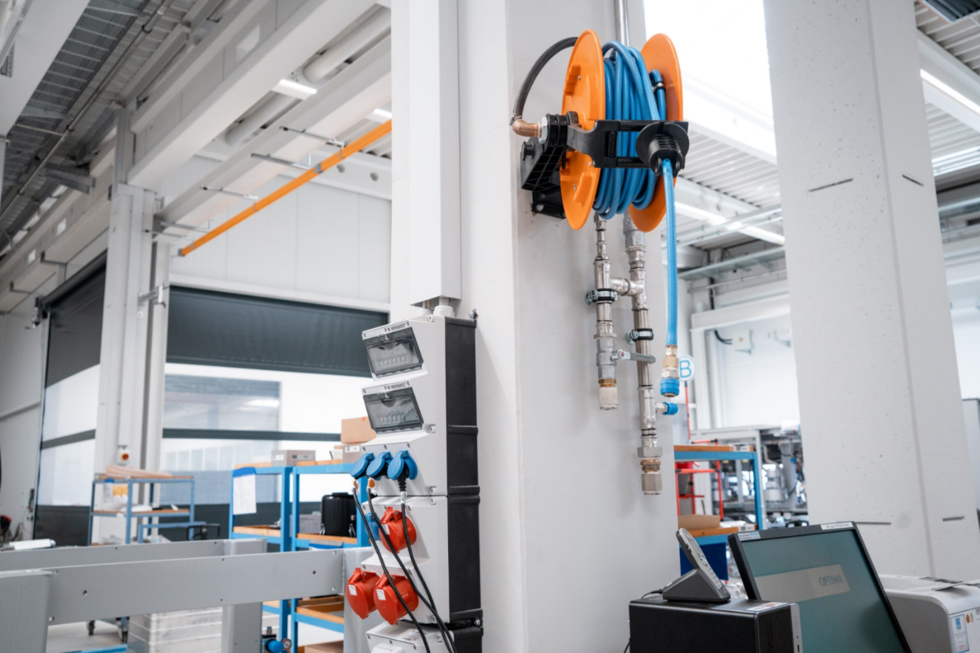
Gigabit and media connections ensure rapid assembly and acceptance processes. (Source: Optima)

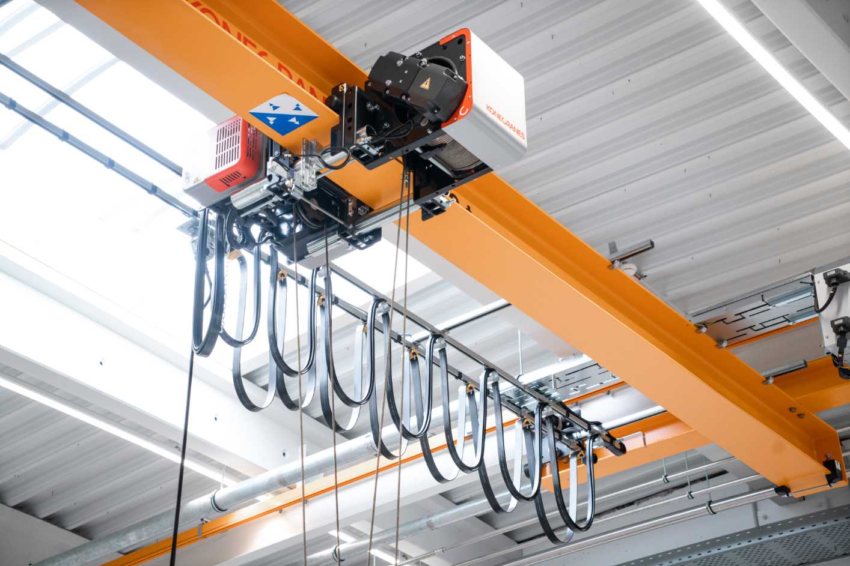
Heavy-duty cranes capable of bearing loads of up to 5 metric tons improve safety and facilitate the relocation of assemblies and machine modules. (Source: Optima)

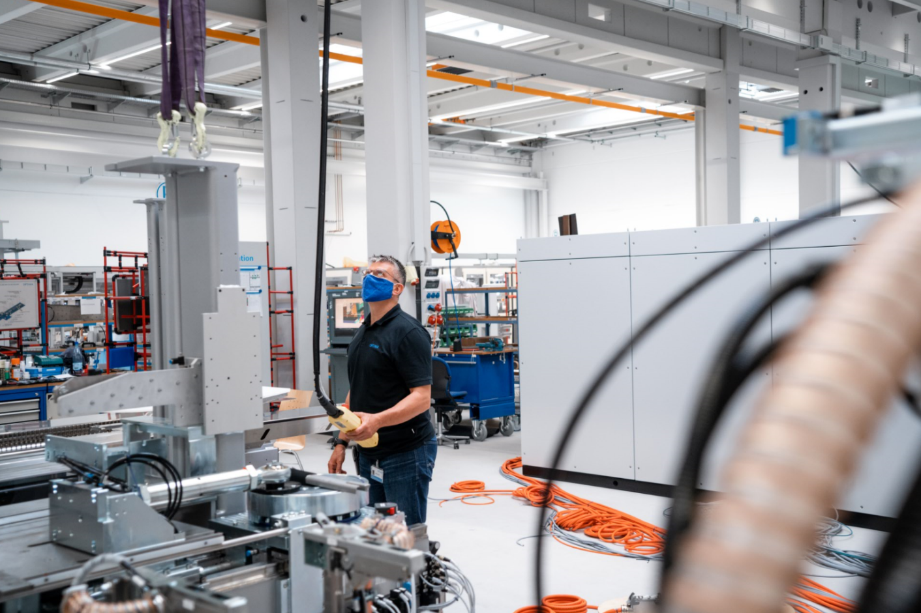
A member of Optima's staff is operating one of the heavy-duty cranes. (Source: Optima)

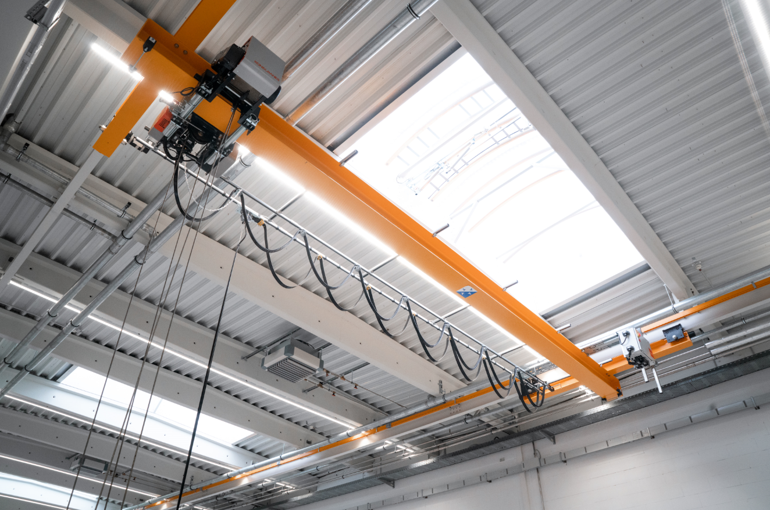
The domelights were renewed. Now considerably less heat penetrates into the building, light conditions and air circulation improve. (Source: Optima)

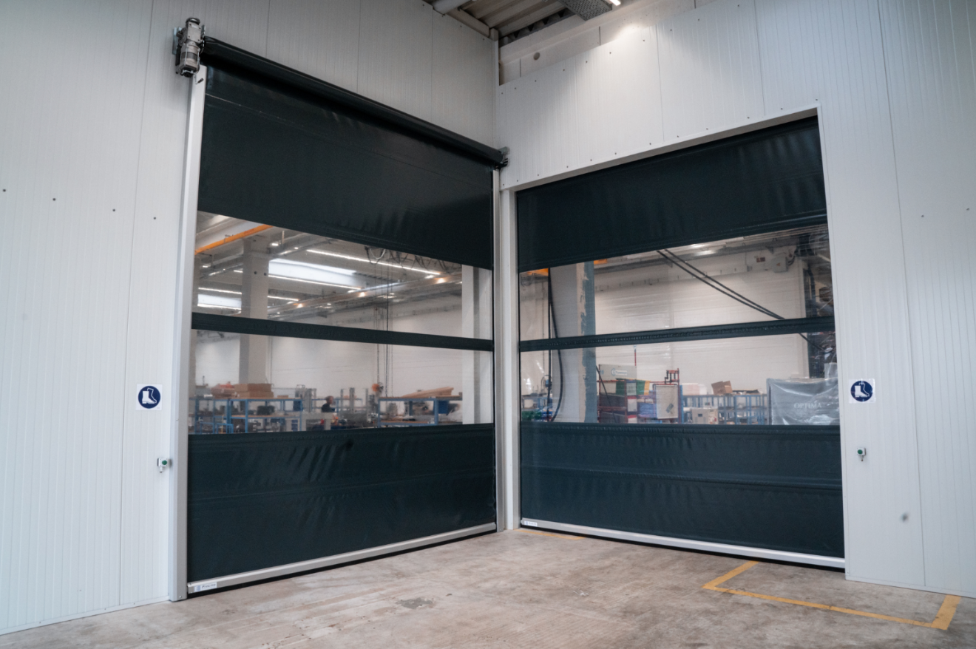
High-speed doors protect the staff working inside the factory against draughts. (Source: Optima)

Characters (incl. spaces): 2,364

Press contact:
OPTIMA packaging group GmbH
Jan Deininger
Editor
+49 (0)791 / 506-1472
jan.deininger@optima-packaging.com
www.optima-packaging.com
Thank you very much for your publication. We look forward to receiving a specimen copy.

