Temperature Control Specialist Honors Global Sales Achievements

LAUDA Award for APP Systems Services, Asistec, Berner and LAUDA-Brinkmann

Lauda-Königshofen, April 17, 2026 – LAUDA DR. R. WOBSER GMBH & CO. KG, the world market leader in precise temperature control, is honoring four sales partners with the LAUDA Award: APP Systems Services Pte Ltd (Singapore), RTD Technology Ltd T/A Asistec (Ireland), Berner Ltd (Finland), and the U.S. subsidiary LAUDA-Brinkmann, LP (Marlton, New Jersey). The awards recognize outstanding sales performance and sustainable growth in 2025 across different regions and industries.

APP Systems Services Pte Ltd (Singapore) – Continuous Growth Over Five Years
APP Systems Services Pte Ltd receives the LAUDA Award for the long-time agency with continuous increase in sales for a remarkable growth story: the distributor, founded in 1982 and employing around 170 people, significantly increased its sales from 2020 to 2025. With LAUDA-Noah process thermostats, APP Systems Services serves the semiconductor market in Singapore, Malaysia, Thailand, the Philippines, Indonesia, India, and Vietnam.

RTD Technology Ltd T/A Asistec (Ireland) – New Agency With Outstanding Sales Success
Already in its first fiscal year as a LAUDA partner, Asistec achieved impressive results – including a major project with four LAUDA Integral XT 550 process thermostats for the pharmaceutical industry. As a new agency with outstanding sales success, Asistec is being honored with the LAUDA Award. Tony Harbison, Owner and Managing Director of the company founded in 2009, brings approximately 40 years of experience in scientific and laboratory environments and operates in one of Europe's most dynamic pharmaceutical markets.

Berner Ltd (Finland) – Highest Sales Increase
Due to a sales increase of 75 percent within one year, Berner receives the LAUDA Award as the most important agency with the highest sales increase. This growth is driven by the core markets of chemistry, pharma, and bioproduction. Since April 1967 – and thus for nearly 60 years – Berner has been one of the most reliable partners of LAUDA. With locations in Finland, Sweden, Denmark, Norway, and Estonia, the distributor covers the entire Nordic-Baltic region.

LAUDA-Brinkmann, LP (USA) – Best Agency for Plant Engineering
With outstanding results in the field of plant engineering, LAUDA-Brinkmann has secured the LAUDA Award “Best Agency for Plant Engineering” and has established this business area as a new growth driver in the North American market. The subsidiary, founded in 2008 as the successor to Brinkmann Instruments, serves the entire North American region. CEO and General Manager Michael Faulkner and his team have thereby created a solid foundation upon which LAUDA will strategically expand its plant engineering business in the areas of pharma, pharmaceutical chemistry, and automotive in North America.

Dr. Gunther Wobser, President & CEO of LAUDA, emphasizes the importance of global partnerships: “APP Systems Services, Asistec, Berner, and our own subsidiary LAUDA-Brinkmann represent what sets LAUDA apart worldwide: partners who know their markets, are technically competent, and deliver results. Their dedication and market expertise are the cornerstone of our international growth – and proof that strong partnerships are the decisive success factor in global competition.”

LAUDA will continue to deepen its existing partnerships in the coming years and will strategically expand its international sales in the pharma, semiconductor, chemistry, and plant engineering sectors.

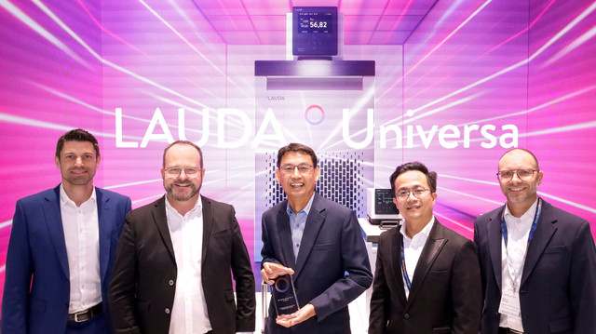  Picture 1: LAUDA Award “Long-Time Agency With Continuous Increase in Sales During the Last Five Years”: CP Lee, Director of Sales & Marketing at APP Systems Services Pte Ltd (center), accepted the award. From left: Felix Heinrich-Bignasse, Director Global Sales; Dr. Gunther Wobser, President & CEO of LAUDA; Chris Pang, Managing Director of LAUDA Singapore; and Marco Hauser, Managing Director of Degree LAUDA Precision. © Jürgen Besserer for LAUDA | 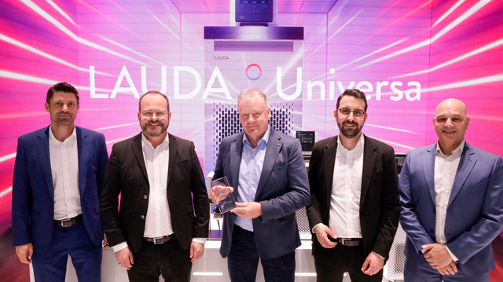  Picture 2: LAUDA Award “New Agency With Outstanding Sales Success”: Tony Harbison, Owner and Managing Director of RTD Technology Ltd T/A Asistec (center), accepted the award. From left: Felix Heinrich-Bignasse, Director Global Sales at LAUDA; Dr. Gunther Wobser, President & CEO of LAUDA; Dr. Tobias Busch, Area Sales Manager at LAUDA; and Paul King, Managing Director of LAUDA Technology. © Jürgen Besserer for LAUDA
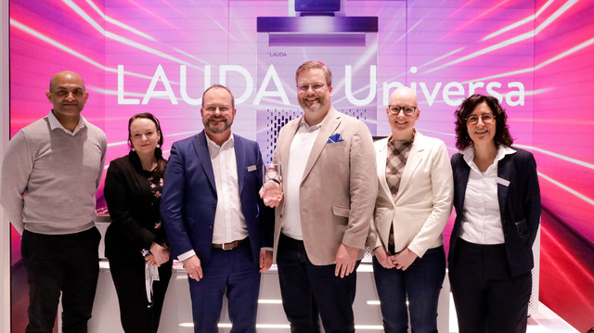  Picture 3: LAUDA Award “Important Agency With Highest Sales Increase”: Antti Jokipii of Berner Ltd (third from right) accepted the award. From left: Atif Javaid, Sales Manager Denmark, Sweden & Norway at Berner; Suvi Kemmo, Sales Director Nordics & Baltics at Berner; Dr. Gunther Wobser, President & CEO of LAUDA; Riitta Tamminen, Sales Specialist Finland at Berner; and Dr. Marta Garijo Añorbe, Area Sales Manager at LAUDA. © Jürgen Besserer for LAUDA | 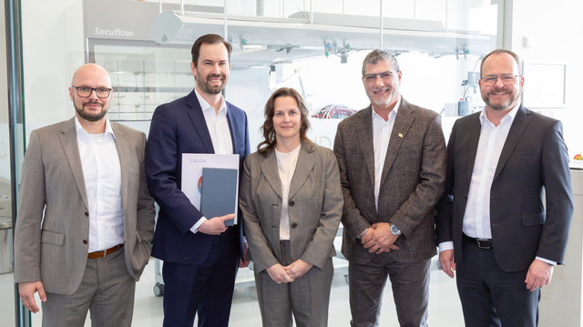  Picture 4: LAUDA Award “Best Agency for Plant Engineering”: Michael Faulkner, CEO & General Manager of LAUDA-Brinkmann (second from left), accepted the award. From left: Dominik Müller, Director Project Management Plant Engineering at LAUDA, Dr. Gunther Wobser, President & CEO of LAUDA, Susan Colfer, COO of LAUDA-Brinkmann, and Jeff Wilson, Director of Sales – North America at LAUDA-Brinkmann. © Jürgen Besserer for LAUDA

We are LAUDA – the world leader in precise temperature control. Our constant temperature equipment and systems are at the heart of important applications, contributing to a better future. As a complete one-stop supplier, we guarantee the optimum temperature in research, production and quality control. We are the reliable partner for Aerospace, Electromobility, Hydrogen, Chemistry, Pharmaceuticals/Biotech, Semiconductors and Medtech. We have been inspiring our customers for over 70 years with our expert mentoring and innovative solutions – every day anew and all over the world.

In our company, we always go one step further. We support our employees’ development and are constantly developing ourselves: to create a better future together.

Press contact
We are more than happy to make prepared information about our company, the LAUDA Factory Gallery and our projects in the area of innovation promotion, digitalization and idea management available to the press. We look forward to hearing from you – just give us a call!

CHRISTOPH MUHR
Director Corporate Communications
T + 49 (0) 9343 503-349
christoph.muhr@lauda.de

LAUDA DR. R. WOBSER GMBH & CO. KG, Laudaplatz 1, 97922 Lauda-Königshofen, Deutschland/Germany. Limited partnership: Headquarters Lauda-Königshofen, Registration court Mannheim HRA 560069. General partner: LAUDA DR. R. WOBSER Verwaltungs-GmbH, Headquarters Lauda-Königshofen, Registration court Mannheim HRB 560226. Managing Directors: Dr. Gunther Wobser (President & CEO), Dr. Mario Englert (CFO), Dr. Marc Stricker (COO)

