## Two decades of LAUDA France

### First foreign subsidiary celebrates its 20th anniversary

Lauda-Königshofen, April 11, 2025 – LAUDA DR. R. WOBSER GMBH & CO. KG celebrated the 20th anniversary of LAUDA France S.A.R.L., its first foreign subsidiary, on March 26, 2025. During a festive boat trip on the Seine in Paris, President & CEO Dr. Gunther Wobser, together with representatives of the German parent company, the French team and sales partners, paid tribute to this important stage in the internationalization strategy of the world market leader for precise temperature control.  
  
The French sales subsidiary, founded in 2005, marks the beginning of LAUDA's targeted global expansion. With a business model that was innovative at the time, in which the company was financed by commissions on equipment and systems sold, the company focused on cooperation rather than competition with existing sales partners.  
  
“LAUDA France was our first foreign company and was based on a completely new business model. The risk was high and the danger of failure enormous. We didn't want to take the tasks away from our successful distributors, but rather provide them with effective local support,” said Dr. Gunther Wobser in his speech, explaining the strategy at the time.  
  
Since its foundation, LAUDA France has developed impressively. From an initial annual turnover of 1.7 million euros, the company has grown to over eleven million euros in 2024. At the same time, LAUDA has expanded from around 200 employees and a turnover of just under 30 million euros in 2005 to 600 employees today and a turnover of around 100 million euros in 2024.  
  
The continuous success also required increasingly larger business premises. After the first few years based in Neuilly-sur-Seine on the prestigious Avenue Charles-de-Gaulle, the company moved to the Parc Technologique in Roissy-en-France in 2009. Since 2018, the company has had prestigious premises with 300 square meters of space.  
  
Eric Couche, who built up LAUDA France from the very beginning as Managing Director and first employee abroad, was awarded the Dr. Rudolf Wobser Medal for his services until his retirement in January 2023. Since January 2023, Maxime Sabre has continued the success story as Managing Director with his nine-strong team.  
  
As part of the anniversary celebrations, Dr. Gunther Wobser and CFO Dr. Mario Englert presented Maxime Sabre with a woodcut by the artist Norbert Gleich from Lauda-Königshofen. The work of art entitled “Sieger” (Winner) symbolizes the successful cooperation between LAUDA France and the parent company as well as with the French trading partners.  
  
“The success of LAUDA France is above all the success of our agencies and service partners,” emphasized Dr. Wobser in his speech, underlining the importance of Franco-German cooperation in economically and politically challenging times.

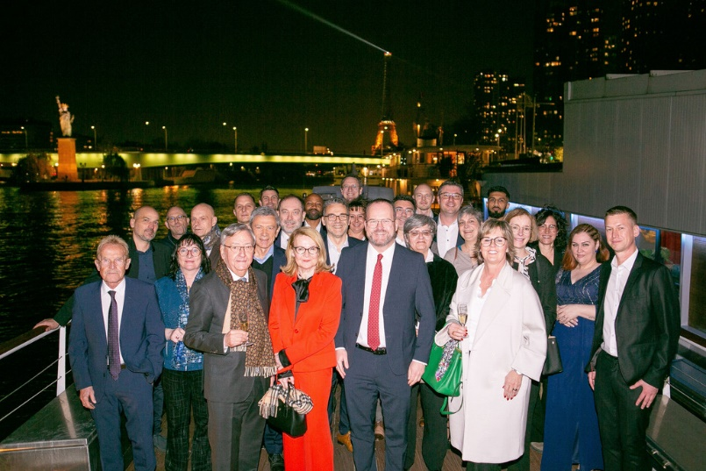

**Picture 1:** Against the majestic backdrop of the Eiffel Tower, the participants of the anniversary celebration gather on the Seine for a group photo. In the middle of the front row Dr. Gunther Wobser (President & CEO), flanked by Maxime Sabre (Managing Director of LAUDA France, right), who has been continuing the French chapter of success since 2023. © LAUDA

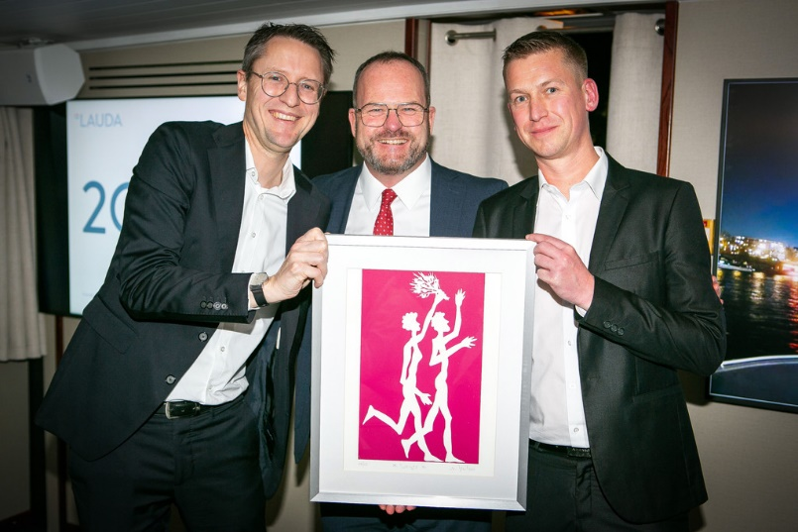

**Picture 2:** A work of art for winners: The beaming faces of Dr. Mario Englert (CFO, left), Dr. Gunther Wobser (President & CEO, center) and Maxime Sabre (Managing Director of LAUDA France, right) reflect the joy of two decades of successful Franco-German partnership at the presentation of the painting “Sieger” (Winner). © LAUDA

**We are LAUDA** –the world leader in precise temperature control. Our constant temperature equipment and systems are at the heart of important applications, contributing to a better future. As a complete one-stop supplier, we guarantee the optimum temperature in research, production and quality control. We are the reliable partner for electromobility, hydrogen, chemicals, pharmaceuticals/biotech, semiconductors and medical technology. We have been inspiring our customers for almost 70 years with our expert mentoring and innovative solutions – every day anew and all over the world.

In our company, we always go one step further. We support our employees’ development and are constantly developing ourselves: to create a better future together.

**Press contact**

We are more than happy to make prepared information about our company, the LAUDA Factory Gallery and our projects in the area of innovation promotion, digitalization and idea management available to the press. We look forward to hearing from you – just give us a call!

CHRISTOPH MUHR

Director Corporate Communications

T + 49 (0) 9343 503-349

[christoph.muhr@lauda.de](mailto:christoph.muhr@lauda.de)

LAUDA DR. R. WOBSER GMBH & CO. KG, Laudaplatz 1, 97922 Lauda-Königshofen, Deutschland/Germany. Limited partnership: Headquarters Lauda-Königshofen, Registration court Mannheim HRA 560069. General partner: LAUDA DR. R. WOBSER Verwaltungs-GmbH, Headquarters Lauda-Königshofen, Registration court Mannheim HRB 560226. Managing Directors: Dr. Gunther Wobser (President & CEO), Dr. Mario Englert (CFO), Dr. Marc Stricker (COO)