PRESS RELEASE
Schwaebisch Hall, January 16, 2020

A focus on the perfect packaging
OPTIMA will be presenting a packaging system with countless new technical refinements, an improved welding station, and digital Smart Services at the INDEX 2020 Trade Show

"Packaging at its finest"– this is Optima's slogan for INDEX 2020. The company will be showcasing two major themes that are of interest to the nonwovens industry. Optima is focusing on unique, sustainable packaging concepts that manufacturers can use to make their mark in the marketplace. The company is also presenting digital solutions under the heading “Smart Services”. These are designed to make packaging processes even more efficient and assist operators. INDEX will be held in Geneva from March 31 to April 3, 2020.
Today's consumers have a lot of requirements when it comes to the packaging for hygiene products. They expect a product that is perfectly suited to their needs, available in the right quantity and preferably available in high-quality, sustainable packaging. Here, differentiation is the solution. That is why “unique, sustainable packaging" will be one of the themes at INDEX 2020. "We will be showing how packaging can be optimized even further by using new technical solutions," explained Oliver Rebstock, Managing Director of OPTIMA nonwovens GmbH.
Manufacturers are successful at the point of sale when they use unique, sustainable packaging
This can be achieved by means of an innovative welding station developed by Optima Nonwovens, for example. This has a positive effect on the quality of the packaging. Oliver Rebstock also revealed, “Another major focus will be a system, consisting of a stacker and a packaging machine, which also concentrates on an optimized packaging design and features numerous new technical refinements.”
Differentiation in the marketplace is achieved both with improved packaging and with new packaging concepts. Optima Nonwovens is open to working collaboratively to develop new packaging solutions. Here, the options include alternative materials such as paper or starch films, new types of packaging such as cardboard packaging, or packaging with a new added value such as the opportunity to customize. However, there is also potential for completely new concepts, which Optima would like to discuss with visitors.
Line management software and optimized operator guidance improve efficiency
In its second subject area, Optima will be demonstrating how further improvements can be made to the efficiency of packaging processes. This is achieved through process optimization with Optima's line management software. This means that production resources can be used in the best possible way and the overall equipment effectiveness can be improved for entire production lines. Sustainability goals can also be met because waste is reduced.
Paper hygiene producers are increasingly faced with the challenge of finding qualified staff to operate packaging machines. In many countries, labor costs are also rising. An example of the application clearly illustrates how Optima uses remote support to assist operators as part of the OPTIMA Total Care life cycle management program. This means that quality issues can be resolved quickly, and the time taken to change formats can be reduced. This support is possible with every conceivable end device, including Augmented Reality glasses, which are used by the customer's operators to connect with Optima service staff.

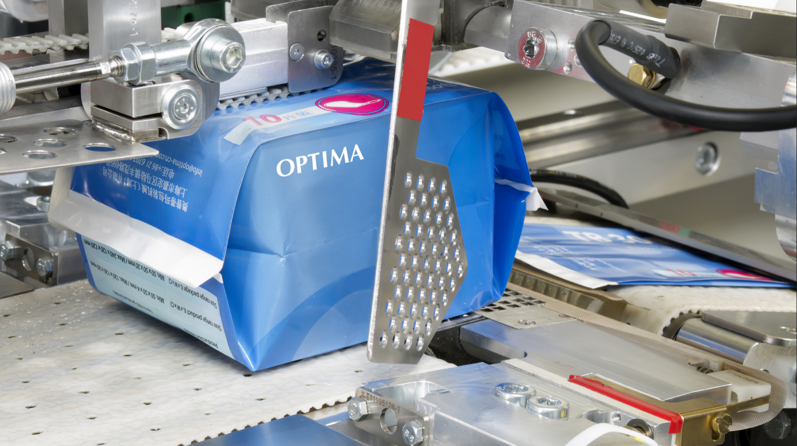
Innovative packaging processes have a positive effect on packaging quality. This can be achieved with an optimized welding station, for example.

Characters (incl. spaces): 3,424

Press contact:
OPTIMA packaging group GmbH
Jan Deininger
Editor
+49 (0)791 / 506-1472
jan.deininger@optima-packaging.com
www.optima-packaging.com
Thank you very much for your publication. We look forward to receiving a specimen copy.

