PRESS RELEASE
Schwaebisch Hall, September 20, 2021

The packaging of the future
OPTIMA and AMOTEK will be presenting solutions for optimal packaging design at the Index 2021

With the Index, a very important trade show for the paper hygiene market will again take place in presence. For Optima Nonwovens, a reason to put the focus on perfect packaging at the trade show. That's why Optima’s slogan at the trade show is “Packaging at its finest”. Optimal packaging design is essential in the area of paper hygiene. Together with the Italian subsidiary Amotek, Optima will be presenting expert solutions for optimal packaging design such as an innovative welding station. The Index will be held from October 19 to 22 in Geneva.
“We are delighted that we can communicate directly with customers and prospective customers again”, says Oliver Rebstock, Managing Director of the OPTIMA nonwovens GmbH. Personal interaction is essential in special machine construction. “Today's consumers have high demands on packaging. They are expected to be unique, of high quality, individual and sustainable. At the Index, we show how we support producers with these trends,” says Rebstock.
Safe and aesthetic closing of packaging
This can be achieved by means of an innovative welding station developed by Optima Nonwovens, for example. This has a positive effect on the quality of the packaging. Packaging can be closed safely and welded aesthetically. As the packaging systems by Optima Nonwovens are able to “learn by machine”, changes to the packaging can be detected automatically and the machine users can respond immediately. An automatic precise adjustment to each packaging format ensures that the first package after each format change is perfect. This avoids start-up and readjustment.
Interactive packaging experience
Differentiation in the marketplace is achieved both with improved packaging and with new packaging concepts. Optima Nonwovens is open to working collaboratively to develop new packaging solutions. Here, the options include alternative materials such as paper or starch films, new types of packaging such as cardboard packaging, or packaging with a new added value such as the opportunity to customize. However, there is also potential for completely new concepts, which Optima would like to discuss with visitors. For this reason, visitors on site can view and discuss packaging with various materials and customization interactively using the gamification element “Hypebox”.
Live-streaming of new machine
Amotek, based in Bologna (Italy), leads the way in developing packaging machines for paper hygiene products and consumer goods. The company's IS81 Performante packaging system is a new machine solution for diapers and feminine care products. Like all of Optima's machine solutions, this allows packaging material to be changed flexibly – for example from PE to paper and vice versa. The machine also features a high output through the dual-web design and a quick and easy format changeover. Visitors at the trade show get an individual, virtual insight into the factory in Bologna and can find out everything about the new solution.
Both Optima and Amotek offer sustainable packaging solutions with any conceivable kind of packaging material and with the Intelligent Production Assistance Services numerous digital tools to ensure even more efficient and resource-saving packaging processes.
Optima Nonwovens at the Index 2021: Hall 2, booth no. 2581
Amotek at the Index 2021: Hall 2, booth no. 2679

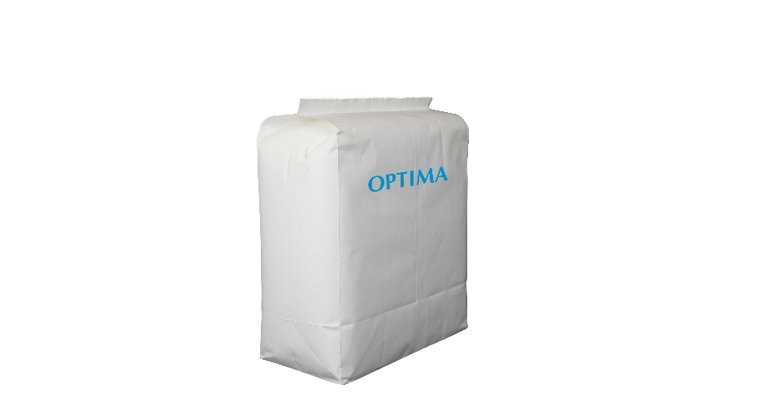
Optima Nonwovens’ systems can be flexibly converted from PE to paper and many other more sustainable packaging materials. The first paper packaging for diapers and sanitary towels has been developed in collaboration with producers for paper hygiene products. (Source: Optima)

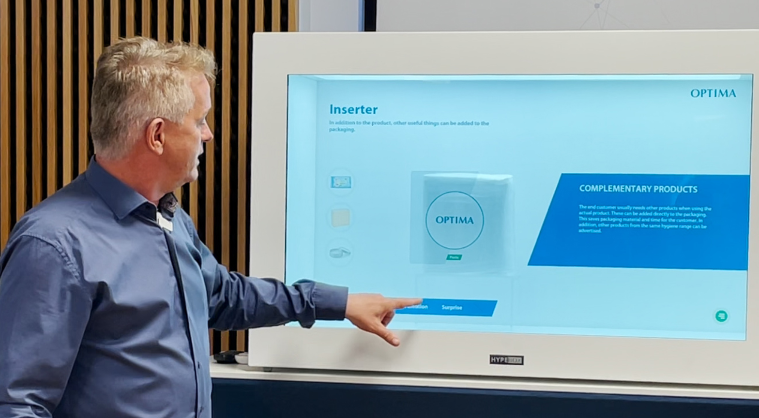
By means of the gamification element “Hypebox” the trade show visitors can view and discuss packaging with various materials and customizations interactively. (Source: Optima)

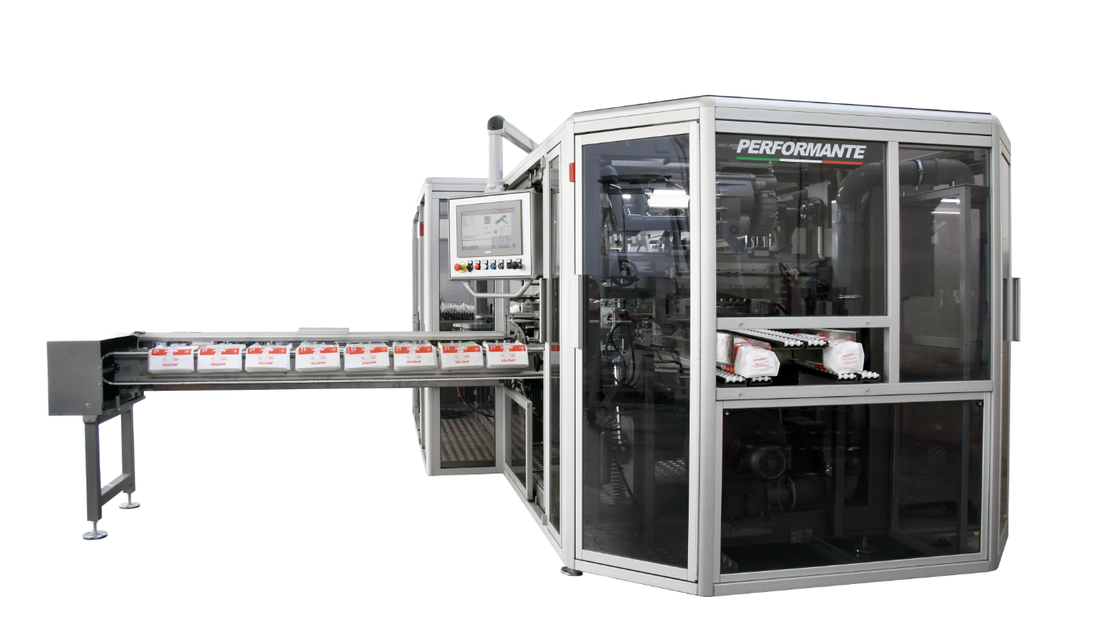
Visitors to the Amotek booth get an individual, virtual insight into the factory in Bologna and find out everything about the new IS81 Performante. (Source: Optima)

Characters (incl. spaces): 3,461

Press contact:
OPTIMA packaging group GmbH
Jan Deininger
Group Communications Manager
+49 (0)791 / 506-1472
jan.deininger@optima-packaging.com
www.optima-packaging.com

About OPTIMA
Optima supports companies worldwide with flexible and customer-specific filling and packaging machines for pharmaceuticals, consumer goods, paper hygiene and medical devices markets. As a provider of solutions and systems, Optima accompanies these companies from the product idea through to successful production and throughout the entire machine life cycle. Over 2,650 experts around the globe contribute to Optima's success. 19 locations in Germany and abroad ensure the worldwide availability of services.

Thank you very much for your publication. We look forward to receiving a digital specimen copy.

